MOSSFIELD PRIMARY SCHOOL
Mossfield Road
Pendlebury

Manchester
M27 6EH

Headteacher: Mrs J Plant
Assistant Headteacher: Mrs M. Dunphy Assistant Headteacher: Mr A Laycock Website: http://www.mossfieldps.salford.sch.uk Telephone No.: 0161 921 2160

14th May 2025

Dear Parents / Carers,

I am delighted to say that we have been able to secure a slot to visit Lledr Hall Outdoor Education Centre in North Wales, for our Year 6 pupils next year (in a Year 5 class now).

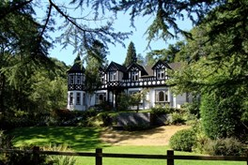
Lledr Hall is Salford’s own residential field centre and is owned and run by the City Council. It is situated in an idyllic setting in the heart of Snowdonia, near to the village of Dolwyddelan. It boasts extremely well qualified staff and has excellent facilities for outdoor pursuits and field studies. The children will follow a varied program during the week, which would include outdoor pursuits and field study.

I know that many of our parents and local people will have visited this centre themselves during their time at school, and taste the many exciting opportunities it has to offer.

Further details about the centre and the programme that is offered can be found at - https://www.lledrhall.co.uk/
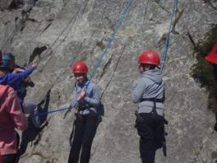

This visit will take place from Monday 19th January 2026 until Friday 23rd January 2026 (5 days/ 4 nights). This trip is only open to the children currently in YEAR 5 - who will therefore be in Year 6 next academic year (2025-2026)

The trip will cost £300 per child.


This includes 5 days / 4 nights at the Centre, all meals and activities; all coach transport costs and relevant insurance for the children.
This price already includes a high level of school subsidy in the cost of this visit.
Mossfield School Governors have a strong belief and commitment to the invaluable personal development experiences that such visits provide to our pupils.

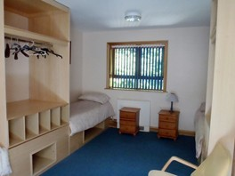
If you would like your child to attend, please could you return the tear off slip below, along with a £40 non-returnable deposit, to school no later than Friday 27th June.

You can also pay the deposit via ParentPay, you do not need to return the slip if you pay this way.

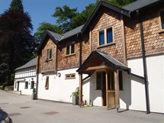
Once we have received your initial deposit, you will be issued with a payment card which will set out a payment plan. The payment plan is a guide; you can make additional payments if you wish. The final balance due date will be Friday 9th January 2026. (We are aware that there has been a cost increase since last year, and so this is why we have offered places now, to enable you time to make payment)

Unfortunately, if full payment is not received by this date, your child would not be able to attend.

A meeting for parents to explain the program and discuss the arrangements for the visit will be held closer to the actual date of the trip.

Yours faithfully,

Mrs J Plant
Headteacher

--------------------------------------------------------------------------------------------------------------

Please complete and return to school no later than Friday 27th June 2025.
Child’s Name...................................................................................................

Class.......................

I would like my child to attend the Lledr Hall residential trip and pay £40.00 cash deposit to secure my child’s place.

Signed............................................................................ Parent/Carer

