
Pupil premium strategy statement Mossfield Primary School

This statement details our school’s use of pupil premium funding to help improve the attainment of our disadvantaged pupils.

It outlines our pupil premium strategy, how we intend to spend the funding in this academic year and the effect that last year’s spending of pupil premium had within our school.

School overview
Detail | Data
School name | Mossfield Primary School
Number of pupils in school | 304 298 283
Proportion (%) of pupil premium eligible pupils | 51% 49.8 50.9%
Academic year/years that our current pupil premium strategy plan covers | 24-25, 25/26, 26/27 27/28
Date this statement was published | September 2024  July 2025  August 2026
Date on which it will be reviewed | July 2025  July 2026  July 2027
Statement authorised by | J. Plant
Pupil premium lead | J. Plant
Governor / Trustee lead | H Kelly
Funding overview
Detail | Amount
Pupil premium funding allocation this academic year | £211,352 (including EY funding)
Pupil premium funding carried forward from previous years (enter £0 if not applicable) | £ 0
Total budget for this academic year  If your school is an academy in a trust that pools this funding, state the amount available to your school this academic year | £ £211,352

Part A: Pupil premium strategy plan

Statement of intent
The intention at Mossfield School is that all pupils, irrespective of their background or the challenges they face, make good progress and achieve high attainment across all subject areas. The focus of our pupil premium strategy is to support disadvantaged pupils to achieve that goal.
Our focus will be upon raising attainment and engagement of the disadvantaged and vulnerable. However, we will always consider the challenges faced by all pupils, as a relatively high proportion of our families face issues of low wages and child poverty, regardless of any official designation. The activities we have outlined in this statement are also intended to support, and have benefits to, our wider school community, regardless of whether they are disadvantaged or not.
Quality first teaching is at the heart of our approach. This is proven to have the greatest impact on closing the disadvantage attainment gap and at the same time will benefit the non-disadvantaged pupils in our school. General classroom support is extensive, and is always arranged to support ‘normal’ class lessons with a broad and balanced curriculum, which is rich in its content. Other interventions are additional experiences, and these take place outside of normal classroom times, on an extensive and rigorous basis.
Implicit in our intended outcomes, is the intention that non-disadvantaged pupils’ attainment will be sustained and improved alongside progress for their disadvantaged peers. At Mossfield School, we carefully track and monitor every child’s progress on an ongoing and frequent basis. Lack of progress is to be identified and addressed as soon as possible.
Our strategy is also integral to wider school plans for education recovery, notably in its targeted support through the National Tutoring Programme for pupils whose education has been worst affected, including non-disadvantaged pupils.
Our approach will be responsive to common challenges and individual needs, rooted in robust diagnostic assessment, not assumptions about the impact of disadvantage. The approaches we have adopted complement each other to help pupils excel.

Challenges

This details the key challenges to achievement that we have identified among our disadvantaged pupils.
Challenge number | Detail of challenge
1 | Well below average attainment on entry to Nursery. Delayed acquisition of language in EYFS and especially reading skills in all ages, for some of our pupils.
2 | Gaps in Phonics: Assessments, observations, and discussions with pupils suggest disadvantaged pupils generally have greater difficulties with phonics than their peers. This negatively impacts their development as readers.
3 | Higher than average levels deprivation and poverty in local area. Relatively high levels of SEND need.
4 | Attendance and Punctuality of some disadvantaged pupil’s causes concern. High levels of persistent absence in some families.
5 | Behaviour and Low Academic Aspiration of some disadvantaged pupils and families leading to disengagement with learning.
6 | High levels of Safeguarding Concerns & some families of disadvantaged pupils who require Early Help and family support.
7 | Limited experiences of areas beyond Salford & limited Enrichment Activities for some disadvantaged pupils.
8 | Emotional and Mental Health concerns of some disadvantaged pupils.

Intended outcomes
This explains the outcomes we are aiming for by the end of our current strategy plan, and how we will measure whether they have been achieved.
Intended outcome | Success criteria
Accelerated progress and attainment in Reading  Progress in phonics scores in year 1 and 2  Improved oral language skills and vocabulary for disadvantaged pupils. | Achieve above national average progress scores in KS2 Reading.  All staff to be RWI trained  Engage with teaching school – Lacey Green (audit)  Reading clubs reignited – focus on vocabulary  Reading specialist to support staff with reading spines  Achieve national average in expected standard in Phonic Screening Check by the end of Year 2.  Assessments and observations indicate significantly improved oral language among disadvantaged pupils.
Greater consistency of progress for SEND pupils, especially disadvantaged pupils. | Aspirational targets and support for disadvantaged SEND pupils  Increase EHCP applications for high needs pupils
To improve attendance and levels of persistent absence for pupils, especially the disadvantaged. | Monitor attendance of disadvantaged pupils  Reduce current rates of persistent absence  Disadvantaged pupil’s attendance to be broadly in line with non-disadvantaged pupils at Mossfield School.
To maintain excellent behaviour and address low academic aspiration in some disadvantaged pupils.  To offer high quality booster groups | Exclusion and suspension rates to be below national average  Children to be offered booster groups after school  Relational policy to be adapted in consultation with a specialist
To ensure that all pupils have early and effective safeguarding and full access to Early Help, as soon as it is required. | Early Help is available promptly, and from a variety of services. Qualitative data from pupil voice, student and parent surveys indicates help is valued and increasing participation.  Family support worker on hand for pupils and families
To support a broad and balanced curriculum in ensuring that families experiencing poverty can access high quality trips and visits, materials, uniforms and ICT facilities | Trips and visits to ask for minimal contribution. Trips closely linked to curriculum provision.  Free used uniform to be available to all pupils.
To achieve and sustain improved wellbeing for all pupils by ensuring Emotional and Mental Health Concerns are addressed quickly and effectively. | Sustained high levels of wellbeing demonstrated by:  - qualitative data from student voice, student and parent surveys and teacher observations  - a significant reduction in bullying  - a significant increase in participation in enrichment activities, particularly among disadvantaged pupils

Activity in this academic year
This details how we intend to spend our pupil premium (and recovery premium) funding this academic year to address the challenges listed above.

Teaching (for example, CPD, recruitment and retention)
Budgeted cost: £ 124000
Activity | Evidence that supports this approach
Senior member of staff to work as a Reading Development Leader.  Support effective early phonics provision, champion reading, identify and act upon children in danger of falling behind. Lead staff CPD and develop pedagogy.  Support effective use of data and gap analysis through improved pupil progress analysis.  To provide support staff in monitoring reading progress and identifying and supporting pupils in danger of making below acceptable progress  To work with identified parents to promote and champion home reading  Lead the implementation of RW inc and ensure good progress in early reading in EYFS and KS  £50000 | Phonics approaches have a strong evidence base that indicates a positive impact on the accuracy of word reading (though not necessarily comprehension), particularly for disadvantaged pupils:  Phonics | Toolkit Strand | Education Endowment Foundation | EEF  Reading comprehension strategies are high impact on average (+6 months). Alongside phonics it is a crucial component of early reading instruction.  https://educationendowmentfoundation.org.uk/education-evidence/teaching-learning-toolkit/reading-comprehension-strategies  Small group tuition has an average impact of four months’ additional progress over the course of a year.  Small group tuition is most likely to be effective if it is targeted at pupils’ specific needs. Diagnostic assessment can be used to assess the best way to target support.  https://educationendowmentfoundation.org.uk/education-evidence/teaching-learning-toolkit/small-group-tuition
To provide effective and dedicated SENCO and assistant sendco release time for disadvantaged pupils. Ensure effective liaison with outside agencies and support services to ensure best possible outcomes for SEND disadvantaged pupils.  To monitor and track the progress of SEND pupils to ensure good progress and attainment.  (£52000) | SENCos fulfil a crucial intermediary role between external agencies, schools and families. Strong and trusting relationships between SENCos, parents and carers facilitate this.SENCos need enough time to carry out their responsibilities and access continuing professional development.  https://www.gov.uk/government/publications/supporting-send/supporting-send  We consider that the role of the SENCO is of such importance that those undertaking that role should have enough dedicated time, pay and knowledge to enable them to do their job well.  https://publications.parliament.uk/pa/cm201919/cmselect/cmeduc/20/20.pdf
Standardised Testing  Purchase of standardised diagnostic and summative assessments, to enable effective pupil tracking.  (£5000) | Standardised tests can provide reliable insights into the specific strengths and weaknesses of each pupil to help ensure they receive the correct additional support through interventions or teacher instruction:  Standardised tests | Assessing and Monitoring Pupil Progress | Education Endowment Foundation | EEF
Purchase new reading resources  1 Reading books closely aligned to phonic knowledge for KS1.  2 Reward materials to encourage and support higher order reading skills.  3 New class reading materials to expand classroom libraries.  Library developed  Reading incentives – reading books to take home  (£10 000) | New RWI resources  Phonics approaches have a strong evidence base that indicates a positive impact on the accuracy of word reading (though not necessarily comprehension), particularly for disadvantaged pupils:  Phonics | Toolkit Strand | Education Endowment Foundation | EEF  Reading comprehension strategies are high impact on average (+6 months). Alongside phonics it is a crucial component of early reading instruction.  https://educationendowmentfoundation.org.uk/education-evidence/teaching-learning-toolkit/reading-comprehension-strategies  913
Writing Teaching and Planning.  Enhancement of our writing teaching and curriculum planning.  We will fund subject leader and class teacher release time to develop a reading and writing spine, CPD and resources.  Writing lead to work alongside another school in the cluster to develop ideas  £7000 | New writing resources  Purchase necessary books  Teacher release time  Subject leader release time  CPD training time

Targeted academic support (for example, tutoring, one-to-one support structured interventions)
Budgeted cost: £ 22 000 - Pupil Premium

EYFS Spoken Language Development  Staffing and provision of a programmes to improve spoken language and vocabulary skills for disadvantaged pupils who have relatively low spoken language skills in our school.  (EYFS Speech programme - NELI + NESSY)  (£6 500) | Oral language interventions can have a positive impact on pupils’ language skills. Approaches that focus on speaking, listening and a combination of the two show positive impacts on attainment:  Oral language interventions | EEF (educationendowmentfoundation.org.uk)
Reading Intervention Groups. To set up and run throughout the year book clubs and reading groups, to take place before school or after school.  Selected KS 2 pupils to group read novels together, with a mentor TA. To promote reading attainment and progress, as well as reading for pleasure.  (£6 000) | Reading comprehension strategies are high impact on average (+6 months). Alongside phonics it is a crucial component of early reading instruction.  https://educationendowmentfoundation.org.uk/education-evidence/teaching-learning-toolkit/reading-comprehension-strategies  Tuition targeted at specific needs and knowledge gaps can be an effective method to support low attaining pupils or those falling behind, both one-to-one:  One to one tuition | EEF (educationendowmentfoundation.org.uk)  And in small groups:  Small group tuition | Toolkit Strand | Education Endowment Foundation | EEF
Additional Educational Psychologist Time Additional support for disadvantaged pupils showing disengagement and / or challenging behaviour or SEND Needs.  £7500 - gold package | EPs provide input at different stages within the education system at individual, group and systems level. However, the main focus will always be to act in the best interests of the child or young person.  https://gov.wales/sites/default/files/publications/2018-03/educational-psychologists-in-wales.pdf
Provide free childcare. Child care places to families where one or more sibling is attending after school small group tutoring sessions. This enables only one pick up time for parents and will increase participation in after school tutoring sessions.  (£2000) | On average, one to one tuition is very effective at improving pupil outcomes. One to one tuition might be an effective strategy for providing targeted support for pupils that are identified as having low prior attainment or are struggling in particular areas.  https://educationendowmentfoundation.org.uk/education-evidence/teaching-learning-toolkit

Wider strategies (for example, related to attendance, behaviour, wellbeing)
Budgeted cost: £ 124,000
Activity | Evidence that supports this approach
Fund a family support worker  To act as an expert champion, giving advice and strategies to staff, children and parents  To aid the effective reintegration of dysregulated pupils back into the classroom.  To increase the support and guidance given to LA ‘looked’ after pupils.  To give greater support and advice to pupils and families with mental health issues.  To lead on school avoidance and concerns. Special responsibility for pupil and parent Mental Health and well-being.  (£41000) | Both targeted interventions and universal approaches have positive overall effects (+ 4 months). Schools should consider the appropriate combination of behaviour approaches to reduce overall disruption and provide tailored support where required.  https://educationendowmentfoundation.org.uk/education-evidence/teaching-learning-toolkit/behaviour-interventions  When the nurture groups were working well they made a considerable difference to the behaviour and the social skills of the pupils who attended them. Through intensive, well-structured teaching and support, pupils learnt to manage their own behaviour, to build positive  relationships with adults and with other pupils and to develop strategies to help them cope with their emotions.  https://www.gov.uk/government/publications/supporting-children-with-challenging-behaviour
Attendance Officer  Monitor attendance and take action as required to promote good attendance.  Family support work and liaison with outside agencies.  To lead on school avoidance and concerns. Special responsibility for school attendance.  This will involve training and release time for staff to develop and implement new procedures and appointing attendance/support officers to improve attendance.  (£22000) | Follow DfE guidance which has been informed by engagement with schools that have significantly reduced levels of absence and persistent absence.  Embed the principles of good practice set out in the DfE’s Improving School Attendance advice.
Fund Attendance Administrative Support Officer –  Monitor attendance and take action as required to promote good attendance.  Family support work and liaison with outside agencies.  To lead on school avoidance and concerns. Special responsibility for school attendance.  Embedding principles of good practice set out in the DfE’s Improving School Attendance advice.  (£41 000) | Follow DfE guidance which has been informed by engagement with schools that have significantly reduced levels of absence and persistent absence.  Embed the principles of good practice set out in the DfE’s Improving School Attendance advice.  Embed the principles of good practice set out in the DfE’s Improving School Attendance advice.
Fund Additional E.W.O support to the school.  (£5000) | Follow DfE guidance which has been informed by engagement with schools that have significantly reduced levels of absence and persistent absence.  Embed the principles of good practice set out in the DfE’s Improving School Attendance advice.  Embed the principles of good practice set out in the DfE’s Improving School Attendance advice.
Subsidy of school trips and events  Subsidy for all pupils who were not able to make a voluntary contribution to costs.  Subsidy for all pupils to bring the generally cost of all school trips and visits to a more manageable level.  (£12000) | HSE fully recognises that learning outside the classroom helps to bring the curriculum to life – it provides deeper subject learning and increases self-confidence. It also helps pupils develop their risk awareness and prepares them for their future working lives.  https://www.hse.gov.uk/services/education/school-trips.pdf  The cost of school trips causes problems for many children. Two in five children who live in families that are ‘not well off at all’ have missed a term time school trip because of the cost.  https://www.basw.co.uk/system/files/resources/basw_21941-5_2.pdf
Contingency fund for acute issues.  (£3000) | Based on our experiences and those of similar schools to ours, we have identified a need to set a small amount of funding aside to respond quickly to needs that have not yet been identified.

Pupil premium strategy outcomes 25/26
This details the impact that our pupil premium activity had on pupils in the 2025 to 2026 academic year.
Our internal assessments for the 2025/26 academic year indicate that our end-of-year EYFS results accurately reflect pupil performance. Phonics outcomes in both Year 1 and Year 2 were in line with our projections, though they remain below both national and local averages. However, our Year 6 end-of-year results exceeded national and local benchmarks across all subjects, reflecting strong progress and attainment.
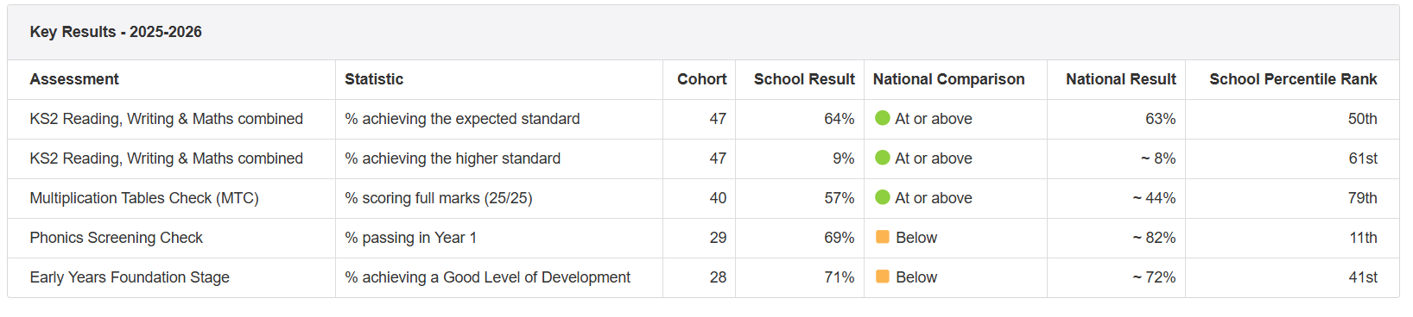
We have retrained all staff in the Read Write Inc. programme and continue to receive support from Lacey Green Teaching School. A new Phonics Lead, supported through a TLR, has been appointed to drive improvements in early reading. Working closely with a Read Write Inc. consultant, she provides targeted tutoring for identified pupils, monitors the quality of phonics teaching and interventions, analyses progress data, and supports staff to ensure consistency and strong outcomes across the school.
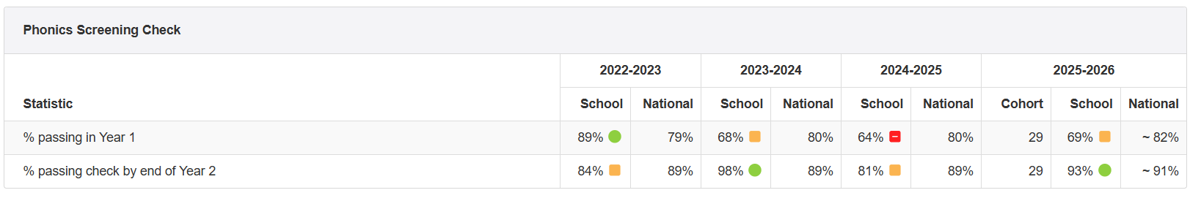
Phonics remains an area for continued development. While the proportion of pupils passing the Year 1 Phonics Screening Check increased from 64% to 69%, outcomes remain below the national average (approximately 82%). However, targeted interventions and strong catch-up provision are having a positive impact, with 93% of pupils meeting the expected standard by the end of Year 2, exceeding the national figure of approximately 91%. This demonstrates that most pupils successfully close gaps in learning over time, although improving Year 1 outcomes remains a key priority, particularly for disadvantaged pupils and those with additional needs. We have completed a case study for all children who did not pass the phonics test.
Reading clubs continue to be well attended and valued by pupils and families. Investment in high-quality texts, supported by grants and school funding and guided by our literacy adviser, has enhanced the provision, alongside the development of dedicated KS1 and KS2 library spaces to promote reading for pleasure. Pupil feedback has helped shape sessions to include creative activities alongside reading, increasing engagement and fostering a positive reading culture across the school.
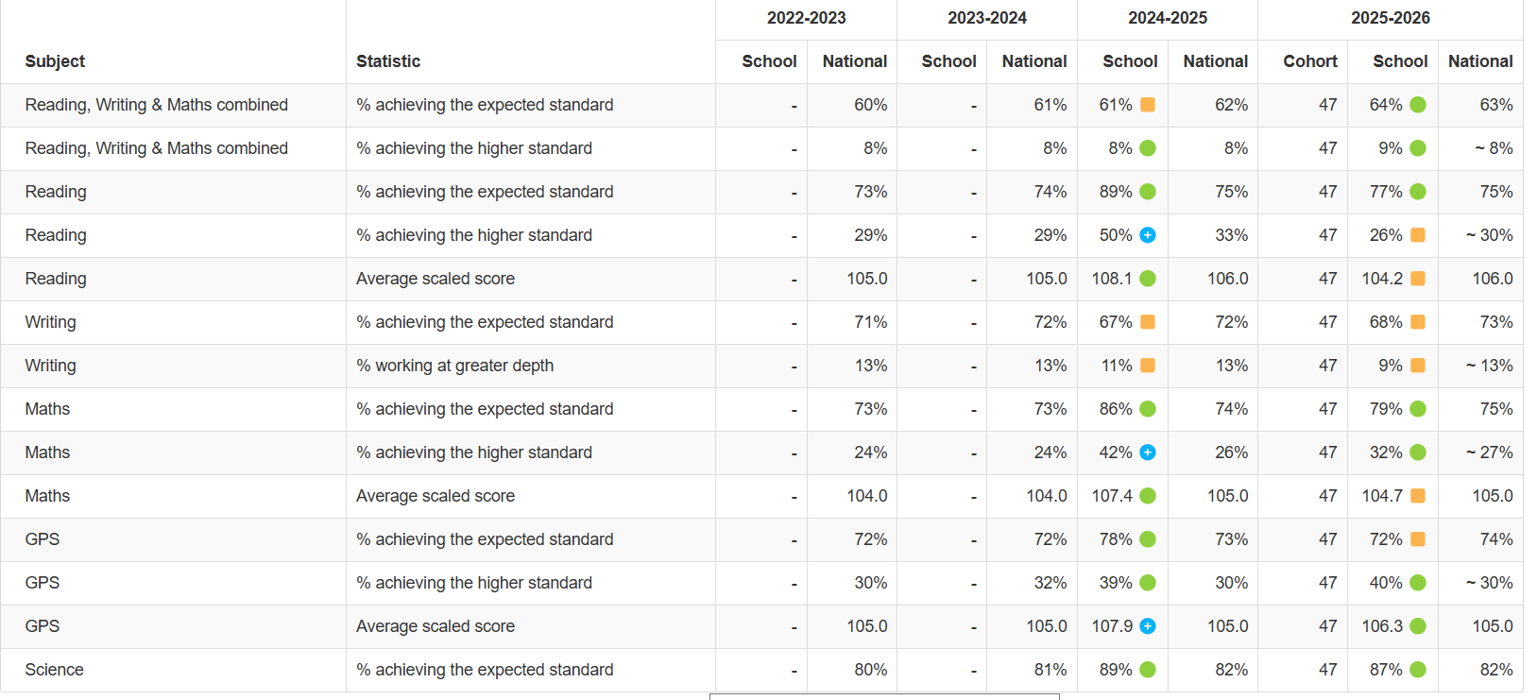
Attainment outcomes remain broadly positive, with performance at or above national averages in several key areas. In 2025-26, 64% of pupils achieved the expected standard in Reading, Writing and Maths combined, slightly above the national figure of 63%. Higher standard attainment also remains above national at 9% compared with approximately 8% nationally.
Reading continues to be a relative strength, with 77% reaching the expected standard, above the national average of 75%. However, the proportion achieving the higher standard has fallen from 50% in 2024-25 to 26% and is now below national figures, indicating a need to further develop challenge for the most able readers, including disadvantaged pupils.
Mathematics outcomes remain strong, with 79% achieving the expected standard and 32% achieving the higher standard, both above national averages. This suggests that recent improvements in teaching and intervention strategies are having a positive impact.
Writing remains an area for development, with 68% achieving the expected standard and 9% working at greater depth, both below national figures. This supports the continued prioritisation of writing across the curriculum, particularly for disadvantaged pupils who often have weaker transcription, vocabulary and composition skills.
In GPS, attainment at the expected standard is broadly in line with national outcomes, while higher standard attainment is significantly above national averages (40% compared with approximately 30% nationally). Science outcomes are also strong, with 87% achieving the expected standard, exceeding the national figure of 82%.
Overall, the data indicates that investment in reading, phonics, targeted intervention and high-quality teaching is improving outcomes. Future pupil premium priorities should focus on sustaining strengths in reading and mathematics while accelerating progress in writing and increasing the proportion of pupils, particularly disadvantaged pupils, attaining the higher standard in reading
 | Year 2 -phonics |  | Year 1 phonics
  25/26 | Reading yr 6
   | Exp+ | Above
  All (47) | 77% | 26%
  PP (23) | 70% | 9%
  28 | 93%
  PP (14) | 93%
  30 | 68%
  PP (12) | 67%
  25/26 | Reading reception
   | Exp
  All 30 | 83%
  PP (15) | 73%
We have seen a substantial increase in the number of Education, Health and Care Plan (EHCP) applications, ensuring our most vulnerable learners receive the specialist support and advice they need. The expansion of our internal alternative provision has enabled us to identify and assess pupils' needs more effectively, contributing to a rise in EHCP requests. The appointment of an Assistant SENDCo has been instrumental in managing the increasing number of EHCPs and neurodevelopmental referrals, helping to ensure timely and appropriate support. We now have 4 pupils receiving band G+ which is much higher than previously.

While overall attendance remained below our ambitious expectations, reflecting a wider local and national challenge. Attendance was further affected by periods of exceptionally high temperatures and increased absence linked to major sporting events, including the World Cup. A continuing concern was the level of unauthorised holiday absence, with some absence reported as illness to avoid penalty notices, resulting in a significant number of Fixed Penalty Notices (FPNs) being issued. Attendance will remain a key priority in 2026/27, with continued targeted support and challenge for disadvantaged pupils who are persistently absent, as this group continues to be most at risk of lower academic progress and reduced engagement with learning.
Our attendance officer has worked closely with several families, offering tailored support and incentives to improve both attendance and punctuality. We had targeted support for several families at risk of falling into PA. We have also tracked the effect the high school dates have on our attendance and have put measures in place to try and improve this.
OVERALL 25/26
Nursery | 90.21%
Reception | 91.14%
Year 1 | 92.29%
Year 2 | 94.84%
Year 3 | 92.29%
Year 4 | 93.72%
Year 5 | 91.46%
Year 6 | 92.04%
OVERALL 25/26
EAL | 93.77%
Non-EAL | 92.33%
OVERALL 25/26
BOY | 91.79%
GIRL | 93.61%
OVERALL 25/26
FSM | 90.21%
Non FSM | 95.29%
OVERALL 25/26
N | 94.51%
K | 90.55%
EHCP | 79.54%

DATES TO NOTE 2025/26
Co-Op INSET | 23/10/2025 | 90.20%
Co-Op INSET | 24/10/2025 | 89.00%
Co-Op INSET | 10/11/2025 | 92.00%
Weather Warnings - Around 35 degrees | 24/06/2026 | 84.50%
Weather Warnings - Around 35 degrees | 25/06/2026 | 78.80%
Weather Warnings - Around 35 degrees | 26/06/2026 | 84.70%
England Match at 1am | 06/07/2026 | 88.01%
Weather Warnings - Over 30 degrees | 09/07/2026 | 88.62%
Weather Warnings - Over 30 degrees | 10/07/2026 | 79.48% | School closed at 1pm
Day after World Cup Final & Co-Op Closed | 20/07/2026 | 85.00%
Co-Op Closed | 21/07/2026 | 88.40%
Co-Op Closed | 22/07/2026 | 87.70%

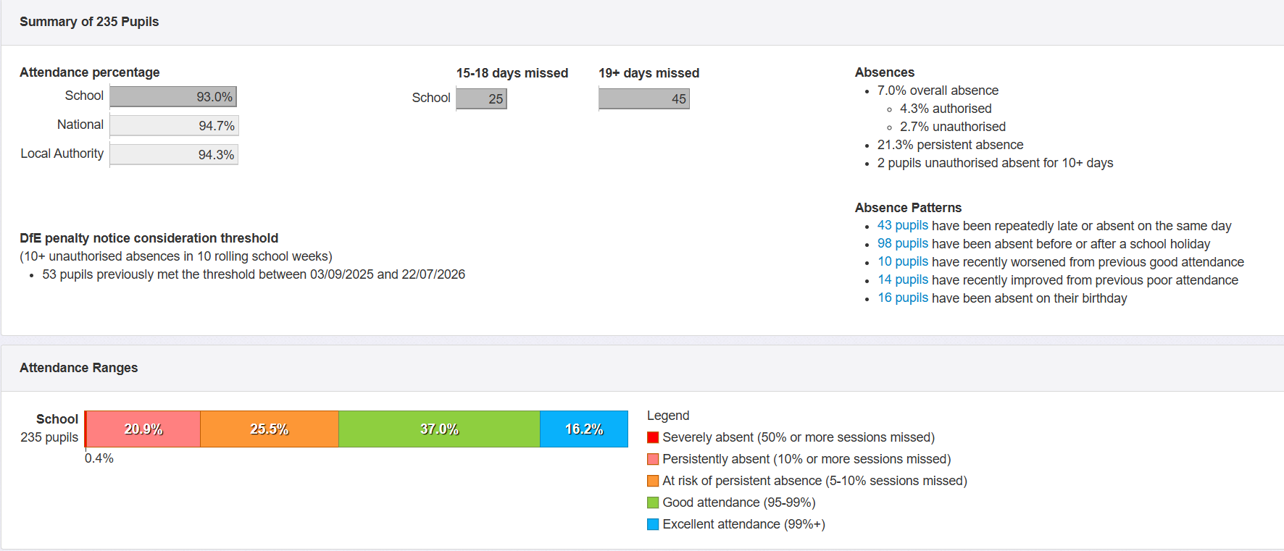

Our Family Support Worker has continued to strengthen support for vulnerable pupils and their families. Targeted interventions, advice and ongoing family support have helped many families facing emotional, social and financial challenges, reducing barriers to attendance, engagement and learning.

To ensure greater value for money and stronger curriculum links, all class visits and enrichment opportunities have been reviewed and redesigned this year. Educational visits are now more closely aligned to curriculum objectives, enhancing learning while helping to reduce costs for families. A designated Trips and Visits Lead monitors trips visits and all clubs to ensure all our families benefit.
.

Pupil premium strategy outcomes 24/25
This details the impact that our pupil premium activity had on pupils in the 2024 to 2025 academic year.
Our internal assessments for the 2024/25 academic year indicate that our end-of-year EYFS results accurately reflect pupil performance. Phonics outcomes in both Year 1 and Year 2 were in line with our projections, though they remain below both national and local averages. However, our Year 6 end-of-year results exceeded national and local benchmarks across all subjects, reflecting strong progress and attainment.
We are currently retraining all staff in the Read Write Inc programme. Although the school has implemented this approach for many years, a recent phonics audit (Lacey Green) highlighted variations in delivery. We are pleased to have been selected for targeted support throughout the coming year and have appointed a new reading lead to provide guidance and coaching to staff.
Reading outcomes in Year 6 have shown a marked improvement compared to last year – particularly in children achieving the higher standard on reading. Staff attribute this to increased opportunities to read aloud to classes, as well as input from an experienced literacy advisor. All teachers have now developed a robust reading spine, featuring high-quality, enriching texts.
Reading clubs were a success, with strong attendance from pupils. Many parents also appreciated the opportunity to access childcare for siblings during these sessions. With the guidance of our literacy advisor, we have invested in new, engaging books. Through pupil voice, we have shaped these clubs to include not only reading but also creative activities, helping to foster a love of reading.
 | Year 2 phonics | Year 1 phonics
  24/25 | Reading yr 6
   | Exp+ | Above
  All | 89% | 50%
  PP (15) | 93% | 40%
  47 | 81%
  PP (23) | 74%
  28 | 64%
  PP (16) | 50%
  24/25 | Reading reception
   | Exp
  All 30 | 67%
  PP (12) | 58%

We have seen a substantial increase in the number of Education, Health and Care Plan (EHCP) applications, ensuring our most vulnerable learners receive the support and specialist advice they need. The appointment of an assistant SENDCo has been instrumental in managing the growing number of EHCPs and neurodevelopmental referrals, helping to maintain timely and effective support for our SEND pupils (3 EHCP’s 2024 – now 10 with a further 3 to do before the end of the year.)
While overall attendance improved significantly this year, it still falls short of our expectations. This mirrors a wider trend both locally and nationally. A notable concern was the high level of unauthorised holiday absence, with some parents reporting illness to avoid penalty fines. As a result, a substantial number of Fixed Penalty Notices (FPNs) were issued. Attendance will continue to be a core priority in 2025/26, with particular focus on disadvantaged pupils identified as persistent absentees, as these children often made the least academic progress.
Our attendance officer has worked closely with several families, offering tailored support and incentives to improve both attendance and punctuality. Unfortunately, we did experience a spike in absence due to a significant outbreak of chickenpox.
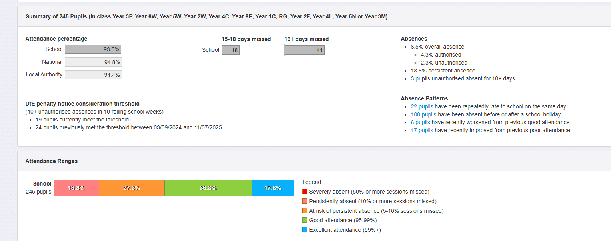
The addition of a family support worker has been invaluable to our school community. Pupils, staff, and parents have regularly accessed this support, benefiting from drop-in sessions and targeted interventions throughout the year.
To broaden pupils’ experiences, each class participated in a wide range of educational visits, well above average. These included both enrichment opportunities and curriculum-linked trips. Year 5 and Year 6 pupils were also offered a residential experience, with the school contributing significantly to help make these more accessible for families. A trips and visits lead monitors these each year.
.

Further information
Our pupil premium strategy will be supplemented by additional activity that is not being funded by pupil premium or recovery premium. That will include:
- Developing high quality skills and knowledge progression schemes in Foundation Subjects. Improve information to parents about our school curriculum.
- Offering a wide range of high-quality extracurricular activities to boost wellbeing, behaviour, attendance, and aspiration. Activities will focus on sports and hobbies building life skills such as confidence, resilience, and socialising. Disadvantaged pupils will be encouraged and supported to participate.

