 | Year 2 English Curriculum Overview
Autumn Core Texts | Week 1 | Week 2 |  | Week 3 |  | Week 4 |  | Week 5 |  | Week 6 |  | Week 7 | Week 8 | Week 9 |  | Week 10 |  | Week 11 |  | Week 12 |  | Week 13 |  | Week 14
Autumn Core Texts | Animals |  |  |  |  |  |  |  |  |  |  |  | Hot and cold lands
Autumn Core Texts | Lottie Potter wants an otter – Willis  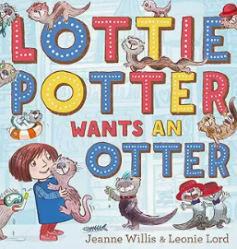  Teacher’s day in bed –  My Dog – Seigal  You Choose  Pet shop clip  100 dogs - | Negative views of dogs  Stay – Latimer  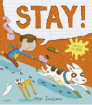  Can I be your dog – Cummings  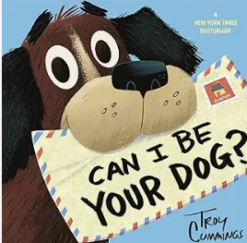 |  |  |  | Positive – Dogs that help us  The Present  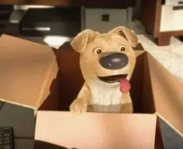 Guide dog short film   |  | Dread cat –  Rosen & Byrne  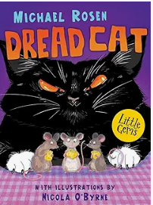 |  |  |  | Poems about animals – ed. Moses  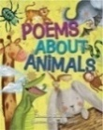 | Meercat Mail - Gravett  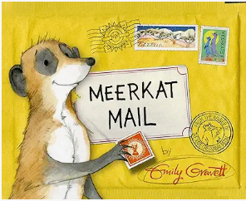  Clips about what Africa is like |  |  | Snail Mail – King Snail  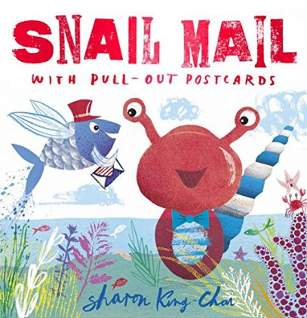  The Ultimate Book of African Joubert & Beverly  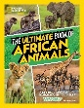 |  | Cold lands – Danny & the penguins  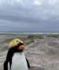  March of the penguins  Images from Young Zoologist – Emperor Penguin  Delightfully different Dilly –  Dale & Darcy  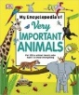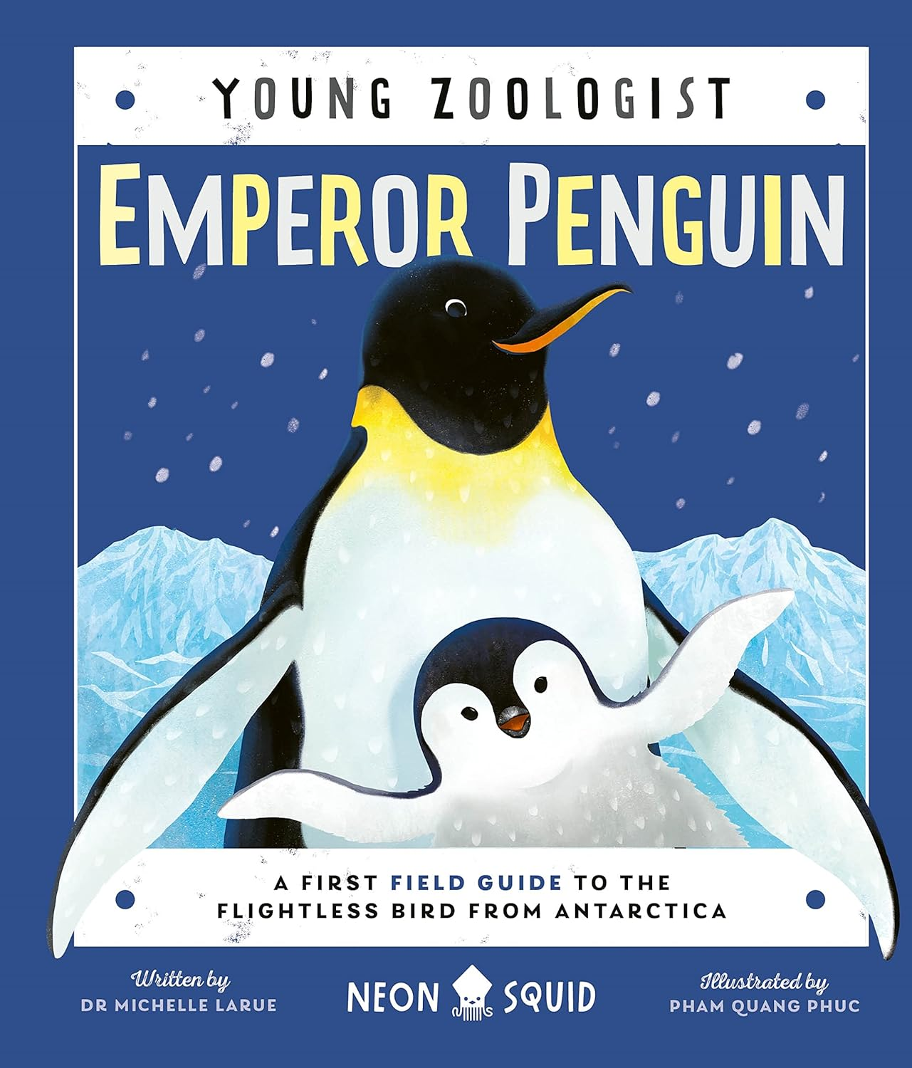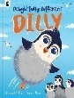  Very important animals – DK |  |  |  |  |  | A Christmas poem to send to Sunny Meercat and rocky the Penguin from Salford  Meerkat Christmas - Gravett  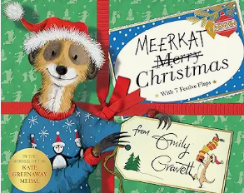
Writing Outcomes | A list poem about a favourite dog  To share List poem about a perfect pet  Read through the poems and perform the ones that everyone agrees is their favourte. Read My Dog and reinforce the use of comparative and superlative adjectives. | Narrative about a naughty dog  Read them the story of Buster up to the point of the family going on holiday. Discuss all the terrible things that Buster does in the house/in the garden/on holiday. |  | A letter of forgiveness from Buster. Read the next few pages to the point that Buster has reeked havoc in the post office. Go into role as Buster begging the ‘family’ for forgiveness. Explicitly show them how to use contractions. |  | A character description about a guide dog who is really helpful.  Watch the short animation about the little three-legged dog that is given to the boy as a present. Collect all their ideas about why he is such a good present because he is friendly and loving. Create a role on the wall to collate these ideas. Then watch the next animation about the wonderful little guide dog. Add detail to the role on the wall and then use this to help create a description of this helpful little fellow. |  | 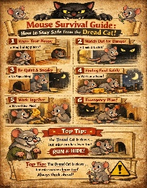  Instructions for the mice so they can survive in the house when the cat is around. Read the next part of the story and think about the poor mice and how they are going to survive in the house with the dread cat living there too. Show them the poster to help them begin to think of their own ideas. Then show them the more detailed survival guide and use a frame to help collect all their ideas. |  |  |  | A poem about different animals based on the poem The Terrible Ten from the anthology above  Develop into a riddle. | Character description of Sunny  Simple sentences using correct punctuation, noun phrases, adverbs, conjunctions  Character description (personality/appearance)Simple sentences using correct punctuation, noun phrases  Use of conjunctions.(Introduce new ones), verb choices with adverbs |  |  | A postcard all about Africa that they could find in Snail Mail  Read Snail Mail and look at what information would be about each country. Discuss postcards and their purpose. Collect ideas about what they know about Africa. Teacher pupils to write in demarcated sentences. Postcard about Africa that |  | A non chronological page about penguins  Danny and Rocky become friends as they are both very lonely.  Use the photos of the penguins & Rocky to generate questions. Become penguin experts & create a simple penguin info page with caption / non chron - Gather information from their own knowledge, film clips and texts to learn more about dogs. Discuss how this can be organised into sections under different subheadings. Teach the children how to organise their knowledge.  Create a list of questions about penguins and model how to answer them in appropriate sentences under each of the subheadings. Pupils can focus on singular and plural rules with words that they can use within their information text. |  |  |  | An innovated narrative based on the story of Rocky the penguin  Use the images of Rocky and create a story board about a lonely penguin who is desperate for friends. |  | Create a Christmas poem that captures what is so magical about Christmas.  A list poem about all the amazing gifts that you could give the meerkat or Rocky.
Text knowledge & GPS | Yr 2: Consolidate Year 1 skills and expectations – demarcate different sentence types using capital letter, full stops, exclamation and question marks. Reinforce terminology – statement, question, exclamation & command. Use co-ordinating conjunctions and, but for extending sentences if appropriate. Use verbs and adjectives. |  |  |  |  |  |  |  |  |  |  | Use facial expressions and gesture when performing Identify and use question sentences within their riddle.  Use verbs to describe action of the animals. use noun phrases and verbs to describe | Yr 1: Use of co-ordinating conjunction and  Use adjectives to describe characters. Use of sub-ordinating conjunction because  Use superlatives to describe characters. |  |  | Use the layout of a postcard to give the reader interesting facts about Africa.  Use expanded noun phrases & superlatives to describe interesting facts. Use conjunctions to add details.  Yr 1: To use Capital letters for names of Proper Nouns |  | Use an appropriate layout for a non-chronological report with support eg. Heading, subheading, technical language.  Children use 4 different sentence types to impart the information eg. A question sentence.  Use of present tense verbs.  Use of conjunctions because, if, so  Recap possessive apostrophes eg. The dog’s food. |  |  |  | Use their story telling skills to impart the tale.Use the four different sentence types with growing accuracy.  Use past tense verbs with ed suffi. |  | Use present tense verbs appropriately to match the nouns in the lines of the poem.  Use adjectives appropriately to match the nouns in the lines of the poem.
Text knowledge & GPS | Speak in sentences and  hold a sentence  See simple sentences modelled  write sentences that include the subject &the verb. | Demarcate a simple sentence with capital letters and full stops .Use past tense verbs.  To use superlatives to capture the naughtiness of the dog. |  | Distinguish between statements and questions To use co-ordinating conjunction and to extend sentences. |  | use adjectives to describe the emotions and actions.  To use conjunction and to extend the descrption. Use simple adjectives to describe |  | Use the layout of an instruction text.  To use command sentences & present tense verbs.  To use co-ordinating and subordinating conjunctions to give extra information within each instructio
Spring Core Texts | Week 1 |  | Week 2 |  | Week 3 |  | Week 4 |  | Week 5 |  | Week 6 |  | Week 7 |  | Week 8 |  | Week 9 |  | Week 10 |  | Week 11 |  | Week 12
Spring Core Texts |  |  |  |  |  |  |  |  |  |  |  |  | Plants
Spring Core Texts | Scene from Happy Feet where the penguins are learning to fly  Flight school – Lita Judge  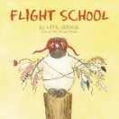  Clip from Chicken Run when they try to shoot the chickens out of the cannon to help them fly. |  |  |  |  |  | Amelia Earhart: Level 2 (National Geographic Readers) – Gilpin/ Little People Big Dreams – Amelia Earhart – Vegara  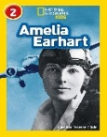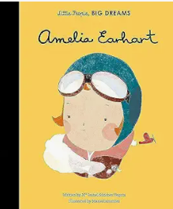  See file for clips about her life |  |  |  | Songs about flying  Eg. I believe I can fly  Come fly with me |  | My Bean Diary  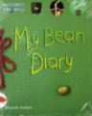  From Bean to  Bean Plant – Ganeri  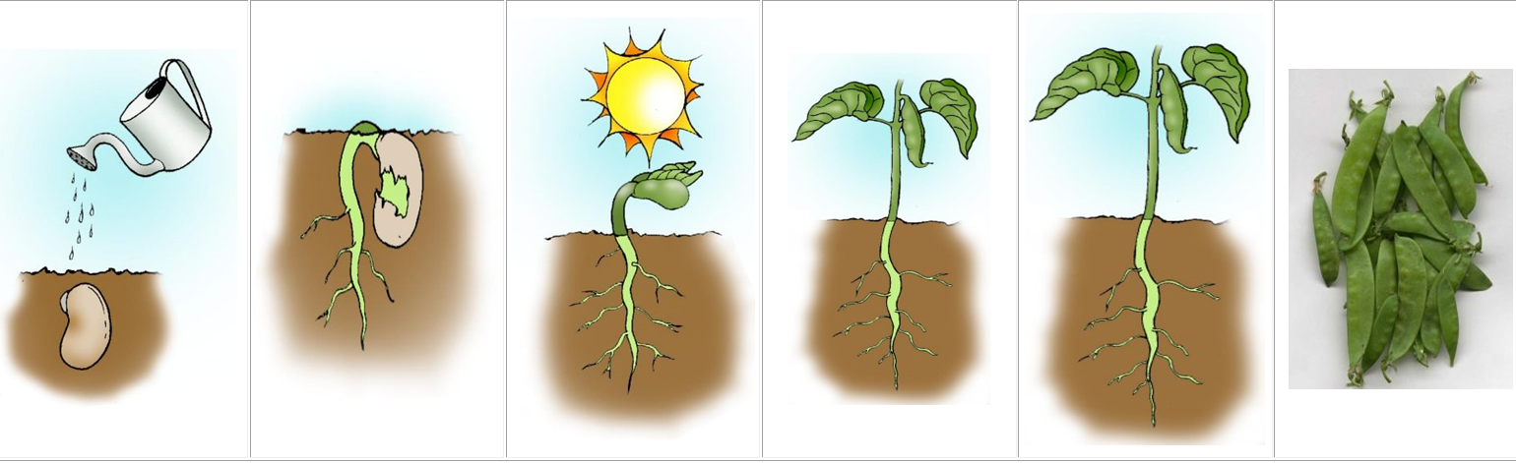 |  |  |  | Plant the tiny seed - Matheson  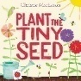  Five little beans  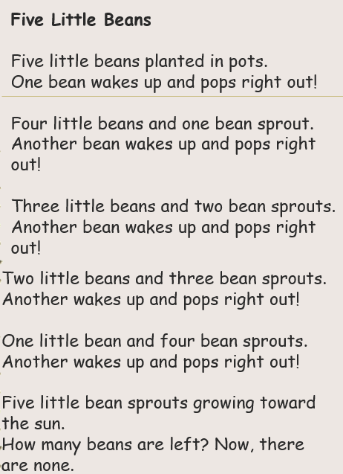  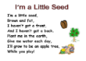 |  | Jack and the beanstalk – Alperin  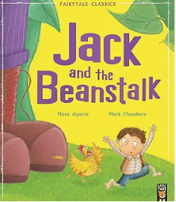  An alternative version eg.  Jim and the beanstalk – Briggs (a class set)  Jack and the Beanstalk – Gledhill /  Kate and the beanstalk – Osborne /  Jack and the Jellybean stalk – Mortimer  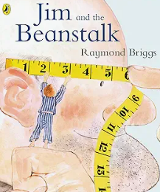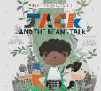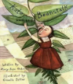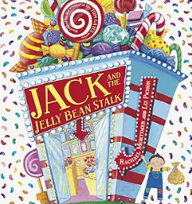
Writing Outcomes | Instructions to help Rocky the penguin fly  – How to help Rocky the penguin fly Read the story Flight School to the point where they have tried lots of different ideas to help the penguin fly. Discuss which ones are the best and then look at the list the teacher has generated. Teach commas in a list. Discuss how they could create instructions to give to Danny so he could help Rocky to fly. |  | An exciting narrative based on what happened when Danny tried to help Rocky to fly.  Read the book Flight School again and recap on all the different ways to help Rocky to fly. Use props and a story map to capture the children’s story ideas about how they could write their own version but it would be about Danny and Rocky rather than this penguin. Use the same type of structure:  - Rocky wants to fly but he can’t.  - Danny tries different ways eg. a catapult, use a trampoline, Danny solves the problem by taking Rocky up in a fast jet (or the children create their own perfect ending)  During the journey visit the prefix un to explore how Rocky felt. |  |  |  | Create a simple fact file about the life and adventures of Amelia Earhart  Watch The British Airways advert to help pupils see how the aeroplanes have evolved over the last 100 years.  Watch clips about Amelia Earhart and discuss what they know about her. Predict what information the book Little People Big Dreams about Amelia Earhart might have in it. Create a simple timeline and then read the book. Can they add other important facts about her to it?  Create a list of questions about her life and model how to answer them in appropriate sentences (see WAGOLL for ideas)  During the learning journey pupils can focus on singular and plural rules with words that they can use within their information text. |  |  |  | A poem all about wanting to fly  Listen to songs about flying and talk about what it would be like to be able to fly.  Read them the poem Learning to fly and act out the different verbs  Model how to use these to create their own poem |  | Diary of a bean Plant the bean. Watch the bean every day and make drawings/take photos.  Create a simple diary of the growth and the changes in the little bean.  Model using co-ordinating conjunctions to give details about the change in the beanstalk eg. The beanstalk had grown to 3 cm and the stalk was very straight. |  | Design a seed packet  Look at lots of different sorts of seed packets for ideas.  Create a magical seed packet showing what amazing plant their seed will grow. |  | A number poem about seeds  Recite the pages from the book to follow the ‘instructions’ for planting the tiny seed.  Read lots of seed/plant poems  Work as a class to make a simple list poem about 5 little seeds eg.  5 little seeds pushing to the sky …  1 little seed waiting in the sun |  | A beware of the giant poster  Read the original version of Jack and the beanstalk and create a simple story map so that pupils can confidently retell it.  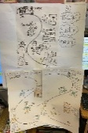  Act out being the giant – fee, fi, fo,fum and then describe how frightening he is  Do a Beware poster of the giant character study of the giant focusing on how horrible he is in the original version. |  | An innovated version of Jack in the beanstalk  Share other versions of the story and explore how they are different to the original. Pupils could work as a class to complete a venn-diagram to compare the original version with the new one or they could complete a table comparing the different versions (depending how confident they are) eg a new main character like Jill and the beanstalk or changing the beanstalk into a jelly bean stalk or making the giant into a very kind character:  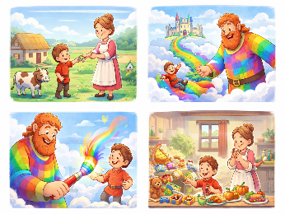  Use props to help change the story with the pupils. They could orally rehearse their ideas using these props. Pupils write their own narrative version of the story. Teach pupils how to proof-read and edit their writing.
Text knowledge & GPS | Pupils are shown how to structure instructional writing. Eg Heading, chronological steps, time order and present tense verbs with ing suffixes to describe what to do with the penguin. |  | Use their story telling skills to impart the tale.  Use the four different sentence types with growing accuracy.  Use past tense verbs with ed suffix consistently to retell the story.  Use of the prefix ‘un’ – Rocky was unhappy. The birds were unkind. It was unfair. He could not fly! He felt so unlucky. |  |  |  | With support, use their knowledge of heading and subheadings (questions subheadings) to help organise the information for the reader.  To use past tense verbs with ed endings with growing accuracy.  To make some use of –s and –es to form regular plurals correctly.  Use of a variety of conjunctions to give more detail within each sentence. |  |  |  | Use present tense verbs with ing suffixes to describe learning to fly.  Use questions marks with growing confidence in their sentence structuring |  | Use the structure of a diary to record their observations.  Use conjunctions to explain what they witnessed.  Use expanded noun phrases to describe what they could see. |  | Use expanded noun phrases and superlatives to describe their magical plants. |  | Use present tense verbs to describe the actions of the seed in the poetic lines. |  | Explore the prefix un when describing the giant on the poster.  Eg unkind, unfair, unwise  apostrophe for possession eg. He climbed down the Giant’s beanstalk. |  | Pupils use first, then, next, so and finally to help them construct this part of the story if they need a defined structure..  Revisit adjectives and superlatives used within this block of learning eg. It grew taller and taller. The tallest beanstalk in the world!  Use commas in a list to show details about the beanstalk or the characters.  Begin to edit their writing.

Summer Core Texts | Week 1 | Week 2 | Week 3 | Week 4 | Week 5 | Week 6 | Week 7 | Week 8 | Week 9 | Week 10 | Week 11 | Week 12
Summer Core Texts | Our Wonderful World |  |  |  |  | Oh I do like to be beside the seaside!
Summer Core Texts | The Koala who could – Bright & Field  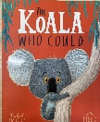 |  | Poems about animals – ed. Moses/One day on our blue planet – in the outback – Flying eye books  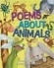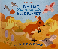 | A range of information texts & films  Eg DK Australia/One day on our blue planet – in the outback – Flying eye books  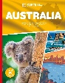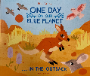 |  | Harry and the Jaggedy Daggers – Fearnley (see file of detailed planning and varied resources)  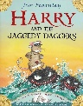 |  |  |  | Clean Up –  Bryon & Adeolo    Youtube telling of this story | Seaside Poetry – Ed. Moses  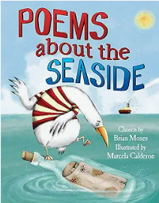
Writing Outcomes | A speech bubble in role as one of the characters trying to persuade Kevin to come down from the tree  Read the beginning of the story to learn what sort of character Kevin the Koala is. Do a role-on the-wall to gather all the evidence about this creature who is scared of everything. The teacher will then go into role to bring this character to life as a model for the children and explain all the reasons why he doesn’t want to get down from the tree. Use masks to help the children to become Kevin and then go into role to explain why he won’t come down. Challenge the pupils to use conjunctions to extend their ideas. Show the how to use contractions within their writing. Draft and edit their writing. | Diary in role as a Koala explaining what a terrible day he had had. Return to the role-on the-wall to help the children talk about what Kevin’s character was like. Read the story up to this point and create a timeline about what he had been up to on that day. Annotate the timeline with emojis for capturing how he was feeling at different points of the day. Orally rehearse this with the pupils focusing on using a variety of conjunctions to explain his feelings through the day. Ensure they can confidently go into role as this frightened creature.  Draft out their diary and show pupils how to proofread it for accuracy and then review it to see if it captures his emotions. | A poem about different Australian animals based on the poem The Terrible Ten  Return to the story of Kevin and discuss all the different animals that are in the book with him. Discuss how the animals moved in the story and then look at information texts and clips to learn more about Australian animals and their movements. Revisit and perform the poem Terrible Ten (from the Poems about animals anthology) and act it out. Explore the structure – the use of numbers and the command sentence.  Challenge the pupils to change this poem into an Australian version by using their knowledge of all the Australian animals. Share the WAGOLL. Draft, edit and perform! | A non-chronological report about Australia  Pull apart a simple non-chronological report so that pupils can see how it is structured.  Discuss what they wanted to know about Australia – eg animals, food, weather. Collect Research these questions using different books and clips about Australia. Gather information using post it notes and show children how to organise these facts into groups to help them create an information page with heading and subheadings to organise the facts. Give them a writing frame to help them structure their drafts. Show them how to move the sections of information around on the page to ensure that the text is easy to navigate for the reader.  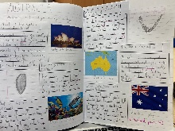  Within the modelled write use past and present tense appropriately if they are talking about the history of this country or about Australia today. Model using the four different sentence types such as questions as subheadings. Show the importance of using subordinating and co-ordinating conjunctions to give the reader more information about Australia. During the learning journey teach pupils about using singular possessive apostrophe eg Australia’s animals and give them the opportunity to practise using commas in a list to describe key facts about Australia. |  | Setting & character description to introduce the story  Use the end paper of the book to begin to explore Bottlenose Bay as it’s a map. Share ideas about what it was like in this quaint seaside town. Share a WAGOLL that shows children the skills of description.  Introduce them to the character of Harry. Have a mouse puppet to help them imagine this creature. Focus on basic sentences that capture his character and the use of expanded noun phrases to describe him. Model how to use conjunctions effectively to give the reader more information about the town and the character of Harry the Harbour mouse. Pupils will draft their writing and then be shown how to make Harry even more likable by thoughtfully revising. | Narrative retelling of part of the story  Read the next few pages to learn more about Bottle nose bay and then focus on the page where Zephyr the wild wind rips Harry’s boats off its moorings and it gets smashed by the Jaggedy Daggers:  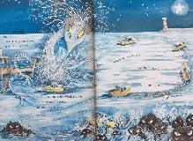  Echo read the words from the pages and act out what happens so that the pupils feel really confident in the retelling of this part. Now ask them to change the name of the wind – give them different ideas to help them create this new character and act it out again changing the words but keeping the plot similar. Model writing this new version of the story focusing on including all the ARE and GD elements within this WAGOLL Give pupils the opportunity to orally rehearse their ideas at the point of writing and also time to edit and revise their writing to make it the most accurate and exciting narrative that they can. |  | Speech bubble in role as the character of the Jaggedy Daggers – angry speech Focus on the page in the book where the Jaggedy Daggers have threatened Harry and his boat. Pupils create their own Jaggedy Daggers and then go into role as the nasty rocks. Show the image of the page and discuss what the rocks might say to Harry. Orally rehearse their sentences focusing on using different sentence types.  Ask one of the children to become the Jaggedy Dagger and shout at the teacher (use a mask to help create the character). Model all the different end of year writing expectations within this WAGOLL. After the children have practise their speech to Harry they will draft and then try to make it meaner at the revision stag. | Persuasive poster/letter about cleaning up the beach Share the first half of the book up until Rocket finds the litter and discuss what happened to her when she went to visit her grandparents on their beautiful island home. Discuss the problem that Rocket discovered and collect their ideas about what they could do to prevent litter. Guide them towards creating posters telling everyone to look after their world and pick up their litter.  Work as a class to generate ideas about what they could include in their poster – show them a WAGOLL and discuss if it has addressed all the different problems and given solutions. Share different ones and show how to revise a persuasive text to improve its impact. Pupil will draft their. | Poetry based on the anthology (see the detailed plan for this unit and pick from the bank of poems) Listen to and watch the song I do like to be beside and practise performing it with the new words about the Seagull that the class could adapt further. Share the poem Shells and look at a variety of shells to help them generate ideas about how to describe them and adapt this into the Mermaid’s Shells if appropriate. At this point, recap the use of singular possessive apostrophe. Read Treasure Chest Mystery if pupils need to develop their questioning skills and continue to hone their description. Listen to Seaside Sounds and discuss. Share The Sound Collector and work with pupils to adapt this to be about the sounds of the sea. Focus then on the use of appropriate verbs.
Text knowledge & GPS | Yr 2: Opportunity to consolidate the end of KS 1 standards for sentence level and word choice independently. To write coherently with accurate demarcation using the different sentence types and punctuation marks. Use appropriate past and present verb tenses. Use co-ordinating and subordinating conjunctions. Ensure pupils have the opportunity to use commas in a list, apostrophe for possession/contraction and use a variety of suffixes to secure GD if appropriate.
Text knowledge & GPS | Use a wide range of subordinating and coordinating conjunctions to explain why he needs to stay in the tree.  Begin to use the contracted form to show that Kevin is talking in a chatty way  Begin to use editing skills to check and change their writing. | Begin to understand and use diary form – recounting in the first person and including emotions.  To use the four different sentence types within the writing. Use past tense verbs to recount what Kevin did and how he felt.  Use appropriate adjectives, verbs and prepositions to bring the day up the tree to life. For GD ness use different suffixes eg. saddest, worthless, hopeless | Develop their poetry recitation skills – volume, speed and use of facial expressions  To use present verbs to capture how the different animals move. | Identify and begin to use structural layout of a non-chronological report eg heading , subheading, sections of related information, captions  Use past and present tense verbs with growing understanding and accuracy.  Use topical language to impart appropriate information to the reader.  Begin to use editing skills to check their writing. |  | Use past tense consistently.  Use appropriate adjectives and verbs (and adverbs) to describe the Harry and his job.  Begin to use commas in a list to group adjectives. | Use their story telling skills to impart this part of the story. Use the four different sentence types with growing accuracy. All pupils use past tense verbs with ed suffix.  Use co-ordinating conjunctions and sub-ordinating conjunctions to give more detail. Create descriptive detail with adjectives and adverbs (if appropriate), thoughtful use of verbs. |  | To use present and future tense verbs confidently in this warning speech bubble. Use all the different sentence types to make the writing dramatic.  Begin to use contractions when writing in role as the Jaggedy Dagger. | To use question sentences.  To use expanded noun phrases/ superlatives to describe the seaside.  To use conjunctions. To use commas in a list eg plastic, bottles, bags, cans and wrappers  To use emotive language eg, sad”, “hurt”, “sick”, “beautiful” | To develop their poetry performance skills.  To use present tense verbs to describe the actions of the seagulls  To use expanded noun phrases/ superlatives/ commas in a list/ alliteration to describe the seashells  Use verbs to create the sounds of the seaside.

