sd | Year 3 English Curriculum Overview
Autumn Core Text | Week 1 | Week 2 |  |  |  | Week 3 |  |  |  | Week 4 |  |  |  | Week 5 |  |  | Week 6 |  |  |  |  | Week 7 | Week 8 |  |  | Week 9 |  |  | Week 10 |  |  | Week 11 |  |  |  | Week 12 |  |  | Week 13 |  |  | Week 14
Autumn Core Text | Stoneage |  |  |  |  |  |  |  |  |  |  |  |  |  |  |  |  |  |  |  |  |  | Why do people live near volcanoes?
Autumn Core Text | The Friendly Mammoth – Terroros-Martin  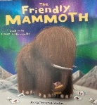  A clip of a tour around the British Museum  See the in-depth planning, lesson plans and resources |  |  |  |  |  |  |  |  |  |  |  |  | DK Find Out Stone Age – mammoth page  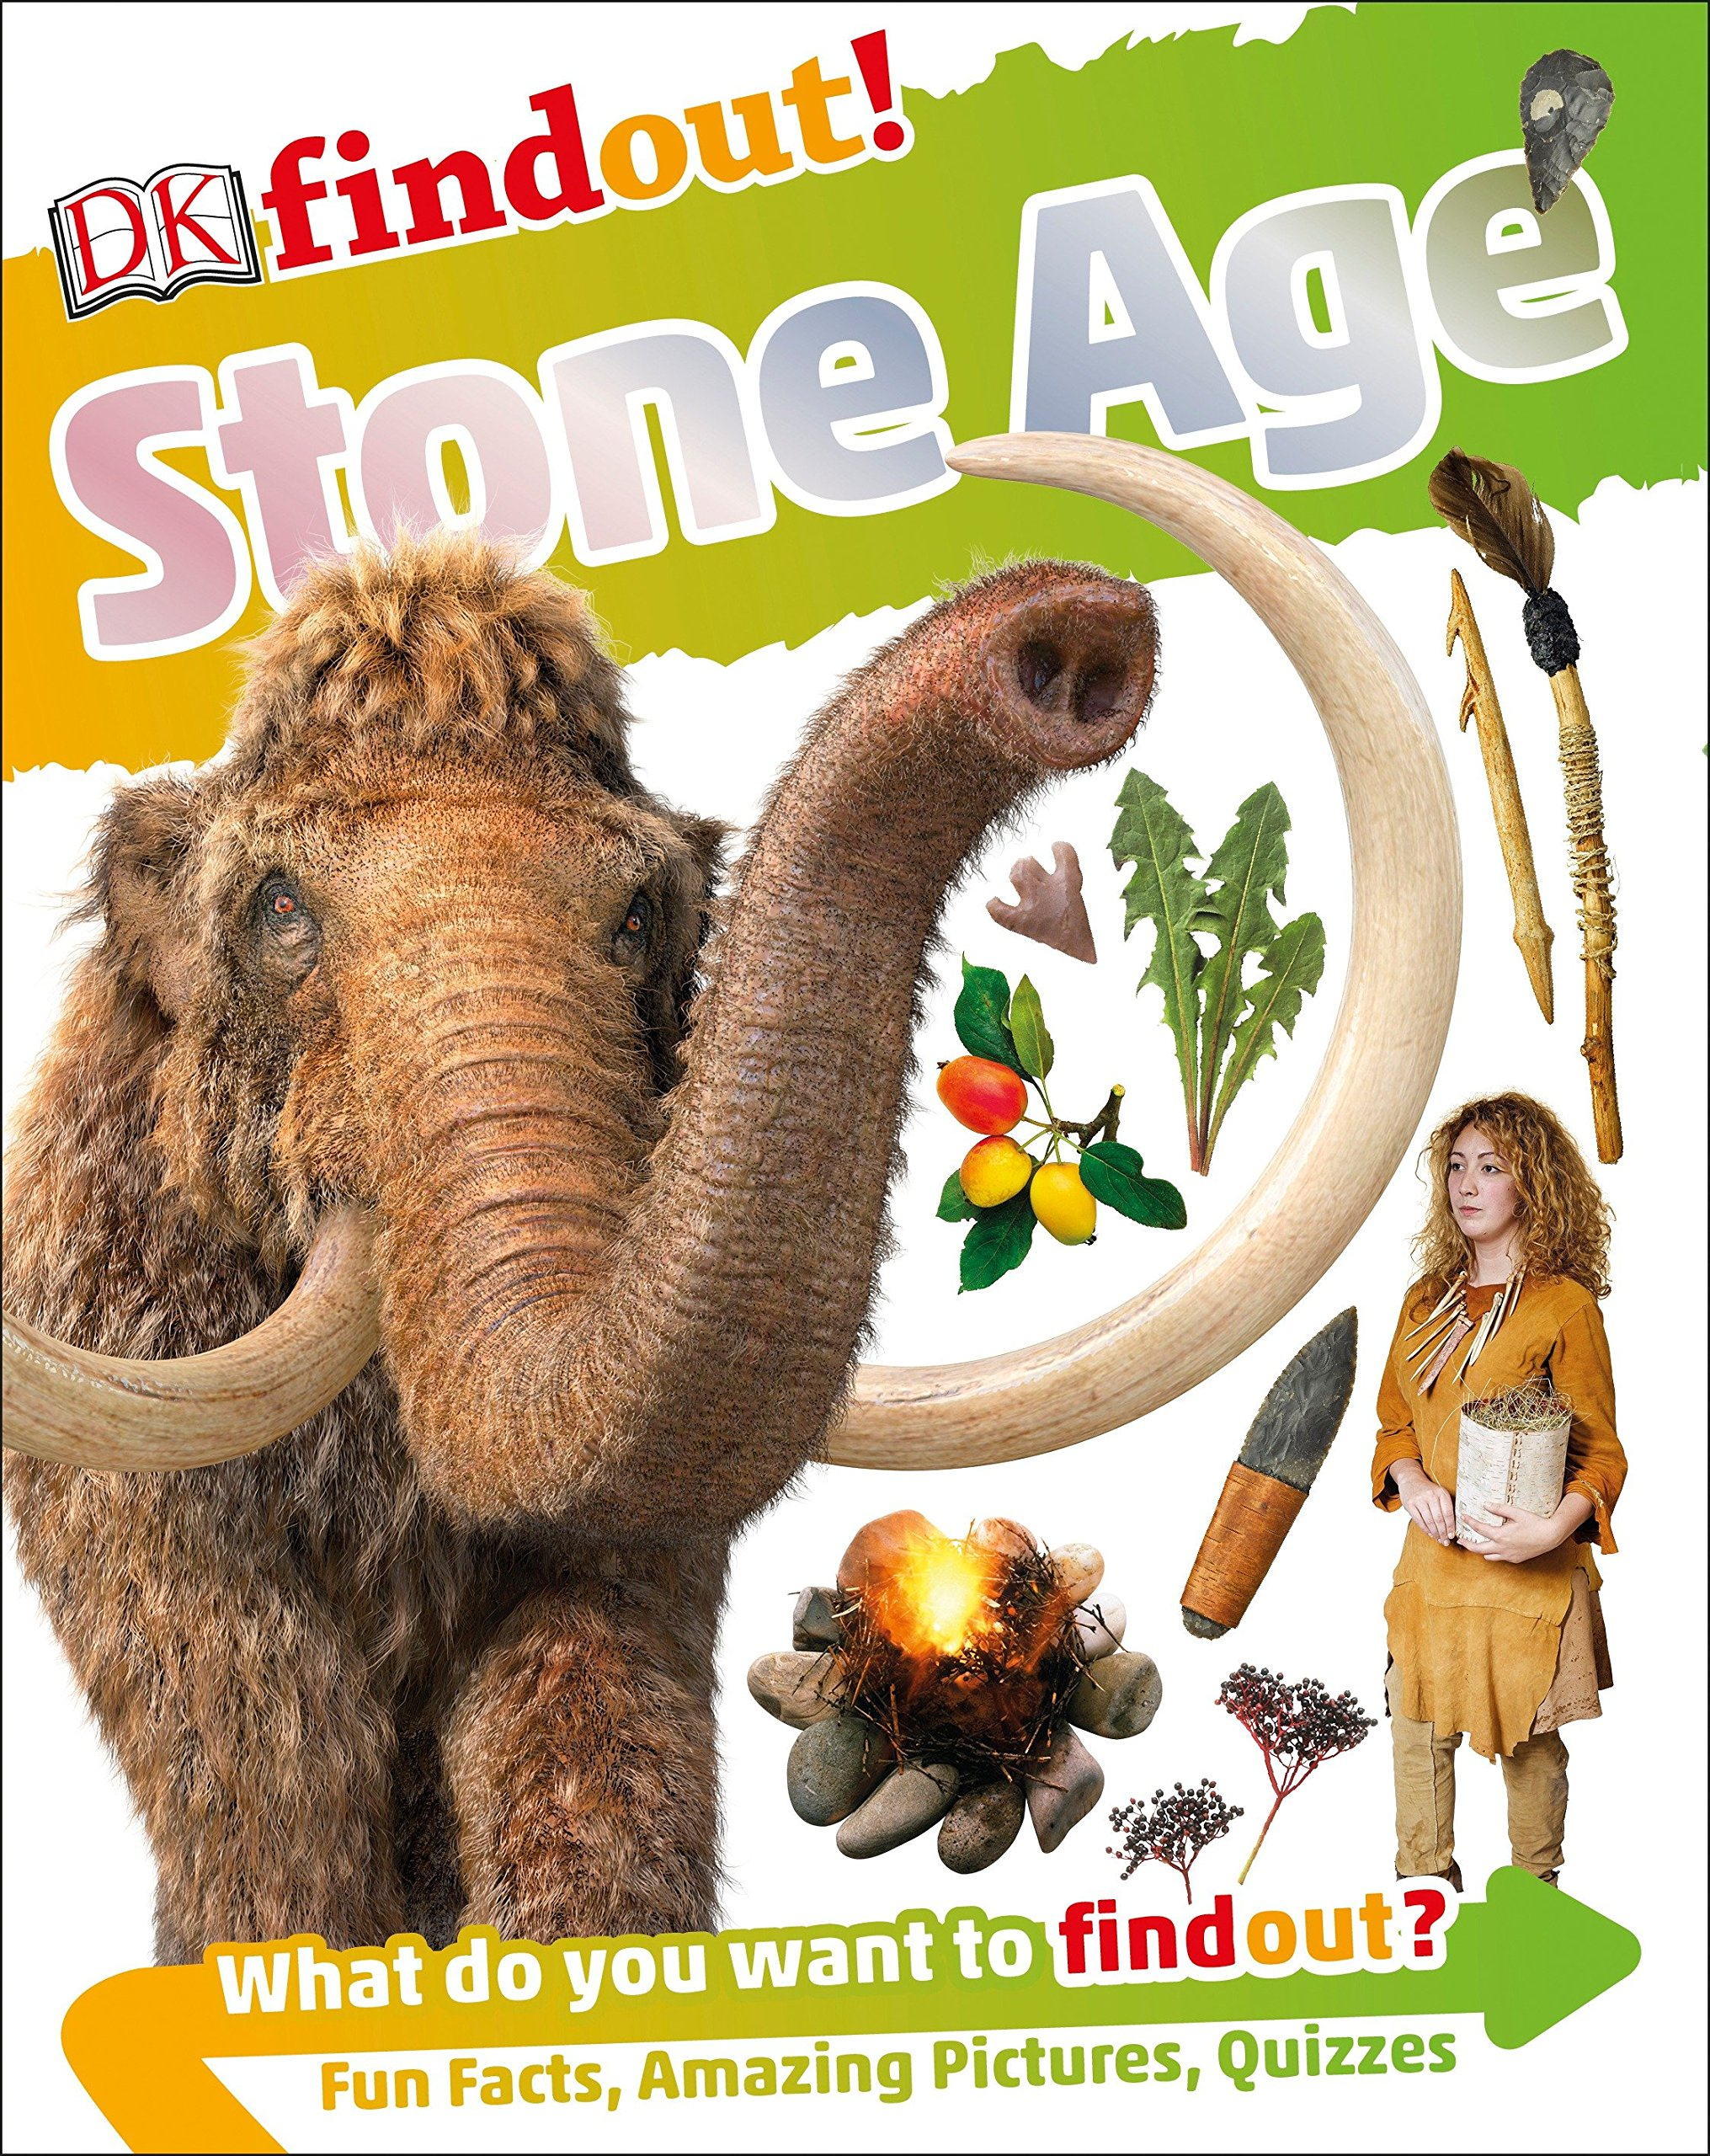 |  |  | Mammoth –  Kemp & Beer How to wash a Woolly Mammoth – Robinson & Hindley  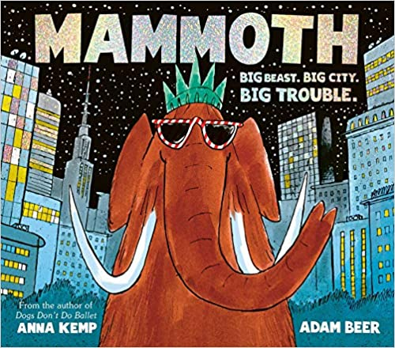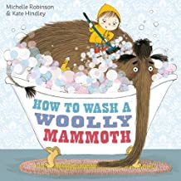 |  |  |  |  |  | Adventure trailers to help pupils generate ideas about the features of an  adventure story  Escape from Pompeii – Balit  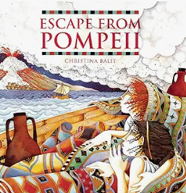 |  |  |  |  |  |  |  |  |  |  |  |  |  |  |  | Word whirls and other shape poems – Foster /Apes to zebras – Brownlee  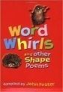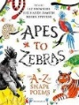
Writing Outcomes | A character description of the mammoth.  Do not show the front cover. Share the first few pages of the story and introduce the character of the mammoth in the museum. Label the creature and create simple sentences to describe it – focusing on the four sentence types.. |  |  |  | Short narrative based on the text:  Continue with the story and discuss how they travelled through the snow. Act out the different verbs to ensure that children understand them. Use images from the text and a story map to help the children tell the story orally. Use appropriate images to help model different sentences that tell the story of them travelling through the snow. Adapt the activity to meet the needs and writing stamina of the pupils |  |  |  |  |  |  |  |  | Create a diamante poem about a mammoth  Understand the structure of a diamante poem by exploring their pattern and use of specific language features. Remind children the role of the different word classes and how that help create the description within the poem.  Return to the images of the mammoth and use the working wall with its mammoth adjectives & verbs. Play with the language choice. Show them how to make a poem about a cute mammoth and a fierce one. Draft and develop. |  |  | Instructions for how to wash a woolly mammoth.  Give oral instructions for how to wash a dog that the teacher has to try to follow them as they are looking after a friend’s dog.  Share the book with them.  Create a practical activity, such as washing toys, so that pupils can see the importance of sequencing the instruction accurately and using the specific verb, amount or positional language so that the reader knows exactly what to do.  Use 6 of the key images from the text to use to underpin their oral instruction work.  Focus on the key skills that pupils need eg. use an imperative verb/accurate use of verb – squeeze rather than put/use of a particular noun/revise the use os singular possessive apostrophe.  Draft out the instruction and then share with another child to see if they can follow the instructions. |  |  |  |  |  | An adventurous survival story based on the text – share whole text with pupils but use individual images to underpin the writing of the story.  Role play will be at the heart of this unit. Pupils will work in groups to watch adventure film trailers and generate ideas about what the key elements of an adventure are.  Opening paragraph - setting description of the town capturing the busy atmosphere. Time will be spent really focusing on the descriptive narrative at this point with an emphasis on using adverbials to create a cohesive narrative. Pupils will develop their expanded noun phrases to ensure that the narrative describes the liveliness of the setting.  Paragraph2 - Action – Tranio’s response to the eruption – character development and reaction Tranio finds Livia and they run through the streets desperately  Paragraph 3 - Dialogue – one of the characters is hurt/falls/wants to give up so the other has to encourage them to continue.  Final paragraph – the climax when they reach the port, but do they survive or not? |  |  |  |  |  |  |  |  |  |  |  |  |  |  |  | Share calligrams and discuss why they are effective.  Introduce different concrete poems to explore the form, idea and language  Create a concrete poem based on a volcano erupting
Text knowledge & GPS | Opportunity to consolidate the end of KS 1 standards for sentence level and word choice independently.  To write coherently with accurate demarcation using the different sentence types and punctuation marks. Use appropriate past and present verb tenses.  Use co-ordinating and subordinating conjunctions. |  |  |  |  |  |  |  |  |  |  |  |  |  |  |  | Use heading and subheadings, bullet points or numbers.  Use paragraphs to organize information.  Use imperative verbs.  Use specific noun and appropriate adjective (eg. soft brush, squeesze of bubble bath)  Use singular  possessive apostrophe  eg mammoth’s tusk |  |  |  |  |  | Introduce the role of a basic paragraph.  Use adverbials of time to begin to link sentence to sentence.  Focus on past tense specific verbs to describe the actions within the story.  Introduce how to set out dialogue using inverted commas and a simple reporting clause.
Text knowledge & GPS | To use a wide variety of expanded noun phrases to describe what the mammoth looked like. |  |  |  | Use past tense verbs consistently and pick appropriate language.  Use adjectives and superlatives to add detail about the noun  Use conjunctions to add detail to the sentence. |  |  |  |  |  |  |  |  | Use appropriate noun phrases to describe the mammoth
Text knowledge & GPS | Week 1 |  | Week 2 |  |  |  | Week 3 |  |  |  |  | Week 4 |  |  | Week 5 |  |  |  |  | Week 6 |  |  |  | Week 7 |  |  | Week 8 |  |  | Week 9 |  |  |  | Week 10 |  |  | Week 11 |  |  | Week 12
Text knowledge & GPS | When did the Romans invade and settle in Britain ? |  |  |  |  |  |  |  |  |  |  |  |  |  |  |  |  |  |  |  |  |  | Who lives in Antarctic ? (stories are set in the North Pole)
Text knowledge & GPS | The Tear thief – Duffy  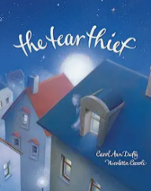 |  |  |  |  |  |  |  |  |  | Trip to Deva in Chester  The Roman Soldier’ Handbook – Usborne  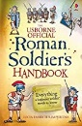  Or Avoid Being a Roman Soldier –  Steward & Antram  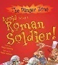 |  |  |  |  |  |  | Boudicca (History VIPs) Harrison  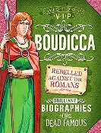  Boudicca’s Speech https://youtu.be/zhcm6z5PT04?si=MjRMdPbl797rH52S  Braveheart /Greta Thunberg speech |  |  |  |  | Pugs from the frozen north – Reeves & McKintyre  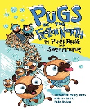 |  |  |  |  |  |  |  |  |  | The Search for the Giant Arctic Jellyfish – Savage  Watch clips about Giant Arctic Jellyfish on YouTube  Very important animals - Dorling Kindersley eg penguin  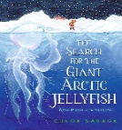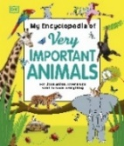
Share the book with the children and discuss the story structure about a fantastical giant artic jellyfish. Create a time-line that captures the story and explores the finding of
different arctic animals
Writing Outcomes | A narrative of part of the story  Read the whole text and orally summarise the story. Time-line the events so that pupils feel confident discussing the plot and characters. Story map this and use it to underpin their own retelling of The Tear Thief.  Durnig the learning journey pupils will bring the story to life and explore the conversation between the tear thief and the small girl. |  |  |  |  |  |  |  |  |  | Diary of an incompetent Roman soldier in Britain (see PowerPoint)  Learn about the life of Roman Soldiers in Britain.  Learn about the structure of diary form.  Imagine what it would be like to be a struggling soldier who couldn’t cope with the regime of the training.  Teach pupils how to use a time-line to underpin the diary and then focus on capturing the highs and lows of the punishing training schedule. |  |  |  |  |  |  | (A character description of Boudicca that captured her fierce nature)  Persuasive rallying speech by Boudicca to encourage her followers – this was covered within the history lessons. |  |  |  |  | Narrative adventure story A 3rd person narrative adventurous story about going to the yeti noodle bar  During the reading of this chapter book pupils will gather information about the two main characters of Shen and Sika, as well as the antagonists – the snow trolls, sea Kraken and hungry yetis. They will also explore the different settings within the story that make it a fast pace adventure set in the Frozen North.  To inspire their writing the pupils will focus on the chapter in the Yeti Noodle bar where they meet the Yetis who first appear to be a bit intimidating but are actually gentle. Maybe the children could explore what might have happened if one of the Yetis was mean and grumpy. They could write their own ideas for how the chapter would have developed and then had the opportunity to write it with a different plot structure. This story will include dialogue that is punctuated with growing accuracy and captures character. |  |  |  |  |  |  |  |  |  | Non – chronological page about a new species of animal only found in Antarctica that they could use to help create their own story eg. a great Antarctic Penguin.  . |  |  |  |  |  |  | create part of a new story based on The search for the ……. Antarctic ……..  Using the new creature create a story similar to the original but based in the Antarctic.
Text knowledge & GPS | Begin to use adverbials more confidently eg. time, place and position.  Use apostrophes for possession with growing accuracy. |  |  |  |  |  |  | Begin to use inverted commas and appropriate punctuation to capture dialogue within a narrative.  Begin to play with synonyms for said. |  |  | Revisit the structural layout and linguistic features of a diary – eg. first person, past tense, language appropriate to the character  Cohesion across the paragraphs  Use of effective questions.  Focus on cohesion so that the recount has a chronology and the use of appropriate emotive language to express feelings and reactions.  Use adverbials of time. |  |  |  |  |  |  |  | Use adjectives and superlatives for descriptive impact.  Explore the power of repetition Play with pronouns to emphasis their differences we/they. |  |  |  | Reinforce paragraphing as a cohesive device:  Setting description -  Use fronted adverbials of time and place to capture the journey. |  |  |  |  |  |  |  |  |  | Use layout for a non-chronological report.  Use paragraphs to organize information  Use technical language |  |  |  |  |  |  | Paragraphs to help organise the story.  Adverbials of time & manner that bring the story to life  eg. suddenly, at that moment  Ensure pupils understand why they are used in the story to make it more exciting.
Summer Core Text | Week 1 |  |  | Week 2 |  |  |  |  | Week 3 |  |  |  | Week 4 |  |  | Week 5 |  |  |  |  | Week 6 |  |  |  | Week 7 |  |  | Week 8 |  |  | Week 9 |  |  |  | Week 10 |  |  | Week 11 |  |  | Week 12
Summer Core Text | Poet study |  |  |  |  |  |  |  | What did the Egyptians believe? |  |  |  |  |  |  |  |  |  |  |  | Are all settlements the same? Countryside v city
Summer Core Text | Poetry of Rosen  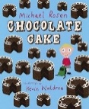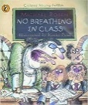  Don’t / Fridge / Telly  The Car Trip /Tidy your room  Hot Food / Goldfish  Mustard Belly |  |  |  |  |  |  |  | Howard and the Mummy: Howard Carter and the Search for King Tut's Tomb – Fern  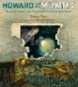  The Egyptian book of the dead / The Ancient Egyptian Afterlife  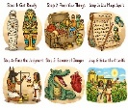 |  |  |  |  |  |  |  |  |  |  |  | Into the forest – Browne / You Choose fairy tales – Goodhart & Sharratt  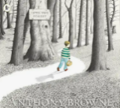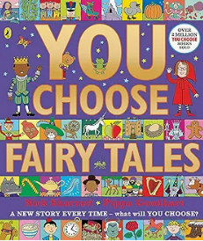 |  |  |  |  |  |  |  |  |  | Town mouse country mouse – Aesop’s Fables  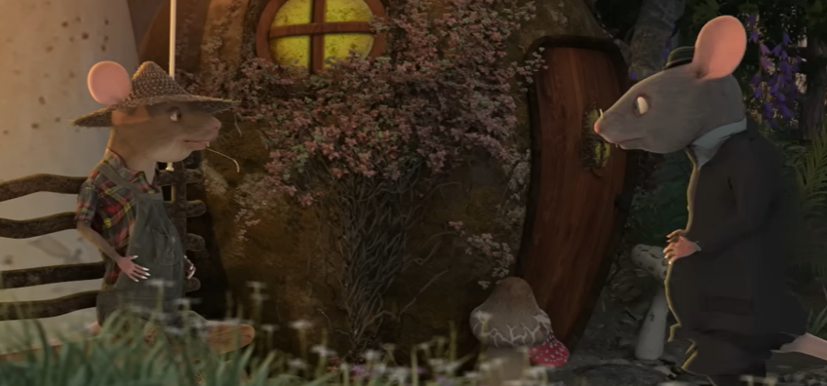  Tourist information programme about Manchester https://youtu.be/DTV4YSfrumY?si=eCr8wIzqwjJRghS4  https://youtu.be/yNogcQDII3w?si=-kBw1ouqd3fz8V4Q  Variety of tourist information brochures  This is the place – Tony Walsh
Writing outcomes | Perform a variety of different Rosen poems for an audience. Create a poem based on Rosen’s poem Car Trip and Don’t  Watch Michael Rosen performing chocolate cake and discuss how he reads his poem aloud. Look at how he use is voice, intonation and gesture to bring the poem to life. Watch other examples of his narrative work and start to make connections between his poems. Watch Rosen performing the poem Hot Food and ask pupils to work in groups to perform this poem for the rest of the class to watch.  Watch Rosen performing The Car Trip and discuss how realistic it is. Look at the written version of the poem , read aloud and text mark any of the lines that resonate with them. Generate their ideas about what different children might say when they are on the bus going to town or on a school trip. Collect their ideas and show them a list of possible lines. Rehearse some of them and work in pairs to create their own lines to add to them in order to create a new poem.  Read Don’t and create a poem that could be shared with the other year 3 class about behaviour Focus on the teaching of contractions within this block of learning. |  |  |  |  |  |  |  | A survival guide for getting to the Egyptian after life  Through their history topic, pupils will learn about the role of the pyramids, mummification and the preparation for the after-life. They will look at the images from the text Howard and the mummy to learn about the valuable information gleaned from Tutankhamen’s tomb. They will also look at the artefacts captured through the film clips and photographs of the tomb to help them think about what the purpose of all the preparations for a pharaoh after his death was. Pupils will keep returning to the question of why someone had to go through all these different procedures. They will watch The Egyptian book of the dead/The Ancient Egyptian Afterlife to gather more information. Show them a simple WAGOLL and then ask them to use that as a base for adding extra detail to so they can use their ideas for a draft.  After that, discuss how they could set out the information in an interesting and informative way. Show them pages from Kate Pankhurst’s Fantastically Great Women series that use different sorts of timelines to capture the lives of famous women.  Discuss if they could have a similar structure for setting out their information about getting to the afterlife. Pupils draft out their ideas and then proof-read their writing and edit their polished pieces. Explore how to move from fact to fact using numbers or other cohesive devices |  |  |  |  |  |  |  |  |  |  |  | Innovation – create a new page for the story - This will include a setting description, dialogue between characters and a plot twist at the end of the narrative unit.  At the beginning of the unit of work show the pupils a slide of examples of books that Antony Browne has written. Can the children see any connection between some of these books? E.g. Some have the same characters (eg Willy the Wimp), some are linked to art (Willy’s  pictures) and others explore different aspects of fairy stories (Hansel & Gretel, Me and You).  A detailed setting description: Share Into the Forest and slowly let the children look for the clues about the type of story it is. Initially focus on the setting description that is very atmospheric and at times quite intimidating for the boy. Show the children the PowerPoint with different images of woods and discuss how they could be described in different ways to make the reader feel contrasting emotions. Discuss what emotions we want the reader to feel when the boy is walking alone through these woods. Show them the WAGOLL and discuss how effective it is and why – the forest seems to be alive and watching him. We don’t want him to go any further by himself. Look again and the structure of the description and think about how it works and how the character moves through the setting – by drawing us into the woods. Show them how to revise their writing to make it more unnerving. Pupils could have a word bank to help them develop their own forest description in the first person. |  |  |  |  |  |  |  |  |  | A persuasive brochure about the merits of Manchester as opposed to Liverpool Watch the animation of the story of the Town Mouse and the Country Mouse and discuss which is the best place to live – the bustling city or the quiet countryside. Use the working wall to explore which they think is the best – town or country – giving their reasons. Hold a short debate about where they think is the best place to live and why. Give pupils sentence stems to help them plan and organize their arguments.  The teacher comes in on the next day and says that it shouldn’t have been a debate about which is the best place, it should be the best city as she believes Liverpool (or the place that is close to the teacher’s heart) is the best. Pupils are then challenged to defend Manchester by gathering evidence. The teacher will show them images of Liverpool, and they must respond with finding as much about Manchester as they can. focus on sport, music, entertainment and shops.  Listen to the poem This is the place to watch the centre of Manchester being full of people proud to live in this city. Watch the tourist information advert to learn more about the city.  The children will analyse a WAGOLL to see if it would persuade someone to want to visit and agree that it is a wonderful city full of love, laughter and loyalty. This can be developed into a working draft.  Pupils will look at tourist information brochures to learn how they function and the relationship between the structure and the contents. Pupils will return to their draft, check for accuracy and then using their new found knowledge about the function of brochures revise their draft accordingly. They will then produce a polished piece in the form of a brochure. one about Manchester, whilst the teacher will create one about their favourite city. They could also create a tourist information advert like the one they’ve watched. |  |  |  |  |  |  |  |  |  | A poem about Manchester with a refrain like the poem This is the place written with a partner of in groups.  Listen again to Tony Walsh reading his poem This is the place. How did it make them feel. Then watch the Northern rail Ad and listen to a child’s poem about how it’s so important to celebrate the language and people of Manchester. Discuss why people are so passionate.  Ask children to imagine they can create a chant/a refrain that captures the heart of Manchester like THIS IS THE PLACE eg We are Manchester/  Come to Manchester./We have heart  Using all the knowledge gleaned from creating an advert work in pairs to use ideas from the learning journey to produce a poem
Writing outcomes |  |  |  |  |  |  |  |  |  |  |  |  |  |  |  |  |  |  |  |  | Create a new page for the story where the boy then meets another fairy tale character who warns him about going any further Look at You Choose Fairy Tales and decide who he might meet. Use the AI generated idea bank to help them think about who they might meet, how that character would approach the boy and what they would say about the forest – would they encourage him to go on to find his father or warn him to leave now? Read WAGOLL that show a positive character and one that warns. Focus on characterization through dialogue and how the reader would know which character could be trusted.
Text knowledge & GPS | To focus on developing performance skills – emphasising key words, changing the volume and speed, projection.  Use contractions with a growing accuracy. |  |  |  |  |  |  |  | To show an understanding of how a survival guide/instruction text is structured eg. heading, subheadings, labelled diagrams & appropriate illustrations., steps or stages, procedural language.  Identify and use adverbial phrases to give the text structure.  Use of tier 3 language within the writing to make the text more technical e g canopic, |  |  |  |  |  |  |  |  |  |  |  | To create a narrative setting description that captures the atmosphere.  Use fronted adverbials appropriately that signal a change in time, a change in focus or a build-up of suspense.  Begin to use a variety of prepositional phrases expressing time, place and cause |  |  |  |  |  |  |  |  |  | Use appropriate layout features for a persuasive brochure.  Begin to use the appropriate tense as a cohesive device  Use adverbials to make the persuasive argument more cohesive and powerful.  Use persuasive language features eg rhetorical question, expanded noun phrases & superlatives to describe |  |  |  |  |  |  |  |  |  | To use performance skills to bring the poem to life eg. projection change in volume, speed, emphasis.  Play with language to capture the different descriptions of Manchester.
Text knowledge & GPS |  |  |  |  |  |  |  |  |  |  |  |  |  |  |  |  |  |  |  |  | Avoid repetition of noun and pronoun by exploring different ways to identify characters To punctuate simple dialogue with growing confidence using appropriate punctuation.  Begin to convey character and play around with use of synonyms for said to support this.

