Year 1 English Curriculum Overview
 | Week 1 | Week 2 |  | Week 3 |  | Week 4 |  | Week 5 |  | Week 6 |  | Week 7 | Week 8 | Week 9 |  | Week 10 |  | Week 11 |  | Week 12 |  | Week 13 |  | Week 14
Autumn Core texts | Entering KS 1 / This is me & my local Area |  |  |  |  |  |  |  |  |  |  |  | Aspiration  Special people in my local area
Autumn Core texts | 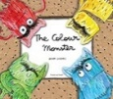  The Colour Monster - Llenas  The colour monster goes to school – Llenas  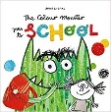  I am …. & A great big cuddle – Rosen’s  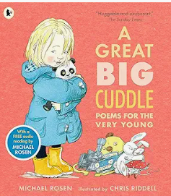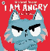 |  |  | Lonely Beast – Judge  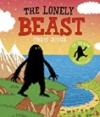  Promotional clip of The Lonely Beast  See the PowerPoint of the floor book and outcomes for guidance |  |  |  |  |  | Maya’s Walk – Butterfield & Geyer  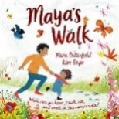  In every house on every street – Hitchman  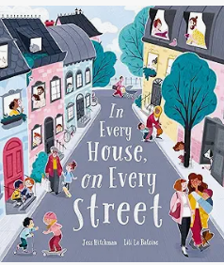  A walk around the  local area |  |  | You Choose –  Goodhart & Sharratt  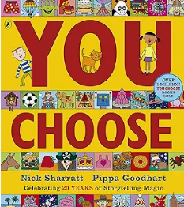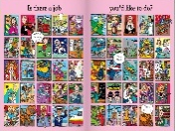  Invite parents/members of the community to interview about their job  When we grow up – Walsh  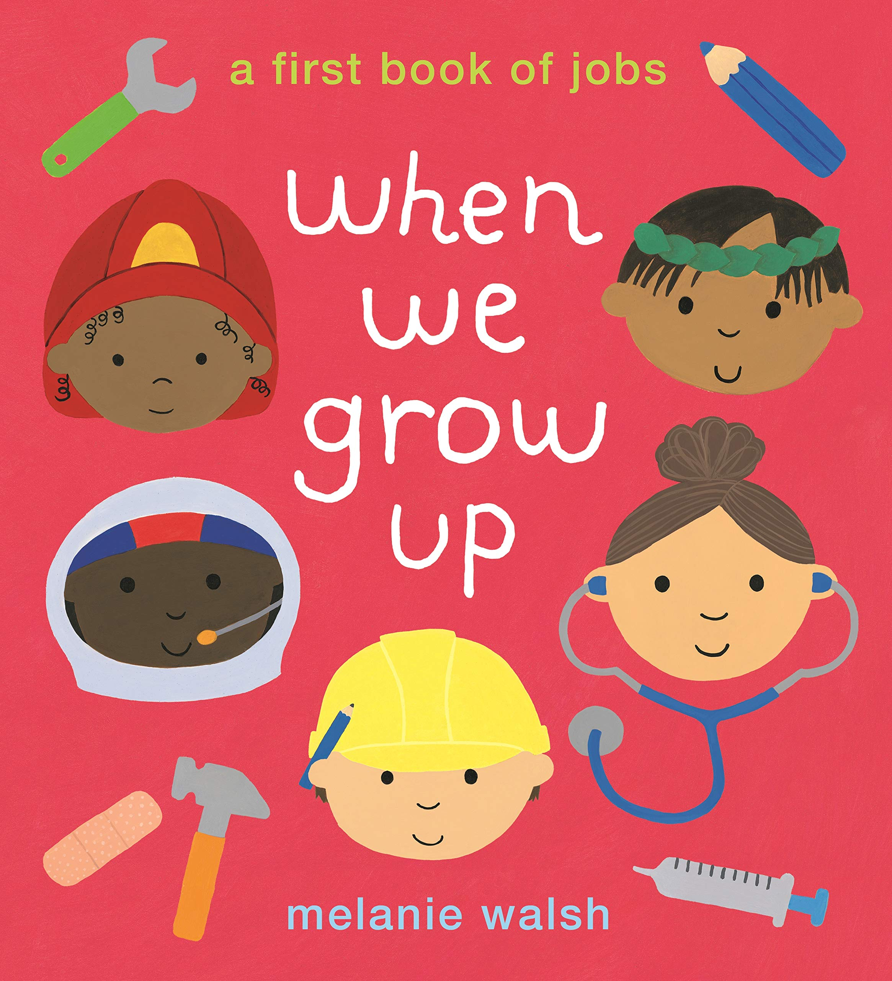 |  |  | Collect books about the different professions that would be in the local area  Eg books from the Busy People series  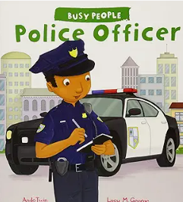  Or Community Helpers meet and respect policeman  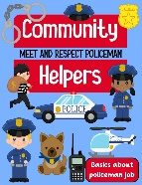 |  |  |  | Basil dreams big  Fraser and Warburton  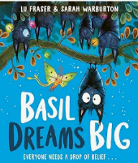 |  |  |  | The littlest Yak – Fraser and Hindley  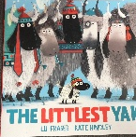
Writing Outcomes | Orally rehearse simple descriptive sentences about their feelings  Share the pop-up version with them. Discuss how they think he is feeling on the different pages. Each day focus on a different mood.  Say simple sentences to describe how the monster feels.  See Literacy Shed Plus unit of work:  Share other books about different feelings with the chidren .  Perform emotion poems from the anthology  Share the poems and act them out. Take photos of the children acting out the different emotions and also capture this through the use of emojis that can be used whenever they are discussing feelings. Share poems like ANGRY by Michael Rosen with the pupils – teacher models it out loud and the pupils echo her. Collect their ideas about what makes them angry. Work as a class to create a list poem with the teacher modelling writing their ideas in a simplistic form. |  |  | Simple character description from the first time the children see the Beast (after watching the promotional advert) and read the first page of the book. See his foot prints in the yard.  Watch the clip and tell the children that he was near the school and then the teacher found a book all about him and share the first page.  Eg . He is big. He is black. He likes cake. He likes tea.  Story map leading to simple narrative of the journey – children act out the journey in the hall or outside with equipment – story map this, orally retell and write simple sentence.  Speech bubble as someone in New York who is frightened of the Beast eg. I am scared. He is big.  Letter to invite the Beast to come to the school so they can be his friend..  A simple booklet (possible geography outcome) all about the local area to tell the Beast why he should come to visit (linked to geography topic) |  |  |  |  |  | Recount a trip around the local area in the style of Maya’s walk.  Pupils walk around the local area to find out what the community is like. Encourage them to take photos to capture all the interesting houses and features that they spotted.  Share Maya’s walk and discuss if they saw anything similar on their walk by looking at their photographs and comparing them to what Maya had seen on her walk. Is our area more like Maya’s walk in the country or her walk through the town. Collect their ideas and use the language from the book to help annotate the photos that were taken in order to make their own version with their name e.g. Dawn’s Walk. Orally rehearse simple sentences e.g. I saw a ………  Introduce the idea of noun and adjective. E.g. The house was big.  Ensure that the children use the past tense verb.  Share ‘In every house on every street’ with the children – Talk about their own houses on their streets and look closely at the images from the book. Label a picture with what people do in their house.  The Dad cooked. The boy sang. |  |  | Teacher tells the class what they wanted to be when they grew up. Use the You Choose picture to talk about jobs.  Invite parents and friends of the school to talk about their jobs.  Ask them questions and show the questions written down. Eg What is your job? Where do you work? Why do you like it?  Simple sentences about what they would like to be when they grow up. |  |  | The class will meet lots of different people from the community and then will follow their interests to learn more about specific people eg. a builder, a hairdresser, a dentist, a doctor.  A simple fact file about the police (different jobs using their knowledge from the visitors) and the books/clips that they have seen. |  |  |  | Instructions for helping Basil fly/ Letter to Basil telling him not to give up and giving him advice about how to fly. |  |  |  | A character description of Gertie the Littlest Yak including superlatives.  Eg. The yak was the littlest. She was the quietest.  A speech bubble as Gertie telling the littler Yak that it s okay to be small.
 |  |  |  |  |  |  |  |  |  |  |  |  |  |  |  |  |  |  |  | Write an exciting part of the story where Basil is saved by the moth when the storm comes.
A simple list poem capturing the story – when Basil can’t fly and then when he can. Act out the different verbs to ensure they know what they mean. (see PowerPoint for a model to work towards )
He fell.
He flapped.
He zoomed.
He swooped.

Text knowledge & GPS | Hold a sentence, say a sentence.  Demarcate simple repetitive sentences using capital letters and full stops.  eg. He is sad. He is cross. |  |  | Demarcate simple sentences reinforcing the notion of a sentence giving a new piece of information. Check that the sentences make sense.  Use Capital letters for names.  Use simple adjectives to describe the Lonely Beast. |  |  |  |  |  | Demarcate simple sentences reinforcing the notion of a sentence giving a new piece of information.  Orally rehearse using adjectives to give detail about nouns.  Use past tense verbs within their sentences.  Begin to use adjectives to describe nouns.  Use the personal pronoun I with capital letters. |  |  | Write a series of sentences with capital letters and full stops to demarcate.  Begin to use question sentences. |  |  | Use ‘and’ to join ideas in sentences. |  |  |  | Use past tense sentences within their writing using appropriate suffix.  To use exclamation sentences. |  |  |  | Use simple adjectives effectively. Use past tense verbs to capture the adventure.  superlatives to show how an adjective can be used to
Spring Core Texts | Week 1 |  | Week 2 |  | Week 3 |  | Week 4 |  | Week 5 |  | Week 6 |  | Week 7 |  | Week 8 |  | Week 9 |  | Week 10 |  | Week 11 |  | Week 12
Spring Core Texts | Welcome to fairy tale land |  |  |  |  |  |  |  |  |  |  |  | Seasonal Change
Spring Core Texts | You choose Fairy Tale – Goodhart & Sharratt  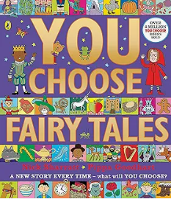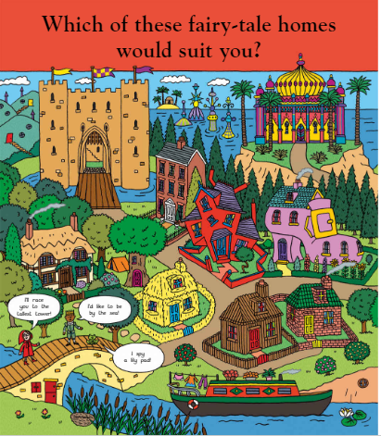  Simplified map of fairy tale land  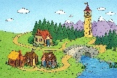 |  | The Gingerbread Man  (an appropriate version)  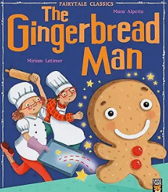  The gingerbread bunny – Allen  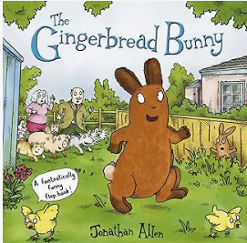 |  |  |  | Three Billly Goats Gruff – Alperin  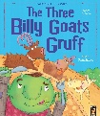 |  | You choose Fairy Tale – Goodhart & Sharratt  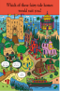  Directions through a fairy tale – Julie Anna Douglas  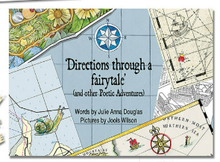 |  | Rain, Snow & Shine / Weather and the seasons – DK  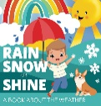  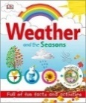 |  | The friend the Weather Monster – Smallman & Merz  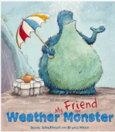 |  |  |  | The little Raindrop – Gray /  The Big Umbrella & clip  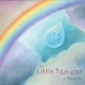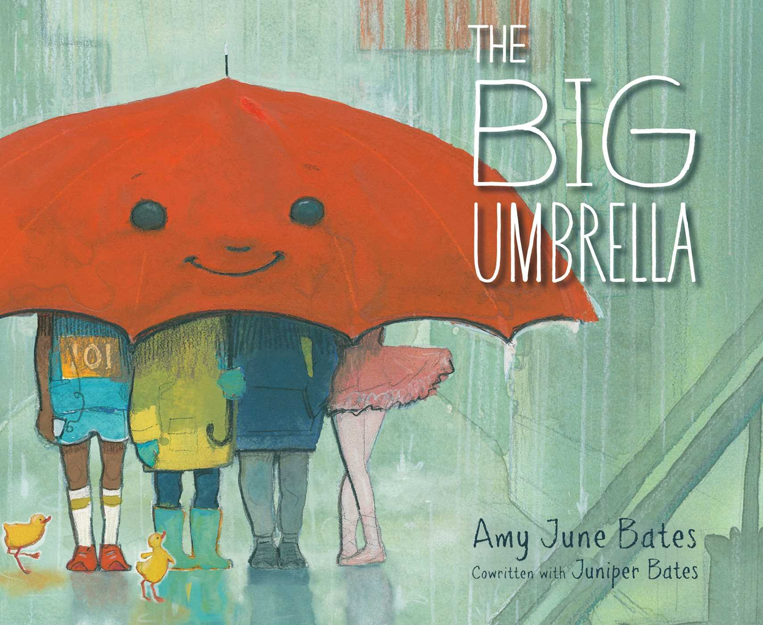  Poems/song  Raindrops keep falling on my head  I’m singing in the rain  I hear thunder |  |  |  | Out and about – a first book of poems – Hughes  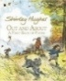  Eg Wind, Winter  Watch What is  the wind  The wind blew – Hutchins  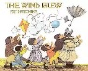 |  | What is the wind ?  (clip capturing the lines of the poem)  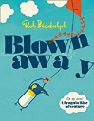  Blown away – Biddulph
Writing Outcomes | Write captions for a map.  Show children the fairy tale map and discuss who might live in the different houses. Annotate a simplified map of fairy tale land in their books to show who might live in the different places. Pupils can create simple sentences about the characters or annotate the map with prepared sentences eg. The Little Pig lives in a straw house. Share fairy tale stories and bring to life. |  | Write simple narrative sentences for a fairy story  Show pupils the first part of the story where the gingerbread man is made and acti it out with props. Share the next part of the story with the pupils using the characters from the story so they can begin to join in with the refrain – Run run as fast as you can ….  Work with the pupils to create a story map of this version. Model writing very simple sentences retelling the key parts of the story.  Show pupils different versions of the story such as The Gingerbread bunny to help them think about changing the characters. Innovate the story by changing the characters that are chasing him by using props. Help the children think of different past tense verbs to describe how these new character move to chase the Gingerbread Man.  Change the ending of the story too by using a frog or spider with the children trying to think of an appropriate ending.  Instructions for making a gingerbread man – Show pupils simple visual instructions for making a gingerbread man. Pupils will have the opportunity to follow them and make the biscuits. Order the simple command sentences. Do a model write to show pupils how to write simple instructions. Pupils write their own instructions on a simple frame.  A speech bubble from a burnt gingerbread man Bring in a burnt gingerbread man and tell them that he is so angry because he was left in the oven for too long so is really burnt. Explore what he might say when they got him out. |  |  |  | Read the story and act it. Bring the characters to life to hear what they say and write it as simple speech bubbles. |  | Show them the map of Fairy Tale land and the page from the poetry book and create a huge ‘map’ to travel through the fairy tale world. Read them the poem about travelling around this land. Give them the opportunity to discuss how they could move around the map using simple prepositions. Model some ’sentences’ to describe how they could move around (e.g. past tense verbs) |  | Daily diary of the weather monster – a sentence about the weather  A sentence about the clothing you wear in different features |  | Look at pages from facts books about the weather and discuss the different weather that we are having – link to science & create a weather diary. |  |  |  | A simple story about the little raindrop and what happens to it. |  | Read The Big Umbrella & watch it Create their own umbrella and a description about what it does based on the story  Eg. It can stop the rain. It can .  Feed into an assembly to explore the theme of kindness. |  | Share some of the poems  Read them the poem  Wind – Hughes  Watch clips of the wind ‘What is the wind’ for ideas about different sorts of wind and collect ideas. Create a wind poem  Create a short film clip with the pupils’’ voices speaking out the lines from their poems |  | Act out part of the story and then adapt it to be about a Penguin Blue and his kite flying around the school.
 |  |  |  |  |  |  |  |  |  |  |  |  | Description of the weather monster  Share the opening few pages and introduce the Weather Monster to the children. Create a role on the wall for the children to help caption with a focus on creating simple noun phrases about this monster. Model how to use the conjunction and to describe the creature. Discuss how scary this monster seems to the villagers and orally introduce the conjunction but eg. He was big but he was friendly.  Model writing five simple sentences about this character for the children to emulate. |  | Speech bubble as Tom asking for the beast’s help
Text knowledge & GPS | Write demarcated statement sentences.  Begin to use adjectives to describe characters with growing independence. |  |  |  |  |  | Write a sequence of sentences to form a short narrative.  Use past tense verbs.  Use simple prepositions to extend sentences  Eg. The goat went to the bridge. He climbed over the bridge. Trip trap trip trap. |  | Identify and write a past tense verb within a sentence  Eg. The girl skipped over the bridge.  Use prepositions to capture where the characters moved. |  | Begin to use layout of a diary and understand the basic functions.  To write in the first person to capture what they would wear on different ‘weather’ days. Use the, pronoun I. |  | Describe the Weather Monster and his feelings using simple adjectives.  Use the conjunction but to show pupils how a clause can be followed by a conjunction that then gives us the opposite piece of information  Eg. He is big but he is friendly |  | Question sentences with capital letter and question mark. |  | Sequence demarcated sentences to capture the actions of the little raindrop. |  | Noun phrases to describe the umbrella  Eg.It is a green umbrella. |  | Use adjectives to describe the different types of weather.  Develop their presentation skills – opportunity to use facial expressions and gesture when performing their wind poetry and play with the volume of their voice in front of an audience. |  | Use exclamation sentences to capture the voice of the penguin. Write a sequence of sentences to form a short narrative.  Use simple prepositions to expand the story.
Text knowledge & GPS |  |  | Begin to understand the layout of an instruction.  Write simple command sentences to help make a very simple recipe.
Summer Core Texts | Week 1 |  | Week 2 |  | Week 3 |  | Week 4 |  | Week 5 |  | Week6 |  | Week 7 |  | Week 8 |  | Week 9 |  | Week 10 |  | Week 11 |  | Week 12
Summer Core Texts | Explorers |  |  |  |  |  |  |  |  |  |  |  | Bees!
Summer Core Texts | The Great Escape – Judge / Other texts eg. The indestructible Tom Crean – Thermes  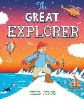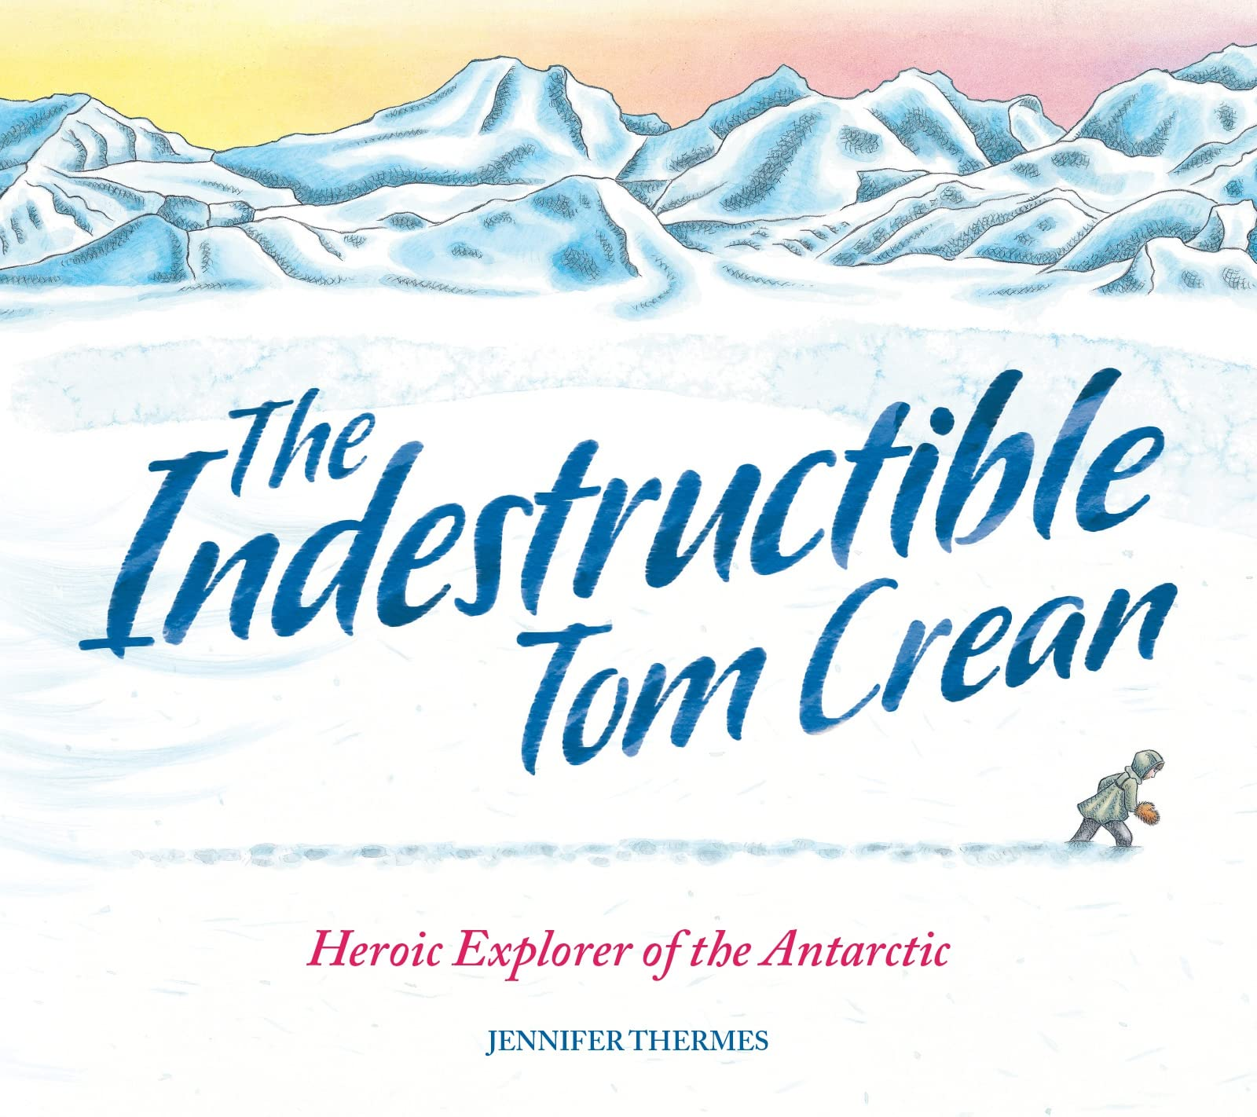 |  |  |  |  |  |  |  | Images of different explorers linked to directly to geography topic |  | Heroes  (page about Henson) – Aye  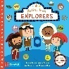  https://youtu.be/NjTmaa4R2M?si=DKsNj59zlpWqLGFB |  | Bee and Me – Jay/ Clips about bees  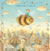
 |  |  |  |  |  |  |  |  |  |  |  |  |  |  | A range of books about bees  Amazing Bees – Unstead /The Bee Book –Milner / What on earth – bees  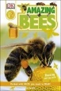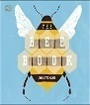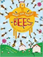 |  |  |  | 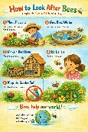 |  | 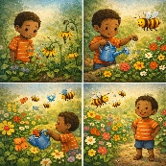
Writing Outcomes | A lost poster with a description of Tom’s Dad  Show the first four pages of the story where Tom has lost his father and help him by creating a lost poster to send the North Pole to try to find him.  Look at examples of Lost Posters and discuss what they are telling the reader. Why do they have a picture on them? Why do they have a question?  Teach pupils how to create simple sentences to describe the missing man. Collect ideas about how to describe this man. Model a WAGOLL. Give them a writing frame to help them construct their lost poem. |  | Pack the rucksack for the adventure and create simple sentences describing why they are packing the different objects.  Tell pupils that Tom needs their help to pack the rucksack for his adventure.  Take a rucksack into school and lay out lots of different objects that you could take with you – some really useful, some not. The class have to decide which ones that can fit in their rucksack for their adventure in the North Pole. Eg Take a thin pair of gloves and a thick pair. Orally, use appropriate adjectives to describe these objects eg. thick gloves to build up a noun phrase bank. Refer back to the illustration from the book. Share stem sentences to support the less confident writers. Show them a WAGOLL - an opening sentence about the trip and three objects (or more) that they will pack with reasons. |  | Narrative of part of the adventure focusing on past tense verbs  Read the first part of the story until Tom has reached the cave. Watch the trailer that captures the basic story up until this point and discuss what has happened in the story so far. Act out what Tom has to do in the story to try to find his lost dad. Orally rehearse it and use images from the story to tell the story so far. |  | A speech bubble in role as Tom trying to stop the Polar Bear from eating him Read the next part of the story where Tom has to try to get away from the Polar Bear. Act this out with the teacher modelling being Tom trying to stop the bear from eating him up. Rehearse what they could say to the creature. |  | A poem about exploring  Look at the book The Great Explorer and discuss all the different adventures that Tom had in the story. Look at the explorers they have been studying in their geography topic work – where did they explore? Use the AI illustration to help them discuss what the different explorers did.  Act out their actions eg He climbed… She swam… He  Create a WAGOLL at the appropriate level for your year 1 class.  Eg. He climbed./He climbed the highest mountain / He climbed up the highest mountain.  Adapt the word bank to support this. Pupils write their own lines for their poem about different explorers. |  | Biography of a great explorer  Discuss why they think explorers like Tom’s dad would visit such cold and distant places like the north and south Poles. Show them images of different explorers. Show them pages from the book – Earhart & Henson. Look carefully at the biography about Henson to learn basic facts. Use their history knowledge to help. Discuss what else they would like to know about this explorer Eg Where did he come from? Where did he explore? Look at the two Power Points about Henson to find more information about him. |  | Speech bubble in role as the girl speaking to the bee when they first meet capturing her feelings Do not show the pupils the front cover yet. Introduce the little girl and read up to the point where she meets the bee and doesn’t know what to do. Teacher goes into role as the girl and models what she might say to the bee and pupils go into role as the bee trying to ask for help. Within the model use the different sentence types so that pupils have the opportunity to use the different end marks in their writing. Act out the speech bubbles so that the pupils can see the importance of the demarcated sentences and the different types o sentences that can be created – eg statement, command, question and exclamation. |  | Non chronological booklet all about bees (see the PowerPoint for ideas on the learning journey)  Continue reading the story up until the point where she is trying to help the bee. Look closely at the illustrations to see that she is reading a book all about bees because she doesn’t know anything about them. Show them different bee books and ask them to generate questions about bees that they are looking for the answers to. Write down their questions on a question mark and write down some answers on a honeycomb.  Research about bees so that they can help the girl know more about bees so she can help her new little friend. Cut up a simple information page Watch the clips about the bees to find out more information. Read lots of texts and watch clips to learn more. Unpick a text so that the pupils know how the text works and then reconstruct their own. Focus on the sentence level with simple language and the basic conjunction and to extend the ideas.  Pupils will make their own little bee books with lots of interesting facts about bees in for the little girl to read. |  |  |  | Instructions for looking after a bee  Look at the next page where the girl has to look after the bee but doesn’t really know what to do. Share the back pages from the picture book as it gives lots of ideas about making a good bee garden. Watch clips about looking after bees to gather more information. Show pupils the AI generated poster showing them how to look after the bees.  Create a simple page about how to look after a bee. |  | Narrative story about a bee adventure  Continue telling the story of the little Bee so that the pupils feel really confident about the sequence of events in the story. Use images from the story to create a story map. Discuss what else could happen in a bee story. Use the AI generated plot ideas to help pupils after showing them the illustrations and asking them to think what might be happening in this new story.  Pupils can write their own versions of these stories or could create their own ideas. They could use props to do this.  Encourage the children to create their own story maps and orally retell their ideas focusing on speaking in the past tense.  Show pupils how to apply their knowledge of writing when creating the model of the text.
Text knowledge & GPS | Begin to show an understanding of the layout and features of a lost poster. Begin to appeal to the reader.  Use different sentence types.  Begin to use noun phrases and superlatves.  Use the co-ordinating conjunction and.. |  | Use adjectives and superlatives to describe the different objects to put into the rucksack. |  | Use their story telling skills to impart the tale.  Use the four different sentence types with growing accuracy.  Use past tense verbs with ed suffix consistently to retell the story. |  | Begin to use persuasive language and sentences to change someone’s mind.  Begin to use the four different sentence types within their writing. |  | Identify and write a past tense verb consistently within the poem  Eg. He zoomed to the brightest star.  Use superlatives to describe the place. |  | Begin to show an understanding of the layout and features of a simple biography – title, subheadings, captions, illustrations.  Use a question sentence. |  | Use the four different sentence types with growing confidence and accuracy. |  | With support, use their knowledge of heading and subheadings (questions subheadings) to help organise the information for the reader.  To use present tense verbs with ing endings with growing accuracy.  Use questions marks with growing confidence in their sentence structuring.  To make some use of –s and –es to form regular plurals correctly – bee - bees |  |  |  | To understand the layout of an instruction.  Write simple command sentences to help make a very simple recipe.  Use a question sentence at beginning of instruction.  Eg Do you want to look after a poorly bee? |  | Use the four different sentence types with growing accuracy.  Use past tense verbs.  Use conjunctions for adding detail to the sentences.  Use adjectives to describe the emotions of the child, the bee and the plants.

