sd | Year 6 English Curriculum Overview
Autumn Core Texts | Week 1 | Week 2 |  | Week 3 |  |  | Week 4 |  | Week 5 |  |  | Week 6 |  | Week 7 |  | Week 8 | Week 9 |  | Week 10 |  | Week 11 |  |  | Week 12 |  | Week 13 |  | Week 14
Autumn Core Texts | Locality history – WWII evacuation and bombing |  |  |  |  |  |  |  |  |  |  |  |  |  |  | Why does population change?
Autumn Core Texts | Good Night Mr Tom – Magorian  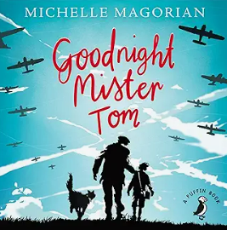 |  |  | Visit to Stockport Air Raid Shelter/ Scene from Hope and Glory Everything World War II facts – National Geographic  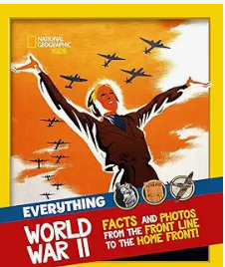 |  |  | Diary of Flossie Albright – Williams  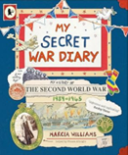 |  |  |  |  | Remarkables – Perrin  (diff children’s identity)  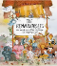  Mask & Reverse Selfie – two films  On the file there are a number of poems for discussion  Body Talk – Zephaniah  The British – Zephaniah  The Mask/ Russian Doll – Rooney  Pretty Ugly – Shoaib |  |  |  | The Journey – Sanna  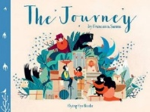 |  |  | The boy at the back of the class – Rauf / The girl at the front of the class – Rauf  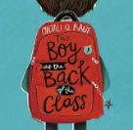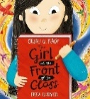 |  |  |  |  |  |  |  |  | Refugees by Bliston Reverse poem –  Refugees – Bilston  
Writing Outcomes | Third person narrative based on the text when a character is taken to meet their host family as in the beginning of Good Night Mr Tom.  Pupils will read the scene from the text where William meets Mr Tom for the first time with the billeting officer. They will gather evidence about the text about the three characters and discuss how Magorian tells the reader so much about the characters through their actions, reactions and dialogue. Pupils will be reminded of the basic skills that they have learnt so far in KS 2 with an onus on the importance of cohesion within and across the writing. They will focus on skills such as using relative clauses(embedded and at the end of the main clause) to add more detail to the narrative through the dialogue and action. Eg Mr Tom, who avoided company, shut the door in their faces.  Time will be spent looking at how dialogue conveys character in this scene and the role of accurate punctuation within the speech narrative to help the reader follow the character’s interaction.  Pupils will then act out their own scenes with a specific setting and use this to help write their own narratives based on the original. |  |  | Instruction writing about surviving in a blitz – an air raid survival guide.  Watch the scene from Hope and Glory or other clips of the Blitz. Discuss why the government wanted children to be evacuated from the cities. Show pupils examples of posters informing adults about air raid shelters and how to use a gas mask.  Discuss the register needed to impart important information to the masses. Is it an order or is it more persuasive?  Show them a boxed-up version to support their own writing. During the journey discuss the use of modal verbs to convey modality  Discuss how brackets could be used to add extra information to their instruction. Draft & revise focusing on tone. |  |  | An informal letter from a child who lives in Manchester to his pen pal who lives in the country capturing the day that war was declared.  Pupils will watch an extract from Hope and Glory showing the Sunday in 1939 when Chamberlain announced on the radio that Britain was now at war. Children will have the opportunity to collect their ideas about how they would feel if they were that child in the scene and also comment on the reaction on the rest of the family. They can discuss how vulnerable Manchester might have been as it would be a target as it was one of the largest northern cities. They could then discuss whether the reaction would have been the same in a sleep village in North Wales. Pupils will discuss what they would write to a friend who was living in this village about the fateful day was declared. |  |  |  |  | To explore identity poetry and to emulate key poems and write them about themselves  Pupils will read a variety of poetry within the unit of work to explore the theme of identity by poets such as Zephania and Rooney. Initially, they will discuss what they think identity is and how they might describe themselves. Then they will watch the two film clips - Mask/ Reverse Selfie – to help them see that often our identity is quite complex as we might hide our true selves or we might have many different parts to who we are. They t write down ideas about their own character traits at this point and use these to create a simple list poem on a thumbprint. Pupils will then read Rooney’s The Mask and then Russian Doll and discuss what they think they are exploring and how the second poem is structured. They will then explore the idea of their own personality and use the structure of the poem to write about themselves after reading examples of other pupils’ versions. During this poem’s journey they will look again at the use of the hyphen as a device within the poem  They could also read Pretty Ugly and explore what happens when you read it down and then up.  This could be used to support another poem. There are resources on the file to support this  The British could be shared as a performance poem or used to create a class poem by taking its structure of a recipe and applying it to all the pupils in the class. |  |  |  | Setting description of the hazardous journey of the family to reach freedom that will capture their responses through dialogue .  Read the picture book to the point where the tension is at its highest (this will depend on the class) and focus on how the write illustrator creates the atmosphere at that point to keep the reader on the edge of their seat. Explore the setting that the characters are in at that point, the element of danger that surrounds them and their responses to what is happening to them. Return to the text and look how Sanna uses this with his images to create the atmosphere and tension. Give pupils a WAGOLL of this narrative and ask them to identify how you have captured it. Discuss how sentences can be linked to heighten this tension and show the precarious nature of their journey.  Pupils use a writing plan to unpick the different elements of their versions of the story.  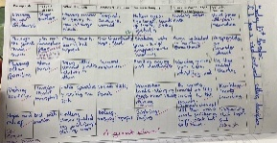  Bring the scene to life through role play to add another element of fear and emotion to the writing.  Pupil draft their own versions and then give to another member of the class for them to critique it. |  |  | Informal & emotive Diary in role as Ahmet capturing his first day of school  After reading the chapter within the book they will create a role on the wall & then a timeline of the events of the day and then capture his thoughts and feelings about each of these experiences. They will then use this to go into role to tell a member of his family or a good friend how his first day went. A WAGOLL will be explored to see how realistic it feels. Pupils will draft this out and then give it to another member of the class and ask them to appraise it as a diary that captures the voice of Ahmet. |  | An informative, persuasive prospectus aimed at parents to show them how impressive Mossfield Primary School is. Pupils will prepare this as a slide show that could be used at parents’ evening or put onto the school web site as a written document. It will be linked to this unit of work as they are trying to show Ahmet and others how wonderful and welcoming their school is. Pupils will be shown how to write this text cohesively and persuasively using rhetorical questions, description and date to persuade. |  |  | Formal letter to the Prime Minister /King in support of Ahmet to allow him to stay – writing as a child  Research the plight of refugees in this country to feed into this formal letter in their own voice.  Give pupils the opportunity to orally rehearse their ideas about this subject by having a class debate with the class versus the teacher in role who represents people who do not want any refugees in the country. Give pupils sentence stems that could be used within a debate that are more controlled and formal. They will be able to draw on these when writing their drafts.  Show pupils a variety of formal letters so they can start to identify their language structures and word choices that show a level of control and formality.  Pupils then write to the Prima Minister as themselves imagining that Ahmet is in their class and asking for his support. They will explore the use of evidence to support their opinion rather than just emotion. |  |  |  | A reverse poem based on Refugees  Earlier in the term pupils read poetry that could be read in reverse. Remind them of this and discuss how the poet is able to create a poem that reverses its message when it is read in reverse. Focus on how he does this by his specific use of line starters and work in pairs to solve this puzzle before being given the challenge of creating their own verse in a similar way.
Text knowledge & GPS | Opportunity to consolidate all the end of lower KS 2 standards. Use a range cohesive devices eg. paragraphs, fronted adverbials, subordinating & co-ordinating conjunctions, pronouns, determiners , correct tense. Sentences will be accurately punctuated with a growing confidence with the use of the comma for demarcation of parts of the sentence – phrases and clauses. Pupils will be using punctuation to capture parenthesis within their sentences. Simple dialogue will be accurately punctuated |  |  |  |  |  |  |  |  |  |  |  |  |  |  | Use paragraphs to achieve pace and tension in the writing.  To capture atmospheric setting/character description (expanded noun phrases/prepositional phrases for description, verbs and adverbs to capture character movement and reaction)  To identify and use conjunctive adverbs to open sentences. |  |  | To review the structure of a diary – use of general opening paragraph, chronological paragraphs, informal and adverbials to give structure.  To connect ideas and clauses with appropriate conjunctions to capture the events in their life. |  | To organise the writing into cohesive paragraphs that presents the argument logically.  Use appropriate present and past tense verbs to ensure reader follows the information.  Use causal conjunctions as a cohesive devices. |  |  | To include features of more formal letter writing eg polite salutations and phrasing, uncontracted form, passive voice.  Revision of modal verbs to capture levels of certainty and for emotional impact |  |  |  | To explore how the structure of a poem can dictate its meaning.  Play with language and ‘sentence’ structure in order to create a similar verse that can be read both ways.
Text knowledge & GPS | Narrative eg Setting description and character development. Use paragraphs and other cohesive devices to achieve pace and tension within the narrative piece.  Use expanded noun phrases, verbs and adverbs to capture atmosphere and characterisation  To Identify and write relative clauses (embedded and at the end of the main clause) as parenthesis To use appropriate punctuation within the dialogue. |  |  | Use features of instruction writing in the style of The British – appropriate verbs to capture how the class is ‘created’. |  |  | To include features of more informal letter writing eg chatty style, colloquialism and phrasing, contracted form,  Use of modal verbs to capture levels of certainty and for emotional impact |  |  |  |  | To understand that the structure of poetry plays a key role for the reader to understand its themes and purpose.  Focus on language choice  Identify and use colons and hyphens to replicate the poem Russian Doll  Use similes and metaphors within the writing to help bring the description to life.
Spring Core Text  pring  Spring Core Texts | Week 1 |  | Week 2 |  |  | Week 3 |  | Week 4 |  |  | Week 5 |  | Week 6 |  |  | Week 7 |  | Week 8 |  | Week 9 |  |  | Week 10 |  | Week 11 |  | Week 12
Spring Core Text  pring  Spring Core Texts | World War II |  |  |  |  |  |  |  |  |  |  |  |  |  |  | What is out there?
Spring Core Text  pring  Spring Core Texts | Women who made history – Pankhurst  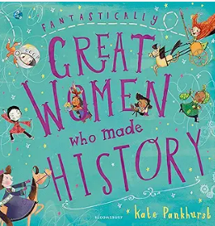  Anne Frank – Little People Big Dreams – Sanchez Vegara  Little guides to great lives – Anne Frank/ Usborne – Anne Frank (for the story of  her life)  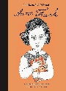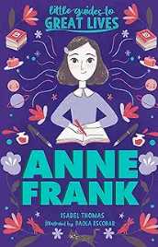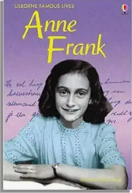 |  |  |  | Diary of a young girl – Anne Frank  Anne Frank’s Diary - The graphic adaptation – Frank & Polonsky  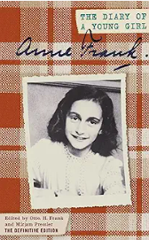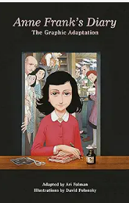  My secret war diary – Williams  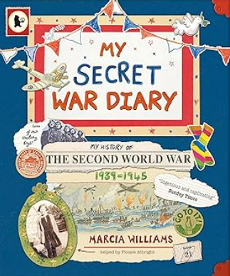 |  |  |  |  | Spider and the fly - Howitt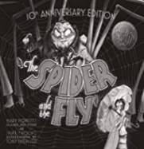 |  |  |  |  | Roads end  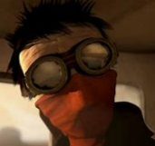  – |  |  |  |  |  |  | How to live for ever - Thompson  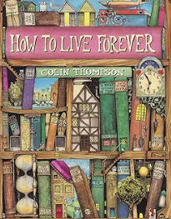
Writing outcomes | Biography of Anne Frank in the style of Pankhurst’s book series Great Women ….  Pupils will gather information about the life of Anne Frank from a variety of sources including video clips and then create a timeline to sequence the key events. This can then become a simple planning structure that they can add cohesive devices to or Anne’s emotional response using different colours or symbols. During this journey they will also complete a role on the wall so they can begin to gather evidence about Anne Frank as a person as this will be key to their understanding of her biography but can also be added to and referred to when creating a diary in role as this young woman.  This will then be used for them to draft and edit before they will create their own polished piece based on the biographical pages they have looked at from The Great Women series. Again cohesion will be a key focus in the learning journey to ensure that the writing flows for the reader. |  |  |  | A diary in role as Anne Frank capturing the diverse events in her life and showing her emotional response to them.  Briefly read a couple of different diaries to remind children of their purpose, organisation and emotion. Show them the text My secret war diary which is fictitious but will inspire them to create a similar interactive text.  Read extracts from The Diary of Anne Frank for the contents of their own piece. Use the graphic novel of her diary to support this.  Continue to develop a role-on- the-wall so children really understand her. Refer back to the timeline from her biography to help the pupils focus in on a few days of her life so they can capture the events and her responses to them within this first-person account.  Show them the WAGOLL that captures a few days in her life with a real focus on emulating the voice of this Jewish child. Cohesion is an essential part of the chronological text so time will be spent ensuring that appropriate adverbials are used to capture time, place and manner (including emotion) During the journey they will revisit the use of modal verbs to capture the precariousness of her life. Their challenge will be to attempt to capture her voice.  Once they have written their first draft pupils can share them with others in the class to see if they have captured the appropriate voice in their writing. |  |  |  |  | An innovated poem based on the theme, structure and rhyme pattern of the original.  Pupils read the poem and focus on the story within it ensuring that the pupils understand the relationship between the spider and the fly and the doomed aspect of the poetic narrative.  Home in on the rhythmic structure and rhyme scheme, giving pupils lots of support and guidance as it is complex. Discuss how the archaic language could be modernized to make the structuring of the lines easier to manipulate. Ask less confident pupils to recreate the poem in modern language, whilst challenge the more confident to pick two new characters to write up and change the setting so it is appropriate to them eg. a frog and a fly might be sitting close to the pond. Provide a boxed-up plan to support the children’s own draft. This can then be used to generate a first draft, which in turn can be carefully edited and revised to ensure that it was in keeping with the original.  Children can be supported and challenged by being asked to do a specific number of stanzas. |  |  |  |  | Atmospheric narrative that captures the tension of the meeting between the two characters – narrative in different forms  Pupils watch the animation a few times to ensure that they are clear about the sequence of events. They will then do a series of tasks, including capturing the atmospheric setting description, as well as asking them to see the story from the Red Scarf’s point of view and then his victim, the car driver, at different points in the story. Pupils will write in the first person to imagine they are either of these two characters – producing internal monologues and even be challenged to imagine the conversation they might have if they actually talked to each other.  This will culminate in the pupils planning a new narrative with different characters but a similar plot line. Their challenge will be to create the foreboding atmosphere and the dynamic relationship between the attacker and their victim, which will also include dialogue that captures the characters. |  |  |  |  |  |  | Balanced argument about whether or not they would want to live forever  Pupils are introduced to the text and make predictions from the front cover and the blurb about what the book will be about. They will then discuss if they would want to live forever and what immortality means to them. The opening pages will be shared and again pupils will predict the plot of the picture book only knowing this opening synopsis. They will be given questions about the book and challenged with more philosophical prompt questions e.g. Why did someone hide the book? What can you learn about the setting? Who is Peter and why is he looking for the book? They will vote about whether Peter would read the book or not. Pupils will be challenged to summarize the whole book in only 80 words – as this will make them really justify what is included into their synopsis and discuss the key events They will be expected to infer characters, thoughts and feelings using the text as evidence.  After these short activities pupils will be given a table of the pros and cons to living forever and asked to complete both sides. Discuss how they could organize a balanced argument to discuss whether it would be good to live forever. At this point, show them different examples of balanced argument that they could analyse to ensure that they understand the structure of them and the language used. The document could be coloured coded to explore when it is a general comment (purple), one side (blue) or the other (red) or hash tagged to examine which side of the argument is being addressed. Less confident writers could have different sentence starters to help them form the cohesive structure or be asked to formulate a persuasive argument for one side rather than a balanced one focusing on both. They could be given three opening paragraphs and have to discuss which one has a neutral, unbiased tone. Within the journey pupils could explore the use of higher-level punctuation such as colons and semi-colons, commas for parenthesis and linguistic devices such as conjunctions to add evidence or detail, modal verbs for emphasis and other elements of persuasive writing.
Text knowledge & GPS | Use the appropriate chronological layout of an information text/biography – eg heading, subheadings, arrows, maps, quotes etc  Use present and past tense verbs to ensure reader follows the information.  Use causal conjunctions as a cohesive devices.  To use relative clauses within their writing to give the reader more detail about the subject.  Identify and begin to use colons to organise information in the text. |  |  |  | To review the structure of a diary – use of general opening paragraph, chronological paragraphs, informal (historically appropriate), and adverbials to give structure.  To connect ideas and clauses with appropriate conjunctions that help capture the cause and effect of events in their life.  To use different forms of parenthesis within this personal writing. |  |  |  |  | To control volume, pitch and pace when performing and to use pausing, emphasis and intonation deliberately to enhance meaning Use personification to explore characterisation and create a foreboding atmosphere.  To show awareness of the rhythm and rhyme patterns within a more complex archaic narrative poem and begin to play around with word choice and position to capture this in their own poetic narrative. |  |  |  |  | To create a narrative setting that captures the atmosphere of foreboding and builds up tension!  To Identify and write relative clauses (embedded and at the end of the main clause) as parenthesis using a relative pronoun.  To use appropriate punctuation when writing dialogue.  Identify and write ellipsis as a stop mark or an incomplete thought within dialogue.  Use of commas to clarify meaning or avoid ambiguity |  |  |  |  |  |  | To create a balanced arguments with paragraphs that present and then build up both sides of the argument.  Use appropriate cohesive devices to structure their evidence eg conjunctions, modal verbs  To substitute commas for brackets and dashes when demarcating relative clauses as parenthesis using a relative pronoun  Identify and use semi-colons to mark the boundary between independent clauses if appropriate for the pupils
Summer Core Texts | Week 1 |  | Week 2 |  |  | Week 3 |  | Week 4 |  |  | Week 5 |  | Week 6 |  |  | Week 7 |  | Week 8 |  | Week 9 |  |  | Week 10 |  | Week 11 |  | Week 12
Summer Core Texts | Identity |  |  |  |  |  |  |  |  |  |  |  | Food glorious food!
Summer Core Texts | Little Freak animation  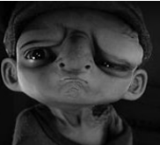 |  |  |  |  | Mr Bunny’s Chocolate Factory /Mayor Bunny’s chocolate town – Dolan  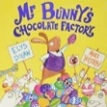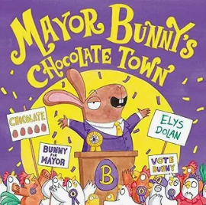  Powerpoint with examples of speeches from the different characters |  |  |  |  |  |  | Food Fight – Latimer  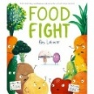  (See powerpoints and detailed planning for this unit of work which  includes clips & WAGOLLS and daily lessons ) |  |  |  |  |  |  |  |  |  | Fight of the year – McGough  (see breakdown of learning journey and resources in the planning file) |  | Watch a clip of Jamie Oliver, Nigella Lawson to hear their voice  How to cook children – Howard & Stimson  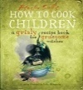
Writing framework | Tense narrative including atmospheric setting description and characterisation. Will include dialogue between the father and the son that captures character and moves the action on  Watch the opening few minutes of the animation with the caravan in the pouring rain. Without continuing, collect ideas about why the scene begins like this. What atmosphere does the storyteller want to convey? Work in pairs to collect ideas about this tense, murky opening that will give clues to the reader that the characters inside lead a difficult life. Complete a setting description planning sheet (see PowerPoint). Create a WAGOLL with the children and keep reading it aloud to ensure that the pervading feeling is one of doom. Watch the next part of the animation that takes place within that caravan which is poorly lit, is cold and empty. Focus in on the character of the boy who has been wearing a shackle. Focus on the description of this child. Discuss how we feel about him and make notes for the working wall. Continue watching the scene when the father enters and watch it until the end after predicting what might happen when the Little Freak seems to stand up to his father. Explore the idea of recreating the scene with more emphasis on the father’s response to the child’s demands. Give them images of alternative fathers – one that is more kindly, explaining that he is loved but they have to eat so he has to work for them, another more like a Bill Sykes character (watch the scene from Oliver to give pupils more ideas about this violent character). Ask the pupils to go into role as the child and father, exploring different characterisations. Which one feels the most effective for bringing this narrative to life? Explore the different WAGOLLS. Pupils then draft out the dialogue focusing on the accurate punctuation and use of the reporting clause. Ensure that pupils are really focusing on the characterisation and the mechanisms for building action and reaction into their writing. |  |  |  |  | Persuasive speech/ letter in role as one of the chickens demanding change in an informal style. (see PowerPoints for inspiration  Read Mr Bunny’s Chocolate Factor to point of the chickens revolting. Return to the images capturing the brutality of the factory and collect ideas about how downtrodden their lives are. Read the imagined play scene between two older chickens who are remembering a better time and moaning about the expectations and poor work conditions/ read the imagined narrative between the two chickens that will lead into the rising up of the chickens. Discuss what they could do before you explore the page of the chicken rally for change! Discuss what they need to do in order to make Mr Bunny listen to their demands. Watch different speeches in order to have a clear idea about structure, voice and language use.  Collect evidence about all the chickens’ grievances about working in the factory e.g. work conditions, health & safety, overwork, low pay, no holidays. Give children a bank of all the grievances to extend their language. Use CHAT GPT to help capture the voice of a disgruntled chicken by telling it the role you want it to take and asking the children to then generate questions to ask it.  Share a couple of different WAGOLLs of the text and discuss how this could be boxed up into three paragraphs  1: Introduction and basic complaint directed to Mr Bunny.  2. Evidence of his unacceptable behaviour and the terrible working conditions within his factory.  3. Demand for recompense and change.  Explicitly teach  During this part of the journey spend time revisiting cohesive devices that have been focused upon during this half term e.g. parenthesising.  Develop tone by exploring the impact of using different modal verbs and sentence types. Orally rehearse ideas using sentence stems if need be. Focus again on cohesion of ideas across the letter/speech.  Pupils will draft their ideas and orally rehearse them in front of the class in order to develop their ideas further |  |  |  |  |  |  | Narrative description of an imagined scene from the book where the fruit are battling the vegetables in a scene full of tension and emotion. Introduce the picture book that focuses on a world of conflict between fruit and vegetables. Show them the opening four pages and show them some of the ‘weapons’ from the kitchen that might be used in a battle scene eg. a grater, a toaster, a nut cracker. Reread the pages and explore why the fruit and veg hate each other so much. Generate some reasons eg. veg are tired of everyone thinking that the fruit are sweeter than them. Fruit want to be taken more seriously by the veg and treated with respect. Using images from the text to inspire talk discuss what a fight might look like and how they could attack each other. Read the WAGOLLs and act the scenes out. Work in pairs to write their first draft |  |  | Narrative of the journey of the mushroom and the grape to visit the Big Cheese to try and resolve the conflict in the kitchen. This will include dialogue.  Read the next few pages to find out about the friendship between Mushroom and Grape and how they decide to travel to meet the Old Cheese to get advice about how to stope the hatred.  Act out the conversation between these two friends and explore different scenarios - with one wanting to go and the other being more reluctant / telling each other how to overcome their fears and encourage each other. Look at the next few pages to explore the journey through the fridge and give pupils a diagram of the fridge so they can capture their ideas about the journey through the fridge to reach the Wise Old Cheese. Look at clips of fridges or reconstruct one in the classroom so pupils can explore how to move through the different foods and drinks. Show them other children’s ideas for a dangerous, but exciting journey. Pupils will work in pairs to create their own stories from the maps with an emphasis on creating an atmospheric and suspenseful narrative. |  |  |  | Write in role as the Wise Old Cheese advising Mushroom and Grape how to resolve the situation –  Continue reading the text until they meet the character of the Wise Old Cheese. Read his speech from the book. Examine how this is constructed and the impact it would have on the little fruit and veg. Explore the possible character of this wise old cheese. Watch different clips to help them explore ‘voce’ such as the turtle from Nemo. Show the WAGOLLS that have been produced and discuss what type of character would be saying those words eg wise and all-knowing/ chilled and dude like!  Ask pupils to read them out loud and then attempt to write their own words of advice in a distinct voice. |  |  | A narrative poem about the battle between healthy and unhealthy food. Share this narrative poem asking pupils to focus on what they think is happening eg a boxing match between the old and new season. Spend time exploring how it could be read aloud (watch commentary of a boxing match for pace etc) Show pupils’ examples and work through a shared text about a doughnut v a carrot. |  | Instruction in role as a witch telling the reader how to cook the children appropriately for their specific country (see PowerPoint)  Read the Yorkshire witch and the French witch out loud to the children. Compare how they speak to the reader that matches their character. Look at how they introduce themselves and then how their recipes reflect them. Eg a cruel witch, granny witch, Italian witch  Text mark the original so that they have a clear idea about how the text is structured. Show them examples written by other Year 6 pupils. Which one do they think is the most effective eg The French or the Indian witch. Ask the pupils to choose their own voice to practice writing in to capture their instructions in.
Writing framework |  |  |  |  |  | OR Read Mayor Bunny’s chocolate town and explore the campaign of Mr Bunny and Debbie the chicken who are both up for election as the Major. Use the images to help collect evidence about the personalities of Mr Bunny and Debbie and discuss the ‘voice’ of each character. Discuss their honest and the way they would behave during an election campaign. Focus on Debbie first and her desire for a better world. Read her speech at the election in the book and work with the pupils to generate ideas about what a strong, fair-minded chicken would offer the chickens in her town. Play with the use of repetition to reinforce ideas and evidence to give weight to her opinion. Show them a WAGOLL and ask them to discuss its impact. After the first draft, give pupils the opportunity to read their speeches aloud to see if they would appeal. Then explore Mr Bunny’s speech in the picture book and have some fun trying to emulate his boasting, arrogant speech and smear campaign of young Debbie. Look at how he would cause panic in the town by mentioning foxes etc. Again give pupils the chance to read aloud and edit accordingly. With both focus on the use of cohesion to make an effective speech and commas to ensure clarity.
Text knowledge & GPS | To consolidate the end of KS 2 standards for writing. This includes writing for a purpose and audience with keen awareness of the different cohesive devices such as exploring the role of paragraphing, sentence level accuracy and word choice. Pupils must have lots of opportunity to proof-read their writing with precision and edit their work with a growing awareness of the reader. Ensure pupils have the opportunity to use greater depth features if appropriate, including writing with an understanding of different registers and levels of formality appropriate to the text type, purpose and audience.
Text knowledge & GPS | To accurately punctuate dialogue. To create dialogue that conveys the character the on and to develop the reporting clause so they advance the plot.  To use ellipsis to create suspense or indicate an unfinished thought.  Eg. “What do you mean… I don’t understand…. |  |  |  |  | Use complex emotive language to express feelings.  Use features of persuasive writing to capture the complaint about Mr Bunny’s despicable behaviour  Use of modal verb as a persuasive device – you should, you must  Use different forms of parenthesis to ‘chat’ to the new employee. |  |  |  |  |  |  | To capture the tense atmosphere. To use appropriate expanded noun phrases To use prepositional phrases to give precise detail about the character’s actions |  |  | To focus on the cohesion across the narrative – through paragraphing, fronted adverbials, colons/semi-colons. To use characterisation throughout the narrative (eg. expanded noun phrases, adverbial phrases) that is cohesive and appropriate for the character.  To ensure that the dialogue captures the character and moves the action on , as well as be written with appropriate and accurate punctuation. |  |  |  | To create an emotive speech of advice. To capture voice within the speech.  Use complex emotive language.  Use of modal verb as a persuasive device. |  |  | To use language that captures the movement of the healthy / unhealthy food  Identify and write personification poetry based Fight of the year but between the food |  | Use an appropriate layout for an instruction text so that other witches could follow it with ease. To capture voice within the writing.  Use colons and semi-colons to help organise the information for the reader.  To use different forms of parenthesis – dashes & brackets- to include key information to the chickens.  To use modal verbs for possibility and emphasis.

