sd | Year 6 English Curriculum Overview 2025 – 2026
Autumn Core Texts | Week 1 | Week 2 |  |  | Week 3 |  |  |  |  | Week 4 |  |  | Week 5 |  |  |  | Week 6 |  |  |  | Week 7 |  | Week 8 |  | Week 9 |  | Week 10 |  |  | Week 11 |  |  | Week 12 |  |  |  | Week 13 |  |  | Week 14
Autumn Core Texts | Why does population change? |  |  |  |  |  |  |  |  |  |  |  |  |  |  |  |  |  |  |  |  |  | Locality history – WWII evacuation and bombing
Autumn Core Texts | The Journey – Sanna  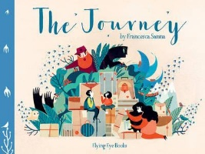 |  |  |  | Reverse poem –  Refugees – Bilston  Clip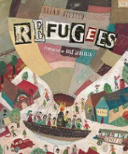 |  |  |  | The boy at the back of the class – Rauf  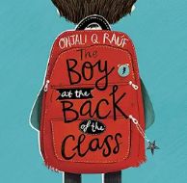  The girl at the front of the class – Rauf  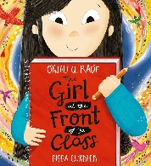 |  |  |  |  |  |  |  |  |  |  |  |  |  | The Remarkables – Perrin  (diff children’s identity)  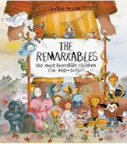  Identity Poetry – see Powerpoint  Mask & Reverse Selfie – two short films  Mask –Rooney  Russian Doll – Rooney  Body Talk – Zephaniah  The British – Zephaniah |  |  |  | Diary of Flossie Albright – Williams  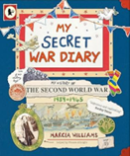  Film: Hope and Glory – Opening scene when war was declared on the radio |  |  |  |  |  | Good Night Mr Tom – Magorian  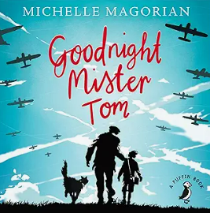 |  |  |  |  |  |  |  | Everything World War II facts – National Geographic  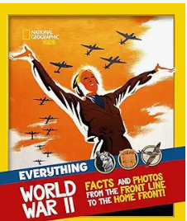  Visit to Stockport Air Raid Shelter?
Writing Outcomes | Setting description of the hazardous journey of the family to reach freedom. Focus will be to vividly describe their travels and also capture their emotional response to them and their level of fear. |  |  |  | A reverse poem based on Refugees by Bliston |  |  |  | Narrative that includes dialogue ? |  |  |  |  |  |  |  |  | Formal letter from the class to the government pleading for Ahmet to be allowed to stay |  |  |  |  | Day 1 – film clips of Mask/ Reverse Selfie  The mask – Rooney  This is me  Day 2 - Russian Doll – an outcome  Day 3 – edit  Day 4 – Creator of Unity / The British – Class poem about the class Inside outside poem  Body talk poem  A school poem based on The British – Whole Class |  |  |  | An informal letter from a child who lives in Manchester to his pen pal who lives in the country capturing the day that war was declared. |  |  |  |  |  | Narrative |  |  |  |  |  |  |  | Instructions for surviving in a bombing. Play around with the level of formality – a parent telling their child/the government telling their citizens.
Text knowledge & GPS | Opportunity to consolidate all the end of lower KS 2 standards. Use a range cohesive devices eg. paragraphs, fronted adverbials, subordinating & co-ordinating conjunctions, pronouns, determiners , correct tense. Sentences will be accurately punctuated with a growing confidence with the use of the comma for demarcation of parts of the sentence – phrases and clauses. Pupils will be using punctuation to capture parenthesis within their sentences. Simple dialogue will be accurately punctuated. |  |  |  |  |  |  |  |  |  |  |  |  |  |  |  |  |  |  |  |  |  | Focus on language choice  Identify and use colons and hyphens to replicate the poem Russian Doll  Use similes and metaphors within the writing to help bring the description to life. |  |  |  | To include features of more informal letter writing eg chatty style, colloquialism and phrasing, contracted form,  Use of modal verbs to capture levels of certainty and for emotional impact |  |  |  |  |  | Use paragraphs to achieve pace and tension in the writing.  To capture atmospheric setting/character description (expanded noun phrases/prepositional phrases for description, verbs and adverbs to capture character movement and reaction)  To identify and use conjunctive adverbs to open sentences.
Text knowledge & GPS | Use paragraphs and different length sentences to achieve pace and tension in the writing.  To capture atmospheric setting/character description (expanded noun phrases/prepositional phrases for description, verbs and adverbs to capture character movement and reaction)  To identify and use conjunctive adverbs to open sentences. |  |  |  |  |  |  |  | To include features of more formal letter writing eg polite salutations and phrasing, uncontracted form, passive voice.  Revision of modal verbs to capture levels of certainty and for emotional impact |  |  |  |  |  |  |  |  | Identify and use colons and hyphens to replicate the poem Russian Doll.  Use features of instruction writing in the style of The British – appropriate verbs to capture how the class is ‘created’.
Spring Core Text  pring  Spring Core Texts | Week 1 |  | Week 2 |  |  | Week 3 |  |  |  |  | Week 4 |  |  | Week 5 |  |  |  |  | Week 6 |  |  |  | Week 7 |  |  | Week 8 |  | Week 9 |  |  | Week 10 |  |  | Week 11 |  |  |  | Week 12
Spring Core Text  pring  Spring Core Texts | World War II |  |  |  |  |  |  |  |  |  |  |  |  |  |  |  |  |  |  |  |  |  | What is out there?
Spring Core Text  pring  Spring Core Texts | Women who made history – Pankhurst  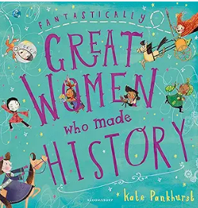  Little guides to great lives – Anne Frank / Usborne – Anne Frank (for the story of her life)  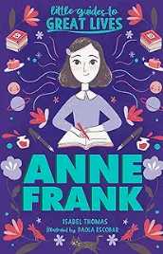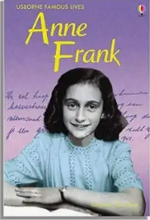 |  |  |  |  |  |  | Diary of a young girl – Anne Frank  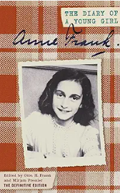  My secret war diary – Williams  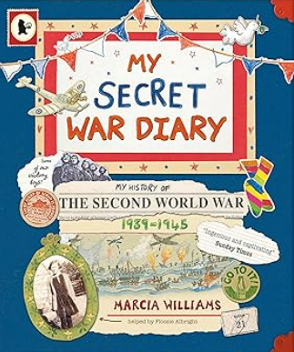 |  |  |  |  |  |  |  | Spider and the fly - Howitt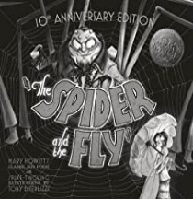 |  |  |  |  |  |  |  | Roads end  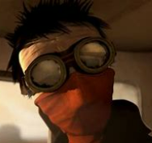 |  |  |  |  | How to live for ever –  Thompson 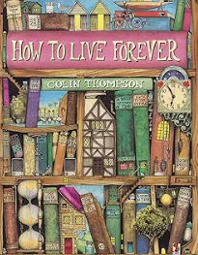 |  |  |  |  |  |  | The Controller    https://youtu.be/U9Uh_H5mCbQ?si=HGs7d4iVYDGx7sUR  Scene from Tron
Writing outcomes | Biography of Anne Frank |  |  |  |  |  |  | A diary in role as Anne Frank capturing the diverse events in her life and showing her emotional response to them.  Use a cohesive device to underpin the structure and the creation of a timeline (eg the extract from the film when they find the German pilot) to help gather information about the events and the character’s responses. |  |  |  |  |  |  |  |  |  |  |  |  |  |  |  | Atmospheric narrative that captures the tension of the meeting between the two characters |  |  |  |  | Balanced argument about whether or not they would want to live forever |  |  |  |  |  |  | A key point of the narrative that captures the atmosphere and characterization through dialogue
Text knowledge & GPS | Use the appropriate chronological layout of an information text/biography – eg heading, subheadings, arrows, maps, quotes etc  Use present and past tense verbs to ensure reader follows the information.  Use causal conjunctions as a cohesive devices.  To use relative clauses within their writing to give the reader more detail about the subject.  Identify and begin to use colons to organise information in the text. |  |  |  |  |  |  | Apply knowledge of structure and language of a diary – chronological, informal (historically appropriate), rhetorical questions, emotive language  Use of commas to clarify meaning or avoid ambiguity |  |  |  |  |  |  |  |  |  |  |  |  |  |  |  | To create a narrative setting that captures the atmosphere of foreboding!
Summer Core Texts | Week 1 |  |  | Week 2 |  |  | Week 3 |  |  |  |  | Week 4 |  |  | Week 5 |  |  |  |  | Week 6 |  |  | Week 7 |  |  | Week 8 |  | Week 9 |  |  |  | Week 10 |  |  | Week 11 |  |  |  | Week 12
Summer Core Texts | Identity
Summer Core Texts | School prospectus |  |  |  |  |  | Little Freak animation  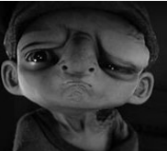 |  |  |  |  |  |  |  | Mr Bunny’s Chocolate Factory – Dolan/Mr Bunny’s chocolate town – Dolan  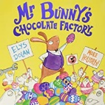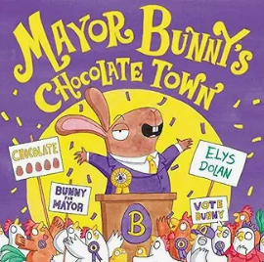  Powerpoint with examples of speeches from the different characters |  |  |  |  |  |  |  | Wonder – Palacio  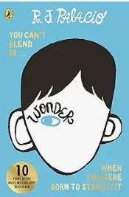 |  |  |  |  |  |  |  |  | Watch a clip of Jamie Oliver, Nigella Lawson to hear  their voice How to cook children – Howard & Stimson  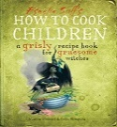  Read the Yorkshire witch and the French witch out loud to the children. Look at how they introduce themselves and then how their recipes reflect themselves. Eg a sadistic witch, granny witch
Writing outcome | An informative, persuasive text aimed at parents to show them how impressive Mossfield Primary School is. Pupils will prepare this as a slide show that could be used at parents’ evening or put onto the school web site. Cohesion will be across 2/4 slides depending on pupil’s ability. |  |  |  |  |  | A narrative that captures |  |  |  |  |  |  |  | A persuasive speech for the chicken’s votes - in role as Debbie, a passionate community minded chicken /Mr Bunny, a selfish candidate who wants power.  Listen to different speeches to hear how language is used to engage the listener. Examine the different characters |  |  |  |  |  |  |  |  |  |  |  |  |  |  |  |  | Instruction in role as a witch writing a recipe for cooking a child!
Text knowledge & GPS | The opportunity to consolidate the end of KS 2 standards for writing. This includes writing for a purpose and audience with keen awareness of the different cohesive devices such as exploring the role of paragraphing, sentence level accuracy and word choice. Pupils must have lots of opportunity to proof-read their writing with precision and edit their work with a growing awareness of the reader.  Ensure pupils have the opportunity to use greater depth features if appropriate. This would mean writing with an understanding of different registers and levels of formality  appropriate to the text type, purpose and audience.
Text knowledge & GPS |  |  |  |  |  |  | To review the structure of a diary – use of general opening paragraph, chronological paragraphs and adverbials to give structure.  To connect ideas and clauses with appropriate conjunctions that help capture the cause and effect of events in their life.  To use different forms of parenthesis within this personal writing. |  |  |  |  |  |  |  | To substitute commas for brackets and dashes when demarcating relative clauses as parenthesis using a relative pronoun  Identify and use semi-colons to mark the boundary between independent clauses if appropriate for the pupils

