Mossfield Primary School


Relational Policy

Written by: J Plant |  | Date: January 2025
Date for review: | July 2026
Approved by governors:
Mossfield Primary School
Relational Policy
At Mossfield Primary School we hold positive relationships. We work hard to repair and restore these relationships following any incident in school where damage may have been incurred.
It is important to recognise that behaviour is often an expression of a need not being met or a person not getting what is expected. We will always seek to explore the cause behind a behaviour rather than focus on the behaviour itself.

This policy aims to:
- Identify how our school establishes positive relationships
- Outline the process to be followed where relationships may have been damaged
- Recognise the importance of de-escalation and prevention in maintaining relationships
- Identify the importance of involving all parties in maintaining relationships – including the children

Ethos
Children in our school are individuals. They are always treated as such. We foster high expectations of all children's behaviour, work and relationships and to celebrate success widely. We build children's self-discipline, and a sense of pride and respect for themselves, their work, peers, school and the wider community. We develop positive relationships between school, parents and our community and a shared understanding of our aims. We create a school environment where children are healthy, happy, safe and secure, where they feel valued and respected within a diverse and inclusive environment.
The building of positive relationships is a fundamental component of life in our school. The building of these relationships is important for all children but it is essential for children who have experienced trauma or Adverse Childhood Experiences or have additional needs – for example children with attachment issues. For these children, positive relationships provide a sense of safety, security and belonging.

Expectations
Pupils within school are expected to:
- Respect themselves
- Respect each other
- Respect all adults
- Respect the school environment
Fostering positive relationships
This is an ongoing process and can be thought of as a system of deposits in a bank. Shared positive experiences form the grounding of any relationship. These do not have to be significant events but small, positive, frequent interactions. This provides common ground and fosters a sense of a shared experience.
Examples of these interactions include:
- Greet at classroom door
- Awarding Dojo’s as recognition of meeting expectations
- Praise and reward (See Appendix A)
- Pay attention
- Laugh with them
- End lessons on a good note
- Learn to apologise
- Develop and cultivate compassion
- Look out for their team’s results
- Play games on the playground
- Use equipment on the playground safely
- Give consistently but receive occasionally
- Brag about them outrageously to others
Research suggests that for every negative experience children will need at least 7 positive experiences in order to maintain the relationship. It is our aim to exceed this through frequent interactions with all children so there are reserves to draw upon from their emotional bank.

De-escalation – a strategy in maintaining relationships
There will be occasions where people may experience anxiety or other feelings that may trigger certain behaviours. This is usually as an expression of an unmet need or not getting their expected outcome in a situation. This can be represented in the following way:
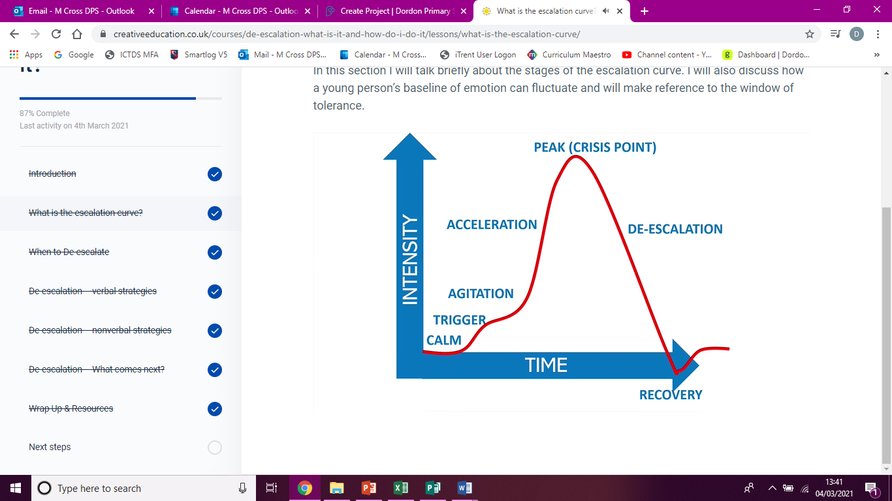
Our aim as a school is to employ strategies to avoid a person reaching their peak. We use a wide range of strategies to achieve this. This is dependent on the age of the child, circumstance, cognitive ability, needs of the children, etc. Interventions are tailor-made to the person involved.
For anyone who dysregulates (reaches PEAK) frequently, positive handling plans are implemented that outline strategies that prove to be most successful for an individual and those to avoid. It also outlines how the child can best support themselves in the regulation of their emotions. Involvement of the child in this process is intrinsic to its success.

Restorative Practice
The process involved in this approach is ongoing and starts with the frequent interactions listed above. Elements of the building and maintaining relationships and the recognition and naming of feelings is woven into every aspect of the curriculum – both the explicit planned curriculum and what we refer to as the ‘hidden curriculum’ the ongoing reinforcement of the key principles through incidental opportunities. These are considered to be preventative and avoid relationships being harmed.
The responsive element of the approach happens when relationships have been impaired. Restorative conversations will take place to repair any harm and move forward in maintaining the relationship that has been established.

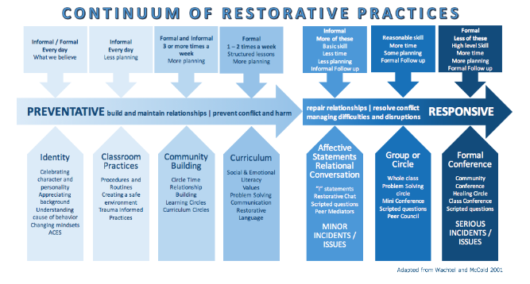

Restorative conversation
There are varying degrees of restorative conversation that can be deployed when an incident happens. The level of formality will depend on what has happened. It ranges from a quick prompt through to a structured conversation between all parties. Staff will use shared language and sentence prompts to support the conversations with children.
Where it is felt a structured conversation is needed with an individual where a person hasn’t been directly affected, the following questions will provide the structure.
LISTEN- What has happened? What were you thinking?
LINK – How did you feel when this happened?
LEARN – What could you do next time?

Where a person has been directly affected by the actions of another, a conversation will take place together, by mutual consent, to explore the situation and repair the relationship. This will use 6 questions to structure the conversation with the harmer going first. The conversation will be facilitated by an adults and both parties get the opportunity to explore the situation.
Prior to this conversation, the harmer and the harmed will be spoken to separately to establish their willingness to participate in the process.

The 6 questions to structure the conversation are as follows:-
- What happened?
- What were you thinking/ feeling?
- Who has been affected?
- What are you thinking/ feeling now?
- What needs to happen to put it right?
- Next time I could….
Prompts to support this conversation will be displayed in classrooms and key areas in school. All staff will have a copy to refer to – Appendix E.

Community
This approach will be used across school. This means that restorative conversations may take place between adults and children, staff members in school and staff members and parents. Our aim with each of these conversations is to maintain the positive relationships on which we pride ourselves.
There are incidents that occur outside of school hours and premises that can impact on the wellbeing and participation of children in school. An example of this could be online incidents or incidents in the local area. It is at the school’s discretion as to whether they intervene in such incidents but where it is deemed essential – a restorative conversation will be facilitated by adults in school to attempt to find a resolution and maintain relationships.

Consequences
Our understanding of the term consequence is that it is a result or effect of an action undertaken by an individual. We believe that consequences should be logical and linked to the action. Therefore the consequence will be determined through the restorative conversation that takes place with those involved.
For example: A child who dysregulates and lashes out when they lost a game on the playground would be involved in a restorative conversation (including the harmed if appropriate and consent is given). A logical consequence here might be to have a graduated return to break times.
There may be occasions where the consequence of an action could be exclusion from school on a fixed term basis. This is to allow school the time to review practice and put in place the plans necessary to minimise the chances of this happening again. If this were to happen, the child would have this explained to them so that their sense of belonging is not harmed.

Legislation and Guidance
- Behaviour and discipline in schools
- The Equality Act 2010
- Supporting pupils with medical conditions
- SEND Code of Practice
- The Children’s Act

Training
Our staff are provided with training on our school’s approach to managing behaviour as part of their induction process. This will focus on the importance of building relationships and the restorative practices in school.
Behaviour management will also form part of continuing professional development seeking external support where appropriate.
Many members of staff have been trained in TEAM Teach techniques, which also forms part of the cycle of continuing professional development.

Monitoring
This policy will be reviewed by the Headteacher every year in consultation with the staff team. At each review, the policy will be approved by the School Standards and Effectiveness Committee.

Links to other policies
- Staff code of conduct
- Child protection
- Positive Handling
- Exclusions
- Anti-bullying

APPENDIX A – Rewards
At Mossfield, we have many rewards that can be given to the children.
Verbal praise is given often in recognition of good work and meeting the expectations of RESPECT in many different ways.
Dojo’s are given using the Class Dojo system. These are awarded to children and are collected across a half term.
Marble jar Year 1-6 have a class marble jar. They are awarded a marble for working together well as a class. The reward is a 20 minute session of fun chosen by the class.
In EYFS they aim to fill a jar of hearts (similar context to the marbles). The children are awarded a heart when staff recognise they have been kind to someone else. When the jar is full the class is rewarded with a 20 minute session of fun.

Visits to the Senior Leadership Team are encouraged to share positive contributions to school whether these are academic or to the wider school community.
Email home is sent on Friday to a child in each class who has shone for any reason across the week. (Using class dojo)
Celebration assembly happens once a week and celebrates success inside and outside of school.

