sd | Year 5 English Curriculum Overview 2025 – 2026
Autumn Core Text | Week 1 | Week 2 |  |  | Week 3 |  |  |  |  | Week 4 |  |  |  |  | Week 5 |  |  |  |  | Week 6 |  |  |  | Week 7 | Week 8 |  | Week 9 |  | Week 10 |  |  | Week 11 |  | Week 12 |  |  | Week 13 |  | Week 14
Autumn Core Text | Gothic …. |  |  |  |  |  |  |  |  |  |  |  |  |  |  |  |  |  |  |  |  |  |  |  | The Greeks
Autumn Core Text | Alma  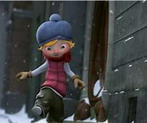 |  |  |  |  |  |  |  |  |  |  |  | Coraline – Gaiman (Graphic novel)  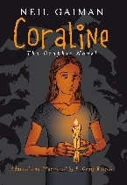  Coraline  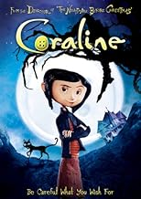  (see Dawn’s PowerPoint) |  |  |  |  |  |  |  | Wolves in the wall – Gaiman 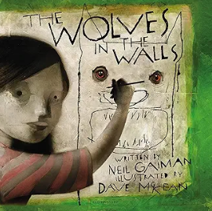  (see Dawn’s PowerPoint) |  |  |  | Greek Myths and Legends – Orchard  Theseus and the Minotaur/  Jason and the Golden Fleece  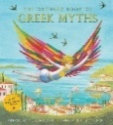  Meet the Heroes, gods and Monsters (Theseus pages) Trad’ Tales from Ancient Greece – Vic Parker /Greek Myths – Williams  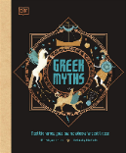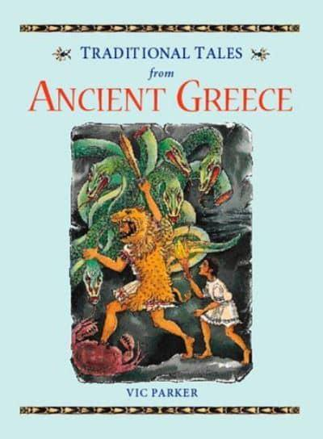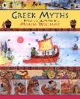  Film eg. Hercules, Jason and the Argonauts Clash of the Titans |  |  |  |  |  |  | Greek Non-fiction |  |  |  |  |  |  | How the grinch stole Christmas – Dr Seuss
Writing Outcome | To consolidate the learning from Year 4 –  developing cohesive devices - paragraphing,  adverbial phrases, use of a range of conjunctions |  |  |  |  |  |  |  |  |  |  |  |  | Suspense narrative based on a scene from the graphic novel. To include a brief atmospheric setting description and dialogue that captured character and moves the action on. |  |  |  |  |  |  | An onomatopoeic poem based on the noises from within the wall Pupils collect atmospheric sounds that will unnerve the reader and play with them to produce couplets that show the mounting fear of what’s behind the wall. They rehearse and perform these for the class. |  |  |  | Retell a myth (eg. Theseus and the Minotaur) /Creation of a myth  Setting description to create atmosphere  Character description  Dialogue & action for a myth |  |  |  |  |  |  |  |  |  |  |  |  |  | Instructions for how to steal Christmas from the Grinch
Writing Outcome | Narrative of the film that captures the atmosphere  Para 1 – Description of Alma happily skipping down the snow covered street  Para 2 -noticing the shop and trying to get in.  Para 3 – entering the shop. Build up of tension and touching the doll.  Para 4 – After being changed into a doll. |  |  |  |  |  |  |  | Lost Poster that describes Alma after she doesn’t return home. Capture the desperation to find her,
Text knowledge & GPS knowledge & GPS | Use paragraphs to achieve pace and emphasis.  Capture characters moving around the setting – verbs, adverbs, adverbials of manner to capture her personality and reactions . |  |  |  |  |  |  |  |  |  |  |  |  | Write cohesively, linking ideas across paragraphs.  Use accurately punctuated dialogue to capture characters and move the action on. |  |  |  |  |  |  |  |  |  |  | Link ideas across paragraphs using a range of adverbial phrases – time, place and manner.  To describe the atmosphere within the setting to paint a vivid picture for the reader.  To develop character through description, action and reaction.  To integrate dialogue into the narrative that captures the character and advances the action.  To Identify and write relative clauses (embedded and at the end of the main clause) as parenthesis using a relative pronoun  Eg Theseus, who struggled through the darkness, held his torch high. |  |  |  |  |  |  | Identify and write an introductory paragraph in expositional writing  Identify and write a concluding paragraph in expositional writing  Eg. This cruel dragon waits in the darkness, with its vicious talons, ready to attack.
Spring Core Text  pring  Spring Core Texts | Week 1 |  | Week 2 |  |  | Week 3 |  |  |  |  | Week 4 |  |  |  |  | Week 5 |  |  |  |  |  | Week 6 |  |  | Week 7 |  |  | Week 8 |  | Week 9 |  |  | Week 10 |  | Week 11 |  |  | Week 12
Spring Core Text  pring  Spring Core Texts | The Highwayman
Spring Core Text  pring  Spring Core Texts | The Highwayman – Noyes  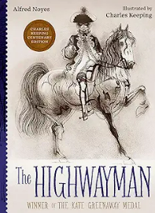 |  |  |  |  |  |  |  |  |  |  |  |  |  |  |  | Inside the villains – Perrin 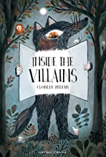  (see Dawn’s PowerPoint) |  |  |  |  |  |  |  | Holes - Sachar / Holes – film  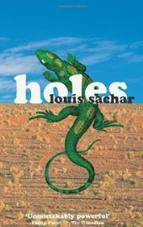
Spring Core Text  pring  Spring Core Texts |  |  |  |  |  |  |  |  |  |  |  |  |  |  |  |  |  |  |  |  |  |  |  |  |  |  |  |  |  |  | A variety of information texts about lizards  Reptiles – DK(a simpler text)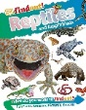  The World’s Most ridiculous animals – Bunting (pg 30) for extending more able writers  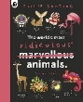 |  |  |  |  | A clip from the film
Writing Outcomes OuOutcomes | A poem describing the setting of the Highwayman full of figures of speech. |  |  |  |  |  | Emotive letter from one of the characters eg A love letter from Bess to the Highwayman.  A letter from Tim to the army explaining how to capture the Highwayman |  |  |  |  |  |  |  |  |  | Create a new page for Inside the Villains for the Highwayman – produce his speech bubble introducing himself |  |  |  |  |  |  |  | Setting description of Camp Greenlake |  |  |  |  |  | Non-chronological report of the Yellow Spotted Lizard – a scientific journal of a new species of poisonous |  |  |  |  | A narrative scene from the book where the Warden meets Stanley with a focus on the tension in the atmosphere and their dialogue
Text knowledge & GPS knowledge |  |  |  |  |  |  | Use appropriate layout of a letter -understand role of the different paragraphs – introduction, heart of the letter, closing paragraph that concludes  Cohesion within the paragraphs  Identify and write appositives (embedded and at the end of the main clause) as parenthesis  Doesn’t need relative pronoun who, which, that, whose, whom Use of modal verb to explore possibility as Juliet decides |  |  |  |  |  |  |  |  |  | Begin to use commas to clarify meaning or avoid ambiguity  Control different length sentences.  Use a variety of punctuation appropriately as in the model eg use of parenthesis. |  |  |  |  |  |  |  | To develop aspects of narrative writing eg. Setting description – expanded noun phrases for desc, verbs and adverbs to capture atmosphere and movement. |  |  |  |  |  | Identify and write an introductory paragraph in expositional writing  Identify and write a concluding paragraph in expositional writing  To use a variety of appropriate cohesive structures within and across paragraphs eg use causal conjunctions Use knowledge of conjunction and relative clauses to incorporate more detail into the report  To use technical language. |  |  |  |  | To write descriptively about the Warden using expanded noun phrases, superlatives etc to ensure that the reader is aware of the cruelty and brutality of this character  Use adverbial phrases within paragraphs to ensure sentence to sentence cohesion.  To use different length sentences to have specific impact on the reader.
Summer Core Text | Week 1 |  |  | Week 2 |  |  | Week 3 |  |  |  |  | Week 4 |  |  |  |  |  |  | Week 5 |  |  |  | Week 6 |  |  | Week 7 |  | Week 8 |  |  | Week 9 |  | Week 10 |  | Week 11 |  |  | Week 12
Summer Core Text | It’s a mystery !
Summer Core Text | Tuesday – Weisner  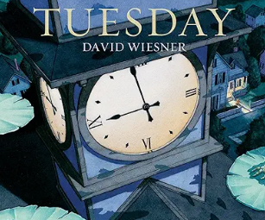  First News – to learn about the structure of a newspaper |  |  |  |  |  |  | High rise mystery – Jackson (to be read over the half term)  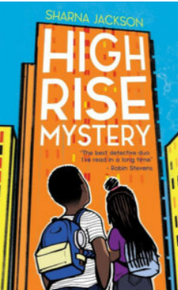 |  |  |  |  |  |  |  |  |  |  | Magical poem |  |  |  |  |  |  | Harry Potter and the philosopher’s stone  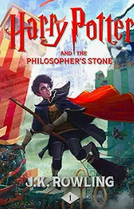
 | A newspaper article about the day the frogs flew  Create a timeline of events of the day. Interview eyewitnesses of the miracle. |  |  |  |  |  |  | A key scene from the book that captures the relationship between the two sisters.  Use role on the wall to gather evidence from the text about their relationship. This will include dialogue that conveys character and moves the action on. |  |  |  |  |  |  |  |  |  |  |  |  |  |  |  |  |  | Possible outcomes
Writing Outcomes |  |  |  |  |  |  |  |  |  |  |  |  |  |  |  |  |  |  |  |  |  |  |  |  |  | A vivid setting description of Harry’s tiny bedroom under the stairs that captures the atmosphere and his loneliness |  | A description of Hagrid when Harry first meets him that conveys how amazing and unusual he is and Harry’s reaction |  |  | A description of a new alley way that the young Harry has to navigate |  | House Speech –A persuasive speech for a new student to join a specific Hogwart’s house |  | Instructions for teaching a young wizard how to fly a broomstick |  |  | Forbidden Forest Encounter – Extend the scene where Harry enters the Forbidden Forest, adding more description and tension.
Text knowledge & GPS knowledge |  |  |  |  |  |  |  | To create an atmosphere of tension using a variety of cohesive devices including adverbials of time, place and manner to link ideas across and within paragraphs.  Use a wide range of clause structures, varying the position within the sentence. Use the full range of speech punctuation to capture characters and move the Use of informal language eg contracted form to capture the voice the child action on.

