sd | Year 4 English Curriculum Overview 2025 – 2026
Autumn Core Texts | Week 1 | Week 2 |  |  | Week 3 |  |  |  |  | Week 4 |  |  | Week 5 |  |  |  | Week 6 |  |  | Week 7 | Week 8 | Week 9 |  | Week 10 |  |  | Week 11 |  |  | Week 12 |  |  |  | Week 13 |  |  | Week 14
Autumn Core Texts | Children from the past |  |  |  |  |  |  |  |  |  |  |  |  |  |  |  |  |  |  |  | The Rainforest
Autumn Core Texts |  |  |  |  |  |  |  |  | Fox – Margaret Wild - The worst children’s jobs in history – Robinson  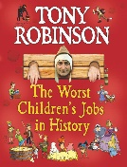 |  |  |  |  |  |  | School poetry unit  (stand-alone)  Variety of schools poems  eg. Please Mrs Butler – Ahlberg  Morning Break – Magee  10 school computers – Thomson  A kid in my class – Rooney  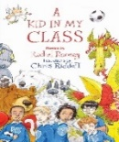 |  |  |  |  | There’s a rang tan in my bedroom – Sellick  Expedition diaries – Borneo Rainforest  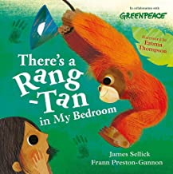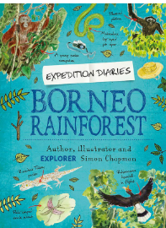  Advert – There’s a rang tan in my bedroom  Clips about orangutans and palm oil |  |  |  |  |  |  |  |  |  |  |  |  | Jungle drop – Elphinstone  (to be shared at the end of the day over the half term)  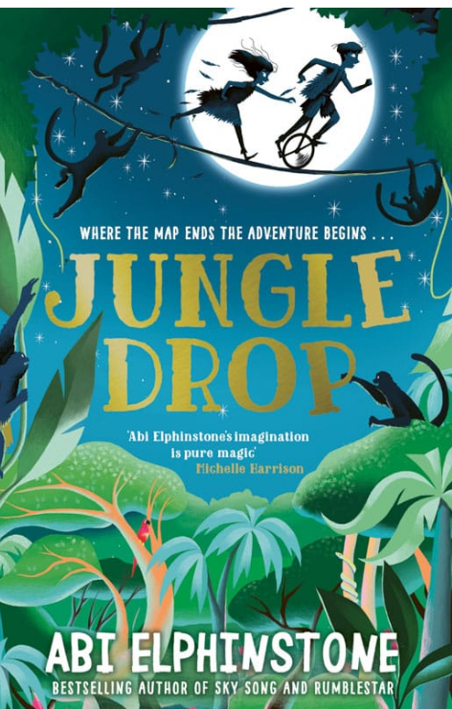  Abi Elphinstone introducing the book  https://youtu.be/SPDyGtaViY?si=TcVqwzTyp_26l2fc
Writing Outcomes |  |  |  |  |  |  |  |  | Non-chronological report about Victorian children’s jobs eg. chimney sweep |  |  |  |  |  |  | List poems of Morning Break & At the end of School Assembly  Performance of Please Mrs Butler  Couplet poem- 10 school computers  Instruction poem  Poems based on the Rooney Book with different structures  Eg Best Friender & Tough kid |  |  |  |  | Rules for the orangutan  Pupils role play the child sharing rules for it to stay in her room. After oral rehearsal teacher models how these could be written down discussing the tone. | Research notes about the orangutan and their lives under threat |  | Emotive dialogue between Sophie and the orangutan |  |  | Read about the work of the Rainforest Warrior Chico Mendes  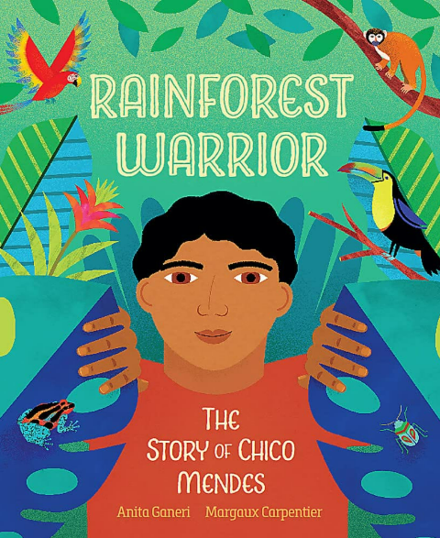  A persuasive letter to the chocolate makers/government about protecting the orangutan’s habitat and saving these vulnerable animals. |  |  |  |  |  |  | A short narrative extract from the book created as a narrative of the twins surviving in the Rainforest
 | Revisit skills of Year 3 –  Use cohesive devices to create a short narrative eg adverbial phrases for time, place and manner |  |  |  |  |  |  |  |  |  |  |  |  |  |  | Use a variety of different poetic structures to underpin the writing of poetry.  Widen pupils understanding of different features of poetry eg. stanzas, lines, couplet, rhyme, rhythm  Use a varied and rich vocabulary with growing precision to create the different types of poetry |  |  |  |  | Use contractive form for rules – discussion about how this makes the rules more informal / chatty |  |  | Use inverted commas to punctuate direct speech.  Use synonyms for said that convey character and emotions of their chosen animal |  |  | Include features of persuasive writing already taught eg rhetorical question, repetition, exaggerated language
Spring Core Text  pring  Spring Core Texts | Week 1 |  | Week 2 |  |  | Week 3 |  |  |  |  | Week 4 |  |  | Week 5 |  |  |  | Week 6 |  |  | Week 7 |  | Week 8 |  | Week 9 |  |  | Week 10 |  |  | Week 11 |  |  |  | Week 12
Spring Core Text  pring  Spring Core Texts | ANGLO SAXONS |  |  |  |  |  |  |  |  |  |  |  |  |  |  |  |  |  |  |  | WHAT A WONDERFUL WORLD !
Spring Core Text  pring  Spring Core Texts | Monster Slayer – Pattern  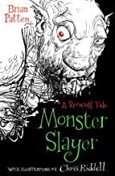  See writing overview for the unit |  |  |  |  |  |  |  |  |  |  |  |  |  |  |  |  |  | The Hero’s Quest – Love  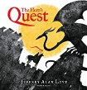 |  | Poets from around the world  Eg. Coehlo from London  Werewolf club rules –  Coehlo  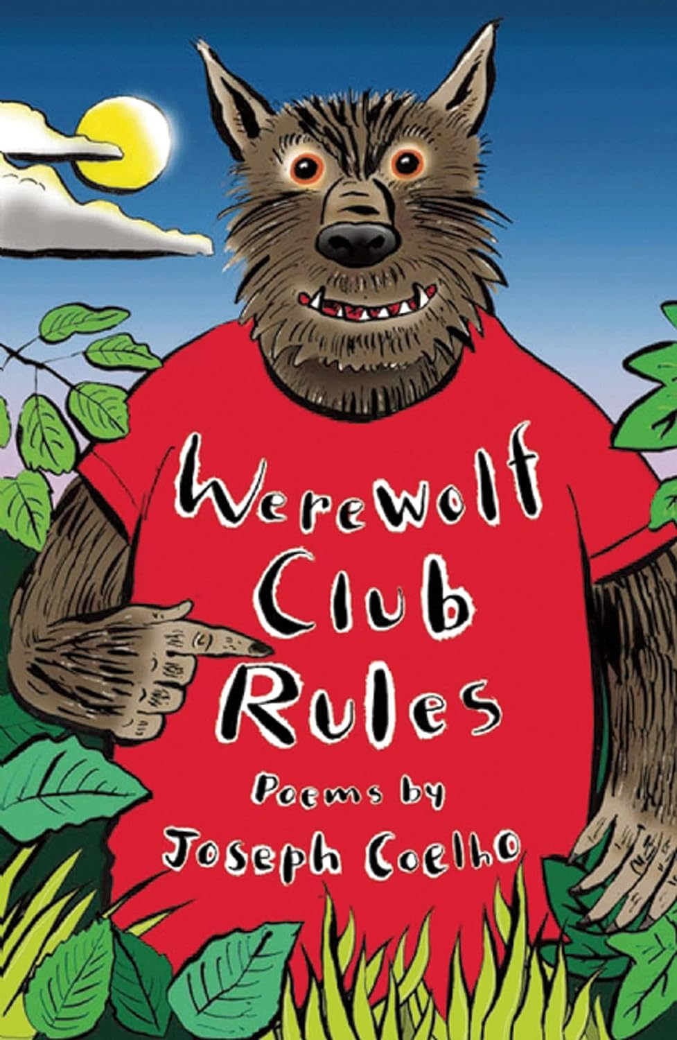  Individual poems:  I am a writer /School Tomorrow/Halloween Crumble /Golden Times  RAP poetry - |  |  |  |  |  |  |  |  |  |  |  | 
Writing outcomes | Look at opening page and discuss why Patten begins the story like this. Read opening chapter and discuss the atmosphere within the castle. How does the chapter finish and why?  Setting description to capture the atmosphere of Grendal’s swamp – pathetic fallacy.  A vivid description of Grendal that would disturb and frighten the reader of the story.  Discuss how the sentences build up the image of Grendal in the reader’s eye. Produce the opening of chapter 2 to ensure that the reader knows that Grendal is evil! |  |  |  |  |  |  | A kenning poem about Beowulfs word eg. a throat slitter, eye gouger,life taker  Or a kenning about Grendal  Eg. Spirit taker |  |  |  | Action description of the battle between Grendal and Beowulf  Examine how Patten describes Beowulf and the language that is used to show his character and strength.  Create an emotive boasting speech that captures Beowulf’s confidence that he announces before he goes into battle. |  |  |  |  |  |  | Performance of the poem |  | Read different poems from this collection and examples of his poetry and discuss what they think of them.  Hamster, Hamster – see PowerPoint for a short learning journey to support the teaching of this poem  See planning ideas for different poems (file) |  |  |  |  |  |  |  |  |  |  |  | An informal guide to staying alive in specific parts of the world
Writing outcomes |  |  |  |  |  |  |  |  |  |  |  | Act out the scene in slow motion so that pupils can see action and reaction and this can be emulated within their writing.
Text knowledge & GPS | To create a narrative setting that captures the atmosphere of foreboding! To describe a monster so that the reader knows how formidable it is.  To use expanded noun phrases, superlatives and figures of speech to create this beast. |  |  |  |  |  |  | To revisit the use of verbs that are transformed into nouns to eg Eye gouger/ Tongue ripper |  |  |  | Use cohesive devices –subordinating and co-ordinating conjunctions eg. when… if…. Because to show Beowulf explaining why he is formidable.  To use similes to show how Beowulf describes himself as an invincible force. |  |  |  |  |  |  |  |  | Hamster, Hamster –  Explore how language can evoke emotions in the reader.  Examine the use of repetition within the poem for impact  Teach on a simple level what antonyms are  Play with language choice -  focus on the use of nouns, adjectives, verbs and adverbs for impact
Text knowledge & GPS |  |  |  |  |  |  |  |  |  |  |  | To use fronted adverbials appropriately that signal a change in time, a change in focus or a build-up of suspense. To begin to include more movement into the dialogue that moves the action on.
Text knowledge & GPS | Week 1 |  |  | Week 2 |  |  | Week 3 |  |  |  |  | Week 4 |  |  | Week 5 |  |  |  | Week 6 |  | Week 7 |  | Week 8 |  | Week 9 |  |  |  | Week 10 |  |  | Week 11 |  |  |  | Week 12
Text knowledge & GPS | Link to Crime and Punishment |  |  |  |  |  |  |  |  |  |  |  |  |  |  |  |  |  |  |  | Rivers
Text knowledge & GPS | Lost Happy Endings – Carol Ann Duffy  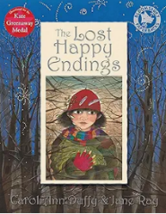  See Powerpoint for ideas for writing outcomes |  |  |  |  |  |  |  |  |  |  |  |  |  |  |  |  |  |  |  | Flotsam – Weisner  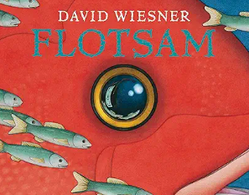 |  |  |  |  | Film unit – Treasure - |  |  |  |  |  |  |  |  |  | Poetry about rivers  River – Bloom
Text knowledge & GPS | Figurative language poem based on the Happy endings flying into the night sky (2 days) |  |  | Rewrite the narrative of when Jub is travelling through the woods that capture the disturbing atmosphere and then encounters the witch! |  |  | Diary in role as Jub after she is attacked by the witch exploring how she is feeling about losing the happy endings. |  |  |  |  | A new narrative ending for one of the fairy stories once the ending has been lost. Look at the original happy endings and then twist them. |  |  | A persuasive report - Who was the guilty one? A class discussion about the guilt of Jub and the witch. |  |  |  |  |  | –
Text knowledge & GPS |  |  |  | Use cohesive devices to create a short narrative eg adverbial phrases for time, place and manner  Use inverted commas to punctuate direct speech.  Use synonyms for said that convey character and capture emotions.

