sd | Year 3 English Curriculum Overview 2025 – 2026
Autumn Core Text | Week 1 | Week 2 |  |  |  | Week 3 |  |  | Week 4 |  |  |  | Week 5 |  |  | Week 6 |  |  |  |  | Week 7 | Week 8 |  | Week 9 |  |  | Week 10 |  |  | Week 11 |  |  |  | Week 12 |  |  | Week 13 |  | Week 14
Autumn Core Text | Stoneage |  |  |  |  |  |  |  |  |  |  |  |  |  |  |  |  |  |  |  |  | Why do people live near volcanoes?
Autumn Core Text | The Friendly Mammoth – Terroros-Martin  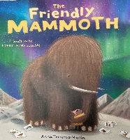  A clip of a tour around the British Museum |  |  |  |  |  |  |  |  |  |  |  | DK Find Out Stone Age – mammoth page  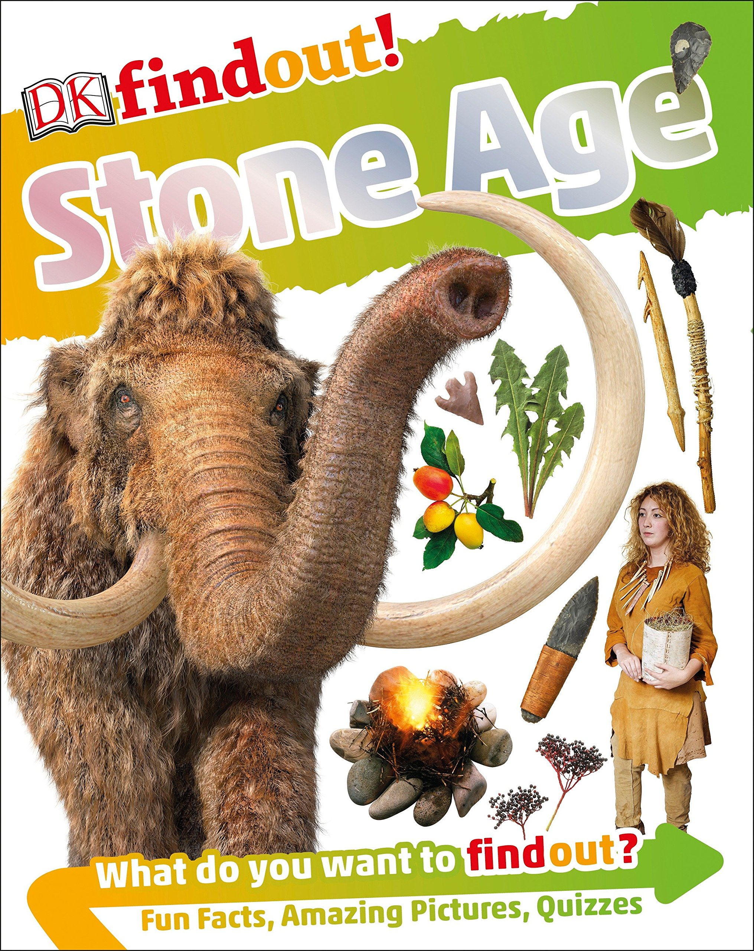 |  |  | Mammoth –  Kemp & Beer  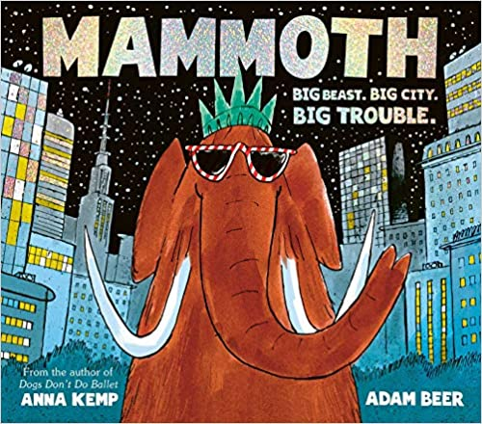  How to wash a  Woolly Mammoth – Robinson & Hindley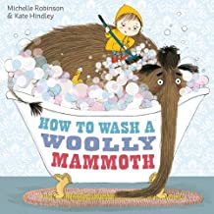 |  |  |  |  |  | Adventure trailers to help pupils generate ideas about the features of an  adventure story  Escape from Pompeii – Balit  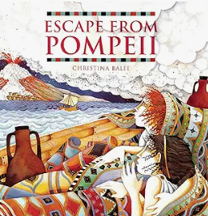 |  |  |  |  |  |  |  | What are … volcanoes  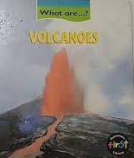  DKfindoutVolcanoes  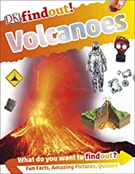  Clip showing an erupting volcano. |  |  |  |  |  |  | Word whirls and other shape poems – Foster  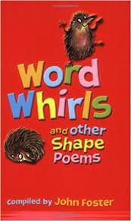  Apes to zebras – Brownlee  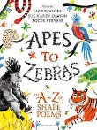
Writing Outcomes | Basic sentence structuring linked to narrative writing  Eg Mansi loved the museum because….. When Mansi got to the museum she…. |  |  |  | Narrative of Mansi’s journey with the Mammoth  (story-mapped)Simple story sentences – using the images to underpin their sentences. |  |  |  |  |  |  |  | Diamonte poem about a mammoth |  |  | Read Mammoth about a mammoth that comes into the modern world Instruction for how to wash a woolly mammoth |  |  |  |  |  | An adventurous survival story based on the text – share whole text with pupils but use individual images to underpin the writing of the story. Role play will be at the heart of this unit. Pupils will work in groups to watch adventure film trailers and generate ideas about what the key elements of an adventure are.  Opening paragraph - setting description of the town capturing the busy atmosphere  Paragraph2 - Action – Tranio’s response to the eruption – character development and reaction Tranio finds Livia and they run through the streets desperately  Paragraph 3 - Dialogue – one of the characters is hurt/falls/wants to give up so the other has to encourage them to continue.  Final paragraph – the climax when they reach the port, but do they survive or not? |  |  |  |  |  |  |  |  | Explanation text  (captions – flow  causal conjunctions) |  |  |  |  |  | Share calligrams and discuss why they are effective.  Introduce different concrete poems to explore the form, idea and language  Create a concrete poem based on a volcano erupting
Text knowledge & GPS | Opportunity to consolidate the end of KS 1 standards for sentence level and word choice independently.  To write coherently with accurate demarcation using the different sentence types and punctuation marks. Use appropriate past and present verb tenses.  Use co-ordinating and subordinating conjunctions. |  |  |  |  |  |  |  |  |  |  |  |  |  |  | Use heading and subheadings, bullet points or numbers.  Use paragraphs to organize information.  Use imperative verbs.  Use specific noun and appropriate adjective (eg. soft brush, squeesze of bubble bath)  Use singular  possessive apostrophe  eg mammoth’s tusk |  |  |  |  |  | Introduce the role of a basic paragraph.  Use adverbials of time to begin to link sentence to sentence.  Focus on past tense specific verbs to describe the actions within the story.  Introduce how to set out dialogue using inverted commas and a simple reporting clause. |  |  |  |  |  |  |  | Opportunity to consolidate the end of KS 1 standards for sentence level and word choice independently. To write coherently with accurate demarcation using the different sentence types and punctuation marks. Use appropriate past and present verb tenses.  Use co-ordinating and subordinating conjunctions
Text knowledge & GPS | Use nouns, adjectives and verbs appropriately |  |  |  |  |  |  |  |  |  |  |  | Use appropriate noun phrases to describe the mammoth
Text knowledge & GPS | Week 1 |  |  | Week 2 |  |  | Week 3 |  |  |  |  | Week 4 |  |  | Week 5 |  |  |  |  | Week 6 |  |  | Week 7 |  |  | Week 8 |  |  | Week 9 |  |  |  | Week 10 |  |  | Week 11 |  | Week 12
Text knowledge & GPS | When did the Romans invade and settle in Britain ? |  |  |  |  |  |  |  |  |  |  |  |  |  |  |  |  |  |  |  |  | Who lives in Antarctic ? (stories are set in the North Pole)
Text knowledge & GPS | The Tear thief – Duffy  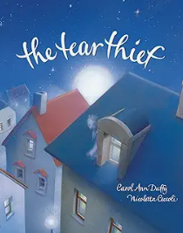 |  |  |  |  |  |  |  |  |  | Trip to Deva in Chester  The Roman Soldier’ Handbook – Usborne  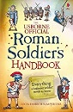  Or Avoid Being a Roman Soldier –  Steward & Antram  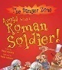 |  |  |  |  |  | Boudicca (History VIPs) Harrison  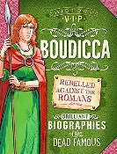  Boudicca’s Speech https://youtu.be/zhcm6z5PT04?si=MjRMdPbl797rH52S  Braveheart /Greta Thunberg speech |  |  |  |  | Pugs from the frozen north – Reeves & McKintyre  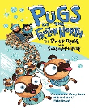 |  |  |  |  |  |  |  |  |  | The Search for the Giant Arctic Jellyfish – Savage  Watch clips about Giant Arctic Jellyfish on YouTube  Very important animals - Dorling Kindersley eg penguin  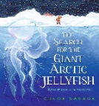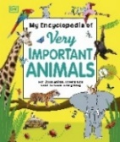
Share the book with the children and discuss the story structure about a fantastical giant artic jellyfish. Create a time-line that captures the story and explores the finding of
different arctic animals
Writing Outcomes | A narrative of part of the story |  |  |  |  |  | Dialogue between the child and his mother |  |  |  | Diary of an incompetent Roman soldier in Britain (see PowerPoint)  Learn about the life of Roman Soldiers in Britain.  Learn about the structure of diary form.  Imagine what it would be like to be a struggling soldier who couldn’t cope with the regime of the training.  Teach pupils how to use a time-line to underpin the diary and then focus on capturing the highs and lows of the punishing training schedule. |  |  |  |  |  | (A character description of Boudicca that captured her fierce nature)Persuasive rallying speech by Boudicca to encourage her followers |  |  |  |  | Narrative adventure story  A 1st person narrative adventurous story about going to the yeti bar.  Vivid setting description. |  |  |  |  |  |  |  |  |  | Non – chronological page about a new species of animal only found in Antarctica that they could use to help create their own story eg. a great Antarctic Penguin.  . |  |  |  |  |  | create part of a new story based on The search for the ……. Antarctic ……..  Using the new creature create a story similar to the original but based in the Antarctic.
Text knowledge & GPS |  |  |  |  |  |  |  |  |  |  | Use appropriate layout of a letter – paragraphing introduction, heart of the letter, closing paragraph that concludes  Cohesion across the paragraphs  Use of effective questions. |  |  |  |  |  |  | Use adjectives and superlatives for descriptive impact.  Explore the power of repetition Play with pronouns to emphasis their differences we/they. |  |  |  | Reinforce paragraphing as a cohesive device:  Setting description -  Yr3: Use fronted adverbials of time and place to capture the journey. |  |  |  |  |  |  |  |  |  | Use layout for a non-chronological report.  Use paragraphs to organize information  Use technical language |  |  |  |  |  | Paragraphs to help organise the story.  Adverbials of time & manner that bring the story to life  eg. suddenly, at that moment  Ensure pupils understand why they are used in the story to make it more exciting.
Summer Core Text | Week 1 |  | Week 2 |  |  |  | Week 3 |  |  | Week 4 |  |  |  | Week 5 |  |  |  |  | Week 6 |  |  | Week 7 |  |  | Week 8 |  |  | Week 9 |  |  |  | Week 10 |  |  | Week 11 |  |  | Week 12
Summer Core Text | Poet study |  |  |  |  |  | What did the Egyptians believe? |  |  |  |  |  |  |  |  |  |  |  |  |  |  | Are all settlements the same? Countryside v city
Summer Core Text | Poetry of Rosen 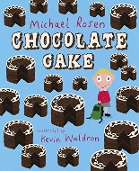  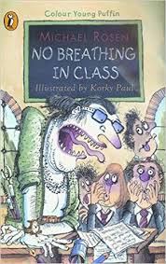  Don’t / Fridge / Telly  The Car Trip /Tidy your room  Hot Food / Goldfish  Mustard Belly |  |  |  |  |  | Howard and the Mummy: Howard Carter and the Search for King Tut's Tomb – Fern  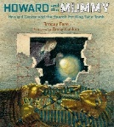  Watch the clips to learn about Howard Carter, his archaeological dig and what he found in the tomb |  |  |  |  |  |  |  |  |  |  |  |  |  |  | Into the forest – Browne 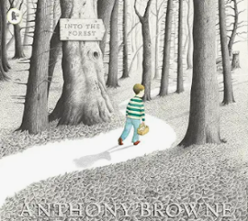 |  |  |  |  |  | –Varjak Paw – Said & McKean  (class set)    Look at the CLPE notes for teaching  this chapter book for ideas to link  to the reading of the text
Writing Outcomes | Watch Michael Rosen performing chocolate cake and discuss how he reads his poem aloud. Ask pupils to work in class/groups to perform part of this poem.  Give pupils poem such as The Car Trip or Hot Food and to prepare it for reading aloud.  Read Don’t and create a poem that could be shared with the other year 3 class about behavour! |  |  |  |  |  | Recount of finding the tomb through the eyes of a Egyptian waterboy – oral telling of a family member and then writing it down for posterity. Watch the clips about Carter  Role play to imagine the day that the entrance of the tomb was found and broken into. Explore what was found.  Time line/emotion graph the events and add all the emotions that the people might have felt. Create a role on the wall about the character of the person who is writing the diary. |  |  |  |  |  |  |  |  |  |  |  |  |  |  |  |  |  |  |  |  | Narrative chapter based when Varak Paw sees the cars for the first time.  This will include dialogue
Text knowledge & GPS | To focus on developing performance skills – emphasising key words, changing the volume and speed, projection.  Revisit accurate contractions |  |  |  |  |  | Revisit the structural layout and linguistic features of a diary – eg. first person, past tense, language appropriate to the character  Focus on cohesion so that the recount has a chronology and the use of appropriate emotive language to express feelings and reactions.  Use adverbials of time.

