 | Year 2 Writing overview 2025- 2026
Autumn Core Texts | Week 1 | Week 2 |  | Week 3 |  | Week 4 |  | Week 5 |  | Week 6 |  | Week 7 | Week 8 | Week 9 |  | Week 10 |  | Week 11 |  | Week 12 |  | Week 13 |  | Week 14
Autumn Core Texts | Animals |  |  |  |  |  |  |  |  |  |  |  | Hot and cold lands
Autumn Core Texts | Lottie Potter wants an otter – Willis  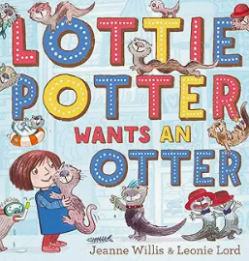  Teacher’s day in bed –  My Dog – Seigal  You Choose  Pet shop clip  100 dogs - | Negative views of dogs  Stay – Latimer  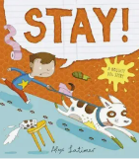  Can I be your dog – Cummings  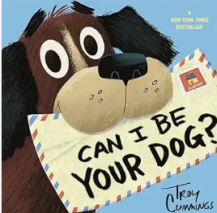 |  |  |  | Positive – Dogs that help us  The Present  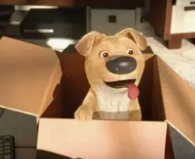 Guide dog short film   |  | Dread cat –  Rosen & Byrne  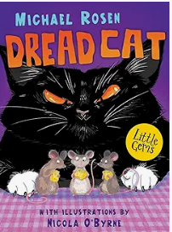 |  |  |  | Poems about animals – ed. Moses  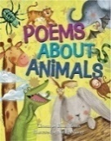 | Meercat Mail - Gravett  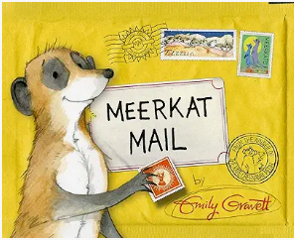  Clips about what Africa is like |  |  | Snail Mail – King Snail  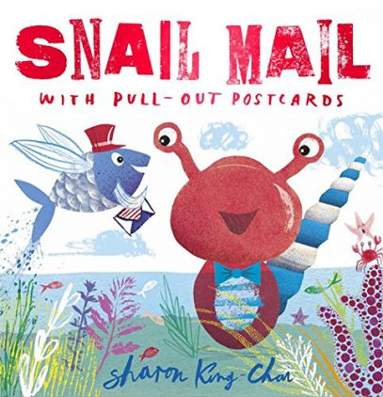  The Ultimate Book of African Joubert & Beverly  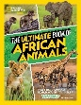 |  | Cold lands – Danny & the penguins  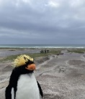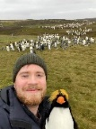  March of the penguins  Images from Young Zoologist – Emperor Penguin  Delightfully different Dilly –  Dale & Darcy  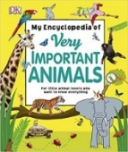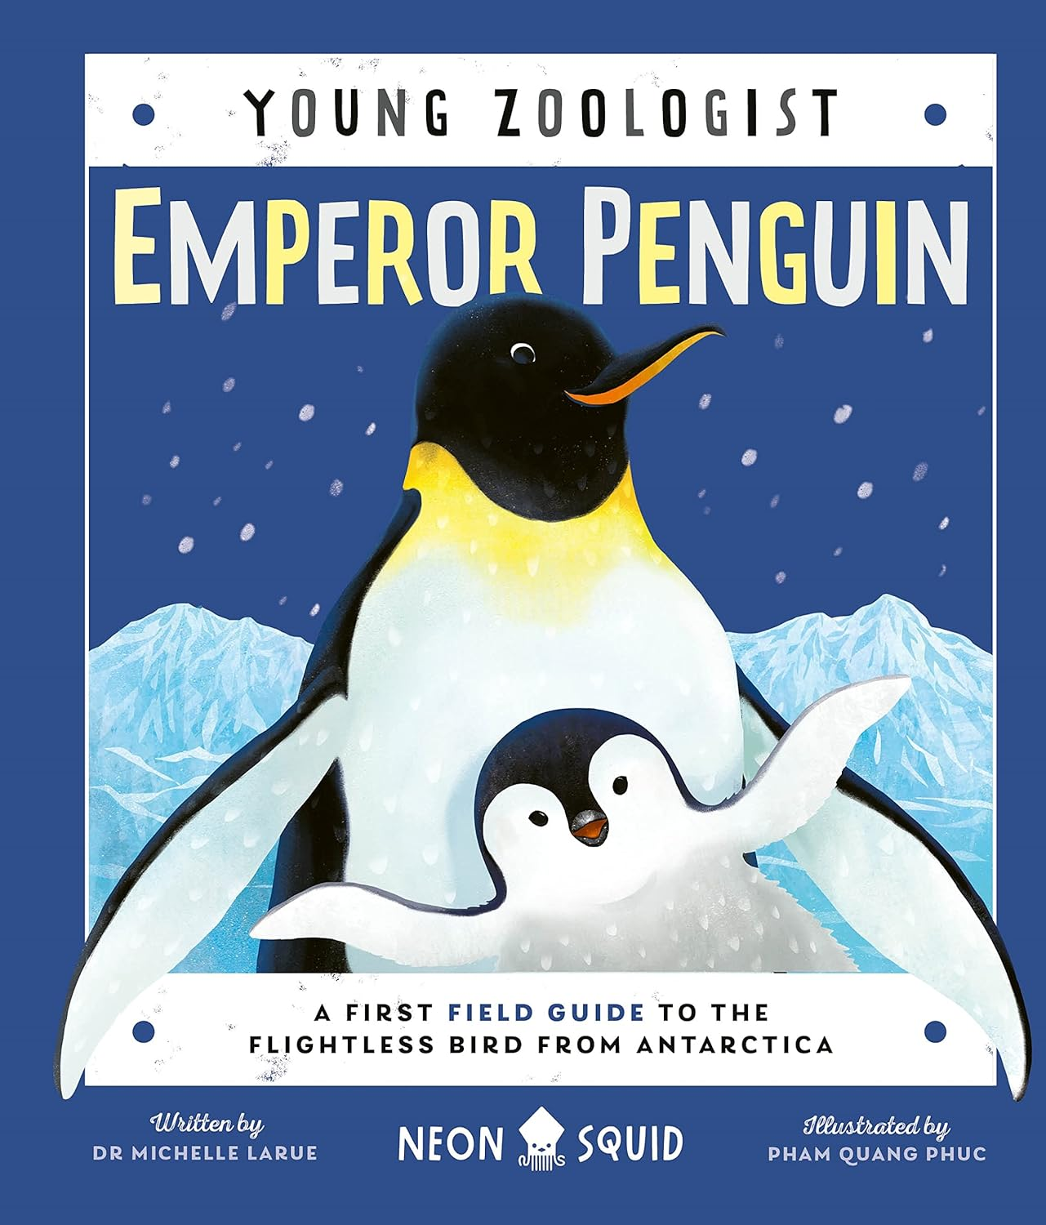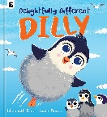  Very important animals – DK |  |  |  |  |  | A Christmas poem to send to Sunny Meercat and rocky the Penguin from Salford  Meerkat Christmas - Gravett  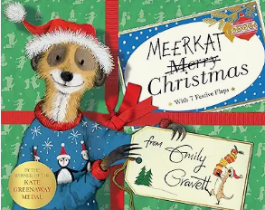
Writing Outcomes | To share List poem about a perfect pet  Read the poems and perform the ones that everyone agrees is their favourite. Read My Dog and reinforce the use of comparative and superlative adjectives. | Narrative of the story – a naughty dog story  Read them the story of Buster up to the point of the family going on holiday. Discuss all the terrible things that Buster does in the house/in the garden/on holiday. |  | A letter of forgiveness from Buster. Read the next few pages to the point that Buster has reeked havoc in the post office. Go into role as Buster begging the ‘family’ for forgiveness. Explicitly show them how to use contractions. |  | A character description about a guide dog who is really helpful. |  | Instructions for the mice so they can survive in the house when the cat is around |  |  |  | A poem about different animals based on the poem The Terrible Ten from the anthology above  Develop into a riddle. | Character description of Sunny  Simple sentences using correct punctuation, noun phrases, adverbs, conjunctions  Character description (personality/appearance)Simple sentences using correct punctuation, noun phrases  Use of conjunctions.(Introduce new ones), verb choices with adverbs |  |  | Read Snail Mail and look at what information would be about each country. Discuss postcards and their purpose. Collect ideas about what they know about Africa. Teacher pupils to write in demarcated sentences. Postcard about Africa that |  | Danny and Rocky become friends as they are both very lonely.  Use the photos of the penguins & Rocky to generate questions. Become penguin experts & create a simple penguin info page with caption / non chron - Gather information from their own knowledge, film clips and texts to learn more about dogs. Discuss how this can be organised into sections under different subheadings. Teach the children how to organise their knowledge.  Create a list of questions about penguins and model how to answer them in appropriate sentences under each of the subheadings. Pupils can focus on singular and plural rules with words that they can use within their information text. |  |  |  | Use the images of Rocky and create a story board about a lonely penguin who is desperate for friends. |  | Create a Christmas poem
Text knowledge & GPS | Yr 2: Consolidate Year 1 skills and expectations – demarcate different sentence types using capital letter, full stops, exclamation and question marks. Reinforce terminology – statement, question, exclamation & command. Use co-ordinating conjunctions and, but for extending sentences if appropriate. Use verbs and adjectives. |  |  |  |  |  |  |  |  |  |  | Use facial expressions and gesture when performing Identify and use question sentences within their riddle.  Use verbs to describe action of the animals. use noun phrases and verbs to describe | Yr 1: Use of co-ordinating conjunction and  Use adjectives to describe characters. Use of sub-ordinating conjunction because  Use superlatives to describe characters. |  |  | Use the layout of a postcard to give the reader interesting facts about Africa.  Use expanded noun phrases & superlatives to describe interesting facts. Use conjunctions to add details.  Yr 1: To use Capital letters for names of Proper Nouns |  | Use an appropriate layout for a non-chronological report with support eg. Heading, subheading, technical language.  Children use 4 different sentence types to impart the information eg. A question sentence.  Use of present tense verbs.  Use of conjunctions because, if, so  Recap possessive apostrophes eg. The dog’s food. |  |  |  | Use their story telling skills to impart the tale.Use the four different sentence types with growing accuracy.  Use past tense verbs with ed suffi.
Text knowledge & GPS | Speak in sentences and  hold a sentence  See simple sentences modelled  write sentences that include the subject &the verb. | Demarcate a simple sentence with capital letters and full stops .Use past tense verbs.  To use superlatives to capture the naughtiness of the dog. |  | Distinguish between statements and questions To use co-ordinating conjunction and to extend sentences. |  | use adjectives to describe the emotions and actions.  To use conjunction and to extend the descrption. Use simple adjectives to describe |  | Use the layout of an instruction text.  To use command sentences & present tense verbs.  To use co-ordinating and subordinating conjunctions to give extra information within each instructio
Spring Core Texts | Week 1 |  | Week 2 |  | Week 3 |  | Week 4 |  | Week 5 |  | Week 6 |  | Week 7 |  | Week 8 |  | Week 9 |  | Week 10 |  | Week 11 |  | Week 12
Spring Core Texts |  |  |  |  |  |  |  |  |  |  |  |  | Plants
Spring Core Texts | Scene from Happy Feet where the penguins are learning to fly  Flight school – Lita Judge  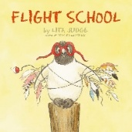  Clip from Chicken Run when they try to shoot the chickens out of the cannon to help them fly.  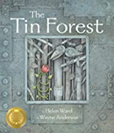 Tin Forest – Ward |  |  |  |  |  | Amelia Earhart: Level 2 (National Geographic Readers) - Gilpin  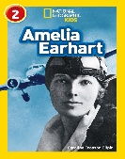  Little People Big Dreams – Amelia Earhart – Vegara  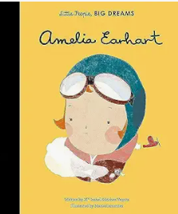  See file for clips about her life |  |  |  | Songs about flying  Eg. I believe I can fly  Come fly with me |  | My Bean Diary  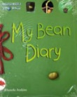  From Bean to Bean Plant – Ganeri  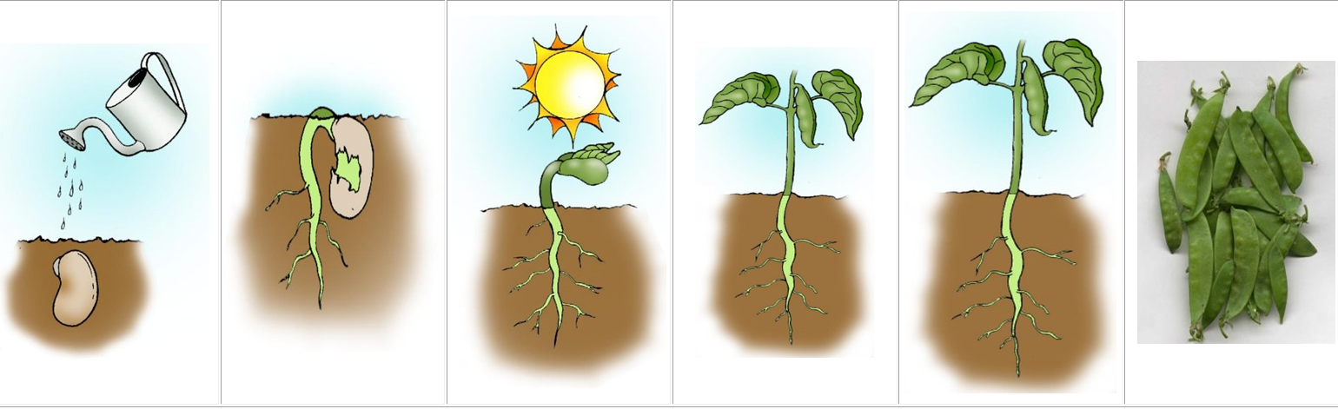 |  | Plant the tiny seed - Matheson  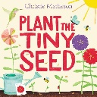  Five little beans  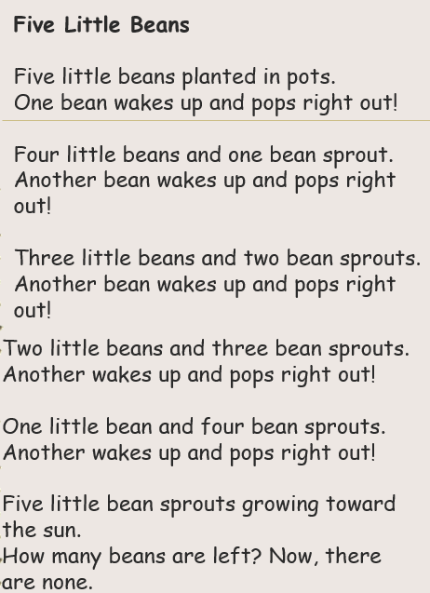  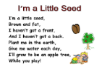 |  | Jack and the beanstalk – Alperin  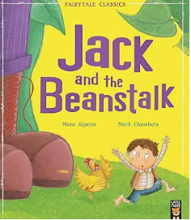  An alternative version eg.  Jim and the beanstalk – Briggs (a class set)  Jack and the Beanstalk – Gledhill /  Kate and the beanstalk – Osborne /  Jack and the Jellybean stalk – Mortimer  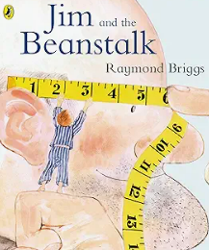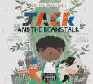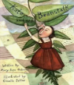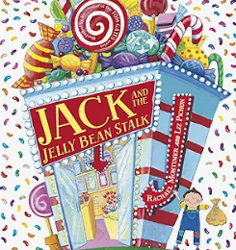
Writing Outcomes | Instructions – How to help Rocky the penguin fly Read the story Flight School to the point where they have tried lots of different ideas to help the penguin fly. Discuss which ones are the best and then look at the list the teacher has generated. Teach commas in a list. Discuss how they could create instructions to give to Danny so he could help Rocky to fly. |  | An exciting narrative based on what happened when Danny tried to help Rocky to fly.  Read the book Flight School again and recap on all the different ways to help Rocky to fly. Use props and a story map to capture the children’s story ideas about how they could write their own version but it would be about Danny and Rocky rather than this penguin. Use the same type of structure:  - Rocky wants to fly but he can’t.  - Danny tries different ways eg. a catapult, use a trampoline, Danny solves the problem by taking Rocky up in a fast jet (or the children create their own perfect ending)  During the journey visit the prefix un to explore how Rocky felt. |  |  |  | Create a simple fact file about the life and adventures of Amelia Earhart  Watch The British Airways advert to help pupils see how the aeroplanes have evolved over the last 100 years.  Watch clips about Amelia Earhart and discuss what they know about her. Predict what information the book Little People Big Dreams about Amelia Earhart might have in it. Create a simple timeline and then read the book. Can they add other important facts about her to it?  Create a list of questions about her life and model how to answer them in appropriate sentences (see WAGOLL for ideas)  During the learning journey pupils can focus on singular and plural rules with words that they can use within their information text. |  |  |  | Listen to songs about flying and talk about what it would be like to be able to fly.  Read them the poem Learning to fly and act out the different verbs  Model how to use these to create their own poem |  | Diary of a bean Plant the bean. Watch the bean every day and make drawings/take photos.  Create a simple diary of growth. |  | Recite the pages from the book to follow the ‘instructions’ for planting the tiny seed.  Read lots of seed/plant poems  Work as a class to make a simple list poem about 5 little seeds eg.  5 little seeds pushing to the sky …  1 little seed waiting in the sun |  | Read the original story and acti it out. Create a simple story map of the original story  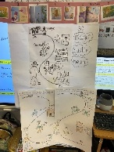  Make sure children are very secure with this. Act out being the giant – fee, fi, fo,fum and then describe how frightening he is  Do a Beware poster of the giant character study of the giant focusing on how horrible he is. |  | Share other versions of the story and work with pupils to innovate their own version of the story about a new version of Jack, the giant and what he stole.  Innovated version of Jack and the beanstalk
Design a seed packet
Look at lots of different sorts of seed packets for ideas.
Create a magical seed packet showing what amazing plant their seed will grow.
Text knowledge & GPS | Pupils are shown how to structure instructional writing. Eg Heading, chronological steps, time order and present tense verbs with ing suffixes to describe what to do with the penguin. |  | Use their story telling skills to impart the tale.  Use the four different sentence types with growing accuracy.  Use past tense verbs with ed suffix consistently to retell the story.  Use of the prefix ‘un’ – Rocky was unhappy. The birds were unkind. It was unfair. He could not fly! He felt so unlucky. |  |  |  | With support, use their knowledge of heading and subheadings (questions subheadings) to help organise the information for the reader.  To use past tense verbs with ed endings with growing accuracy.  To make some use of –s and –es to form regular plurals correctly.  Use of a variety of conjunctions to give more detail within each sentence. |  |  |  | Use present tense verbs with ing suffixes to describe learning to fly.  Use questions marks with growing confidence in their sentence structuring |  |  |  | Use present tense verbs to describe the actions of the seed in the poetic lines. |  | Explore the prefix un when describing the giant on the poster.  Eg unkind, unfair, unwise  apostrophe for possession eg. He climbed down the Giant’s beanstalk. |  | Pupils use first, then, next, so and finally to help them construct this part of the story.  Revisit adjectives and superlatives used within this block of learning eg. It grew taller and taller. The tallest beanstalk in the world!  Use commas in a list to show how many ways they could try to help Rocky..

Summer Core Texts | Week 1 | Week 2 | Week 3 | Week 4 | Week 5 | Week 6 | Week 7 | Week 8 | Week 9 | Week 10 | Week 11 | Week 12
Summer Core Texts | Growth |  |  |  |  | Oh I do like to be beside the seaside!
Summer Core Texts | Hair Love – Cherry  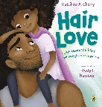  Hair – Zetter |  | Godfrey is a frog – Latimer  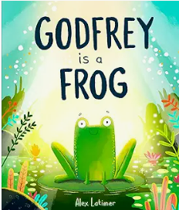 |  |  | Stella and the seagull – Stevens & Burton  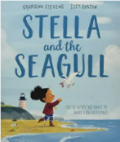  Clean up – Bryon & Adebo  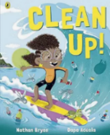 |  |  | Seaside Poetry – Ed. Moses  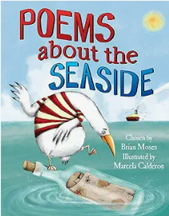 | Look what I found at the seaside – Butterfield & Verona 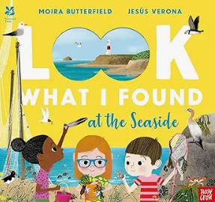  Clips of the seaside and  rock pooling
Writing Outcomes |  |  |  |  |  | Retell the beginning of the story to show what good friends Stella and the seagull are and make the reader feel sorry for the seagull.  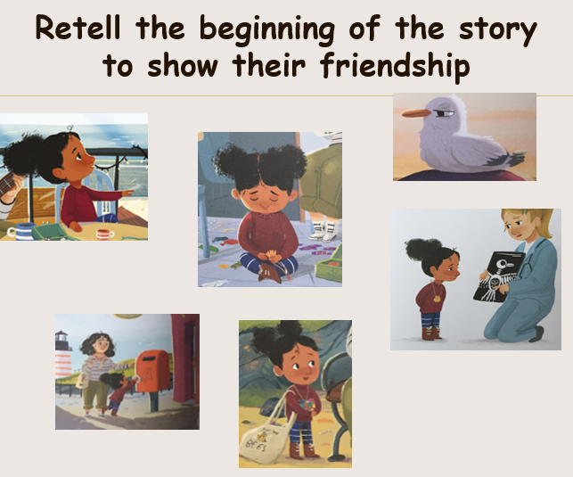 | Diary of Stella – to capture how she felt when she found her best friend the seagull really poorly. | Persuasive posters about cleaning up the beach / Persuasive letter to the chocolate factory persuading them to stop creating their packaging. | Performing the seagull poem  Write a poem based on the Seagull Song poem | A leaflet about the seaside that will include all the key information.
Text knowledge & GPS | Yr 2: Opportunity to consolidate the end of KS 1 standards for sentence level and word choice independently. To write coherently with accurate demarcation using the different sentence types and punctuation marks. Use appropriate past and present verb tenses. Use co-ordinating and subordinating conjunctions. Ensure pupils have the opportunity to use commas in a list, apostrophe for possession/contraction and use a variety of suffixes to secure GD if appropriate.
Text knowledge & GPS |  |  |  |  |  | Yr 1: To use the four different sentence types within the writing.  Use correct use of past tense verbs within narrative writing.  Use past tense  Use appropriate adjectives and verbs to bring the story to life (extend more able with adverb) | Use of the contracted form to show how Stella felt about her little friend eg. I’m worried…. | To extend more able – introduce words such as hopeful, | To develop their poetry performance skills.  To use present tense verbs to describe the actions of the seagulls. | To use expanded noun phrases/ superlatives to describe the seaside.

