Year 1 overview 2025 2026
 | Week 1 | Week 2 |  |  |  |  | Week 3 |  |  |  | Week 4 |  |  |  |  | Week 5 |  |  | Week 6 |  |  |  |  | Week 7 |  |  | Week 8 |  |  |  |  | Week 9 |  |  |  |  | Week 10 |  |  | Week 11 |  |  |  |  | Week 12 |  |  |  | Week 13 |  |  |  | Week 14
Autumn Core texts | Entering KS 1 / This is me & my local Area |  |  |  |  |  |  |  |  |  |  |  |  |  |  |  |  |  |  |  |  |  |  |  |  |  | Aspiration  Special people in my local area
Autumn Core texts | 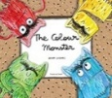  The Colour Monster - Llenas  The colour monster goes to school – Llenas  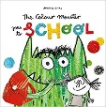  I am …. & A great big cuddle – Rosen’s  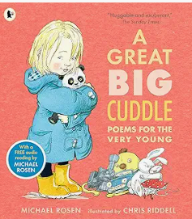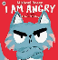 |  |  |  |  |  | Lonely Beast – Judge  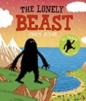  Promotional clip of The Lonely Beast  See the PowerPoint of the floor book and outcomes for guidance |  |  |  |  |  |  |  |  |  |  |  | Maya’s Walk – Butterfield & Geyer  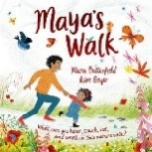  In every house on every street – Hitchman  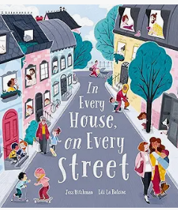  A walk around the  local area |  |  |  |  |  |  |  | You Choose –  Goodhart & Sharratt  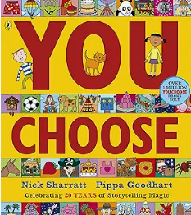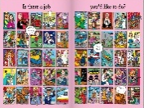  Invite parents/members of the community to interview about their job  When we grow up – Walsh  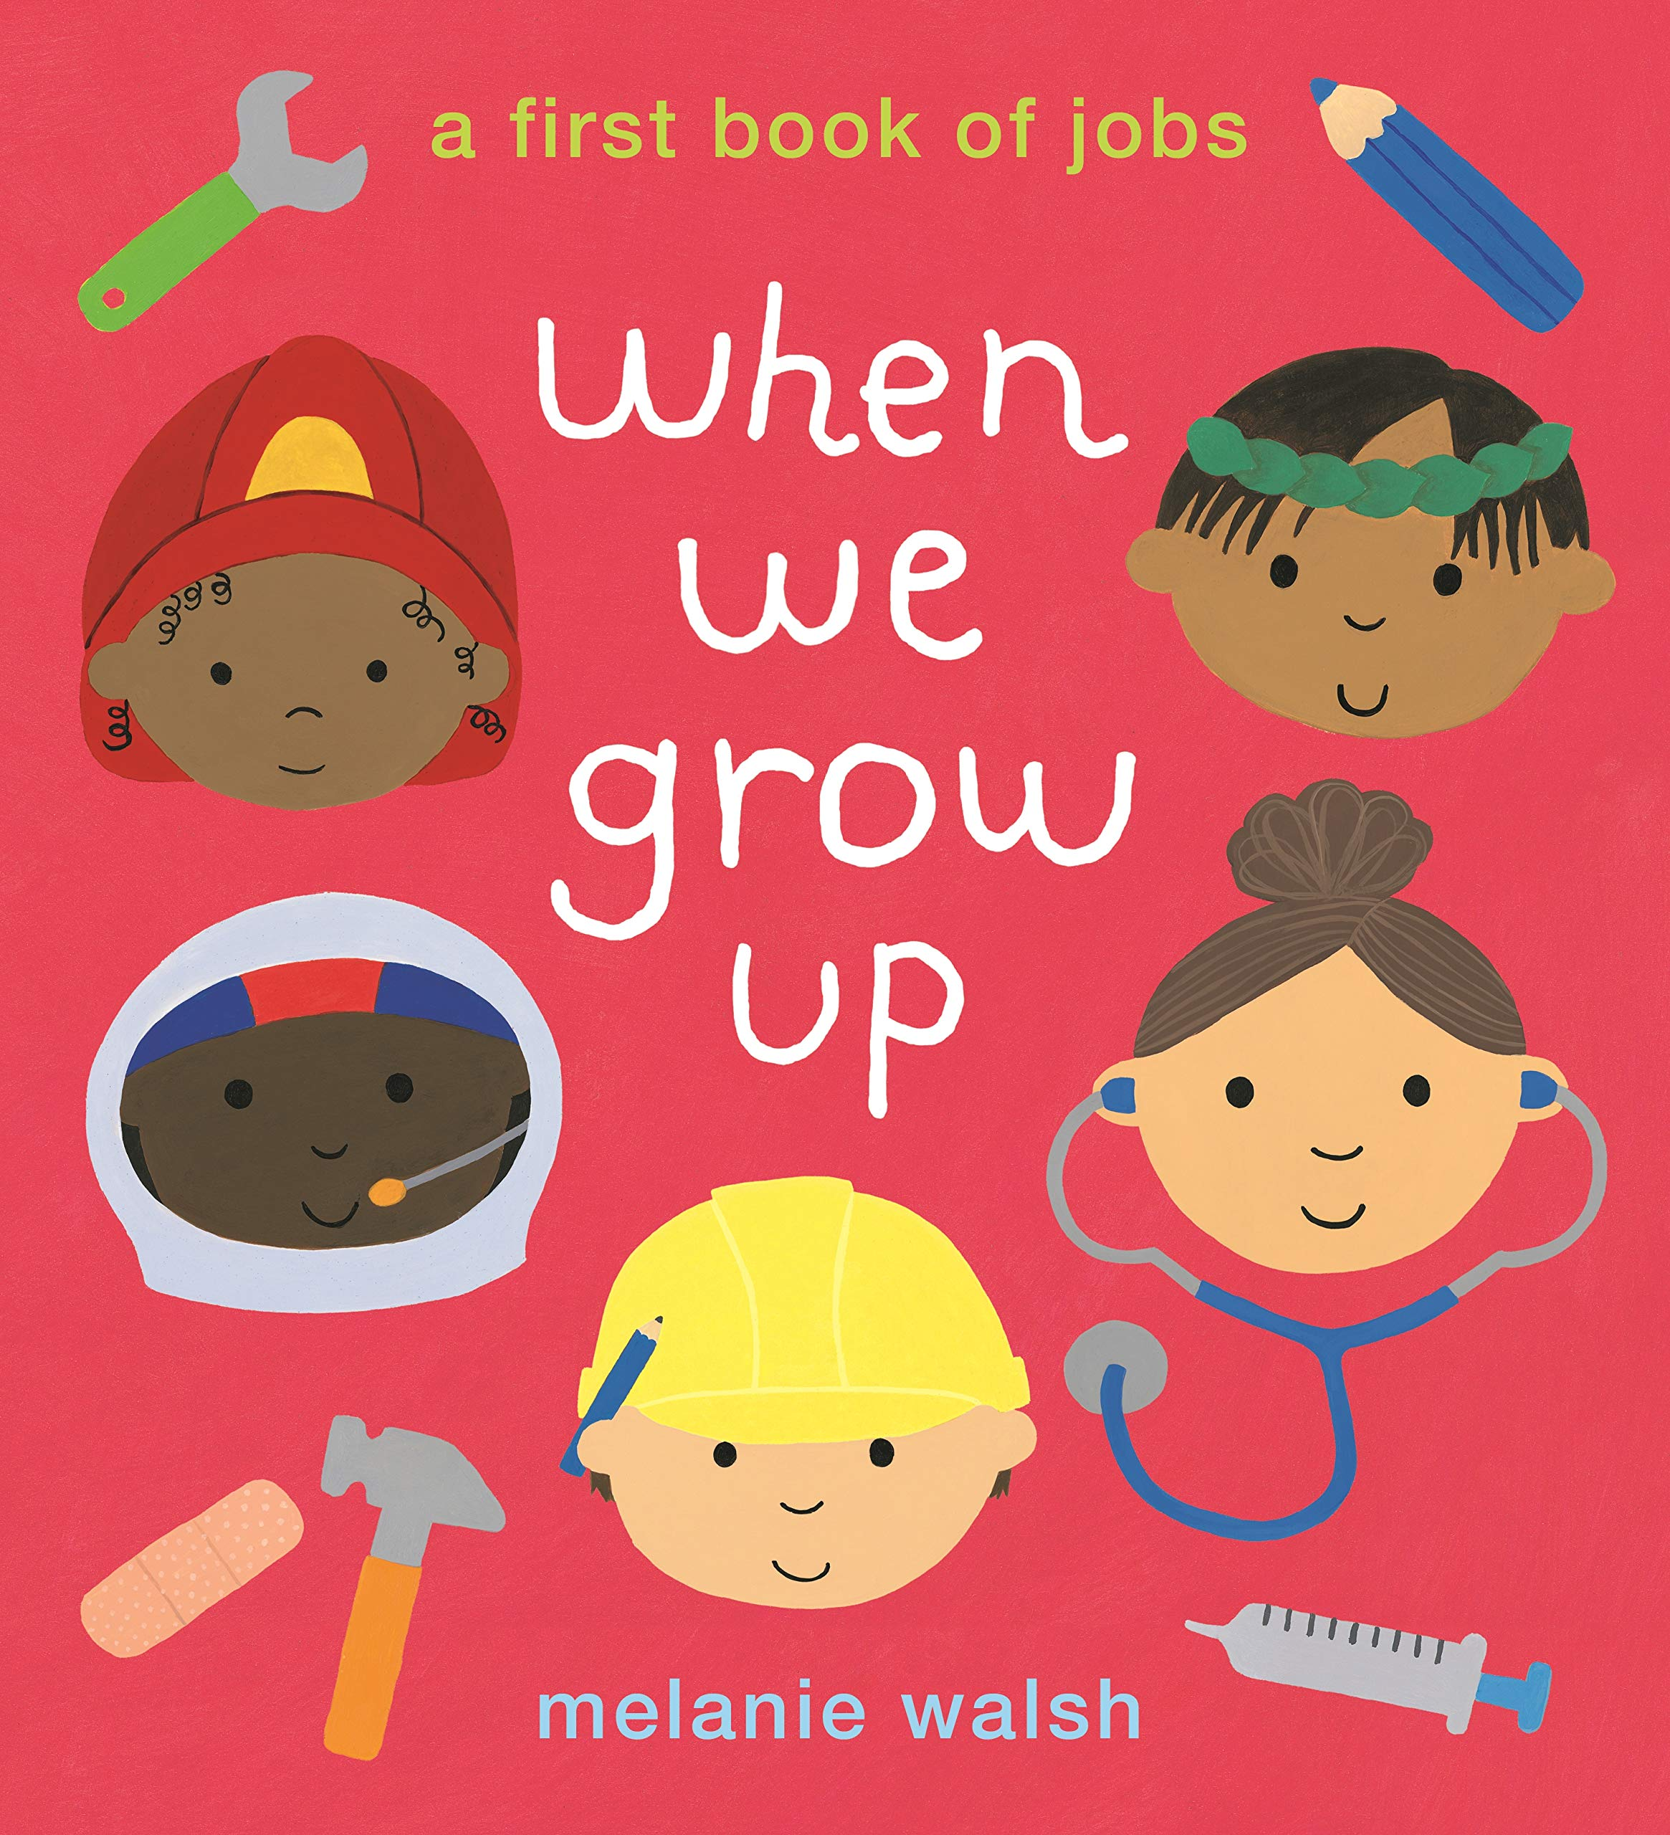 |  |  |  |  |  |  |  |  |  | Collect books about the different professions that would be in the local area  Eg books from the Busy People series  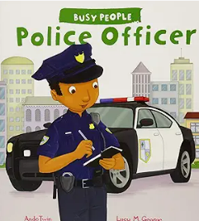  Or Community Helpers meet and respect policeman  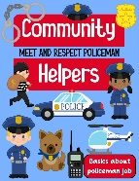 |  |  |  |  |  |  |  | Basil dreams big  Fraser and Warburton  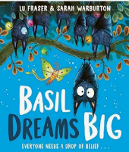 |  |  |  |  |  |  |  | The littlest Yak – Fraser and Hindley  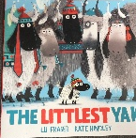
Writing Outcomes | Share the pop up version with them. Discuss how they think he is feeling on the different pages. Each day focus on a different mood.  Say simple sentences to describe how the monster feels.  See Literacy Shed Plus unit of work:  Share other books about different feelings with the chidren .  Share the poems and act them out. Take photos of the children acting out the different emotions and also capture the through emojis that can be used whenever they are discussing feelings. Create list poems like the Rosen poems. |  |  |  |  |  | Simple character description from the first time the children see the Beast (after watching the promotional advert) and read the first page of the book. See his foot prints in the yard.  Watch the clip and tell the children that he was near the school and then the teacher found a book all about him and share the first page.  Eg . He is big. He is black. He likes cake. He likes tea.  Story map leading to simple narrative of the journey – children act out the journey in the hall or outside with equipment – story map this, orally retell and write simple sentence.  Speech bubble as someone in New York who is frightened of the Beast eg. I am scared. He is big.  Letter to invite the Beast to come to the school so they can be his friend..  A simple booklet (possible geography outcome) all about the local area to tell the Beast why he should come to visit (linked to geography topic) |  |  |  |  |  |  |  |  |  |  |  | A walk around the local area to find out what the community is like. Take photos.  Share Maya’s walk and create a time line of what they saw when they walked around the school.  Simple sentence recounting the visit.  I saw a ………  Introduce the idea of noun and adjective. Eg. The house was big.  Ensure that the children use the past tense verb.  Share ‘In every house on every street’ with the children – Talk about their own houses on their streets and look closely at the images from the book. Label a picture with what people do in their house.  The Dad cooked. The boy sang. |  |  |  |  |  |  |  | Teacher tells the class what they wanted to be when they grew up. Use the You Choose picture to talk about jobs.  Invite parents and friends of the school to talk about their jobs.  Ask them questions and show the questions written down. Eg What is your job? Where do you work? Why do you like it?  Simple sentences about what they would like to be when they grow up. |  |  |  |  |  |  |  |  |  | The class will meet lots of different people from the community and then will follow their interests to learn more about specific people eg. a builder, a hairdresser, a dentist, a doctor.  A simple fact file about different jobs using their knowledge from the visitors and the books/clips that they have seen. |  |  |  |  |  |  |  | Instructions for helping Basil fly/ Letter to Basil telling him not to give up and giving him advice about how to fly. |  |  |  |  |  |  |  | A character description of Gertie the Littlest Yak including superlatives.  Eg. The yak was the littlest. She was the quietest.  A speech bubble as Gertie telling the littler Yak that it s okay to be small.
 |  |  |  |  |  |  |  |  |  |  |  |  |  |  |  |  |  |  |  |  |  |  |  |  |  |  |  |  |  |  |  |  |  |  |  |  |  |  |  |  |  |  |  |  | Write an exciting part of the story where Basil is saved by the moth when the storm comes.
A simple list poem capturing the story – when Basil can’t fly and then when he can. Act out the different verbs to ensure they know what they mean. (see PowerPoint for a model to work towards )
He fell.
He flapped.
He zoomed.
He swooped.

Text knowledge & GPS | Hold a sentence, say a sentence.  Demarcate simple repetitive sentences using capital letters and full stops.  eg. He is sad. He is cross. |  |  |  |  |  | Demarcate simple sentences reinforcing the notion of a sentence giving a new piece of information. Check that the sentences make sense. Use Capital letters for names.  Use simple adjectives to describe the Lonely Beast. |  |  |  |  |  |  |  |  |  |  |  | Use the personal pronoun I with capital letter. |  |  |  |  |  |  |  | Write a series of sentences with capital letters and full stops to demarcate.  Begin to use question sentences. |  |  |  |  |  |  |  |  |  | Use ‘and’ to join ideas in sentences. |  |  |  |  |  |  |  | Use past tense sentences within their writing using appropriate suffix.  To use exclamation sentences. |  |  |  |  |  |  |  | Use simple adjectives effectively. Use past tense verbs to capture the adventure.  superlatives to show how an adjective can be used to
Spring Core Texts | Week 1 |  | Week 2 |  |  |  |  | Week 3 |  |  |  | Week 4 |  |  |  |  | Week 5 |  |  |  |  | Week 6 |  |  |  | Week 7 |  |  | Week 8 |  |  |  | Week 9 |  |  |  |  | Week 10 |  |  |  |  | Week 11 |  |  |  |  | Week 12 |  |  |  | Week 13
Spring Core Texts | Welcome to fairy tale land |  |  |  |  |  |  |  |  |  |  |  |  |  |  |  |  |  |  |  |  |  |  |  |  | Seasonal Change
Spring Core Texts | You choose Fairy Tale – Goodhart & Sharratt  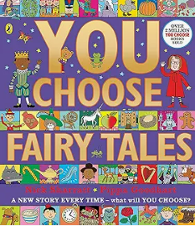  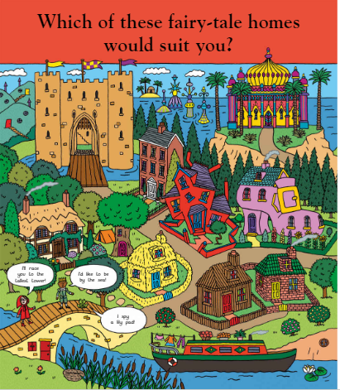 |  |  | The Gingerbread Man  (an appropriate version)  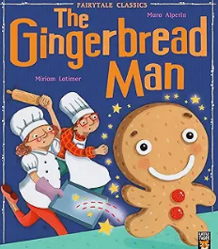  The gingerbread bunny – Allen  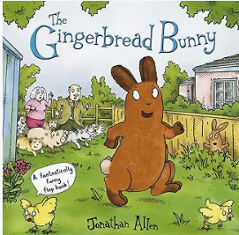 |  |  |  |  |  |  |  |  | Appropriate texts:  Three Billly Goats Gruff  Three Little Pigs |  |  |  |  | Directions through a fairy tale – Julie Anna Douglas  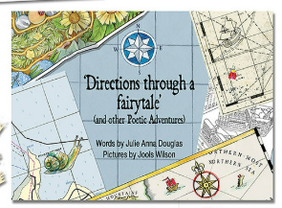 |  |  |  |  | Rain, Snow & Shine / Weather and the seasons – DK  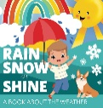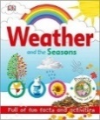 |  |  | The friend the Weather Monster – Smallman & Merz  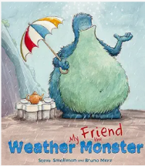 |  |  |  |  |  |  |  | Rain  The little Raindrop – Gray  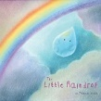  The Big Umbrella & clip  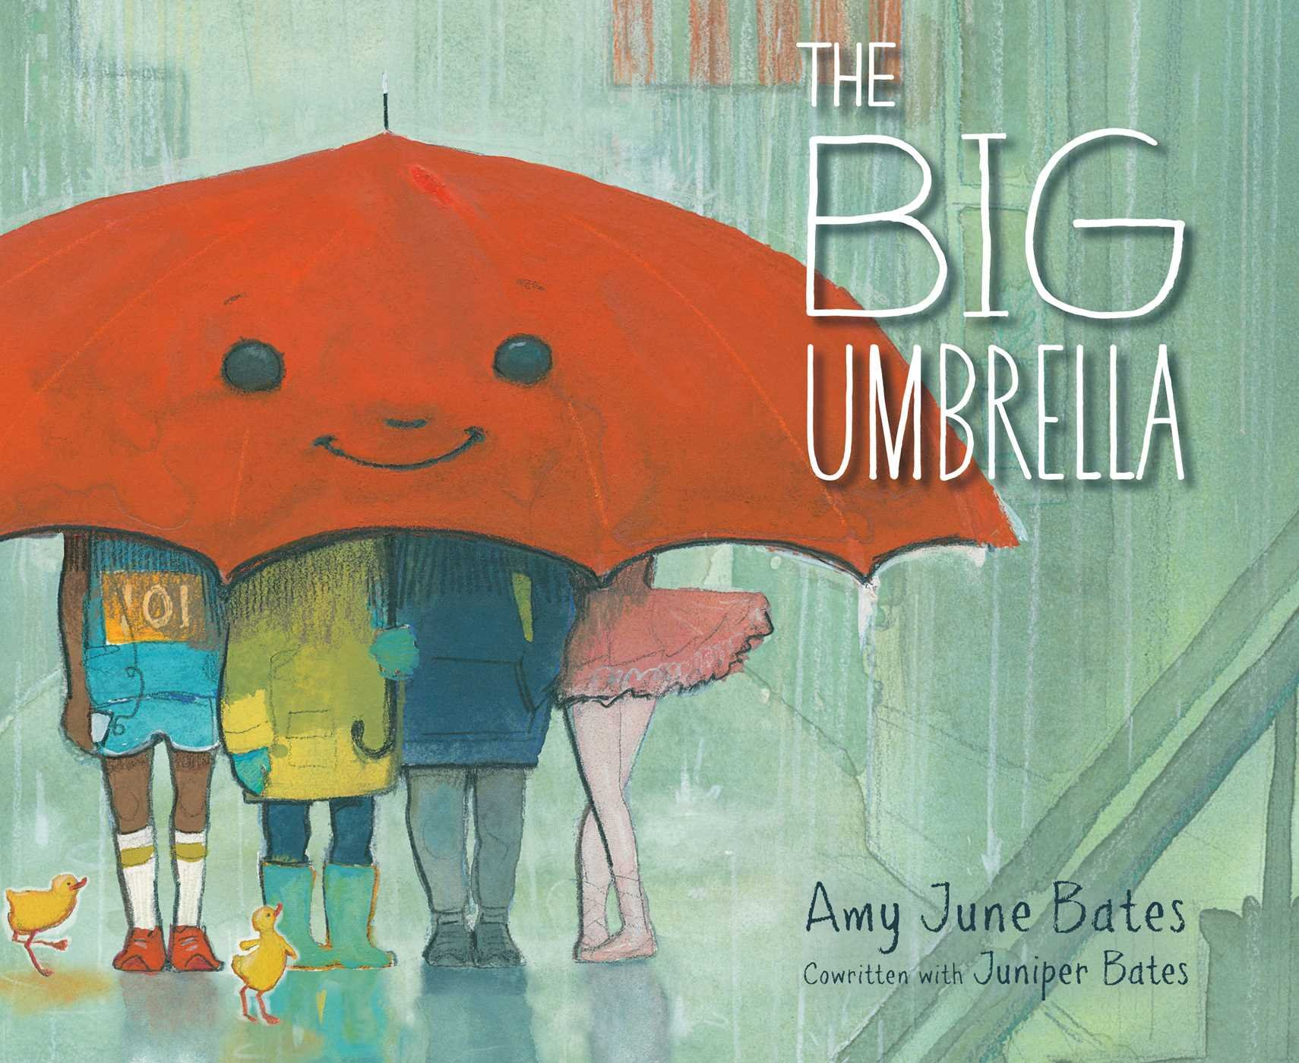  Poems/song  Raindrops keep falling on my head  I’m singing in the rain  I hear thunder |  |  |  |  |  |  |  |  |  | Out and about – a first book of poems - Hughes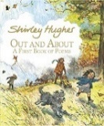  Eg Wind, Winter  Watch What is the wind  The wind blew – Hutchins  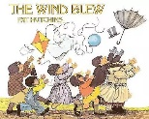 |  |  |  |  |  |  |  | What is the wind ?  (clip capturing the lines of the poem)  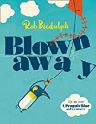  Blown away – Biddulph
Writing Outcomes | Show children the map of all the different places in Fairy Tale land and discuss who might live in the different houses. Show them different books of the different stories. Act them out and find out their favourites |  |  | Retell the story with props  Innovate the story eg. Pizza Man  Change the ending eg. a frog or a spider  Instructions for making a gingerbread man – follow them. Order them.  A speech bubble from a burnt gingerbread man. |  |  |  |  |  |  |  |  |  |  |  |  |  | Show them the map of Fairy Tale land and the page from Yu from the poetry book and create a huge ‘map’ in the |  |  |  |  | Daily diary of the weather monster – a sentence about the weather  A sentence about the clothing you wear in different features |  |  | Look at pages from facts books about the weather and discuss the different weather that we are having – link to science & create a weather diary. |  |  |  |  |  |  |  | A simple story about the little raindrop and what happens to it. |  |  |  |  | Read The Big Umbrella & watch it  Create their own umbrella and a description about what it does based on the story  Eg. It can stop the rain. It can .. |  |  |  |  | Share some of the poems  Read them the poem  Wind – Hughes  Watch clips of the wind ‘What is the wind’ for ideas about different sorts of wind and collect ideas. Create a wind poem  Create a short film clip with the pupils’’ voices speaking out the lines from their poems |  |  |  |  |  |  |  | Act out part of the story and then adapt it to be about a Penguin Blue and his kite flying around the school.
 |  |  |  |  |  |  |  |  |  |  |  |  |  |  |  |  |  |  |  |  |  |  |  |  |  | Description of the weather monster |  | Speech bubble as Tom asking for the beast’s help
Text knowledge & GPS | Revisit all the skills used in the autumn term in writing to help children consolidate understading of sentence structure, use of verbs, adjectives and supelatves |  |  |  |  |  |  |  |  |  |  |  |  |  |  |  |  |  |  |  |  |  |  |  |  | Describe the Weather Monster and his feelings using simple adjectives.  Use the conjunction but to show pupils how a clause can be followed by a conjunction that then gives us the opposite piece of information  Eg. He is big but he is friendly. |  | Question sentences with capital letter and question mark. |  |  |  |  |  | Sequence demarcated sentences to capture the actions of the little raindrop. |  |  |  |  | Noun phrases to describe the umbrella  Eg.It is a green umbrella. |  |  |  |  | Use adjectives to describe the different types of weather.  Develop their presentation skills – opportunity to use facial expressions and gesture when performing their wind poetry and play with the volume of their voice in front of an audience. |  |  |  |  |  |  |  | Use exclamation sentences to capture the voice of the penguin. Write a sequence of sentences to form a short narrative.  Use simple prepositions to expand the story.
Summer Core Texts | Week 1 |  |  |  | Week 2 |  |  |  | Week 3 |  |  |  |  |  | Week 4 |  |  |  |  |  | Week 5 |  |  |  | Week6 |  |  |  |  | Week 7 |  |  |  |  | Week 8 |  |  |  |  |  | Week 9 |  |  |  |  | Week 10 |  |  |  | Week 11
Summer Core Texts | To be developed
Writing Outcomes

Text knowledge & GPS

