sd | EYFS Overview working document 2025 2026
Autumn Core Texts | Week 1 |  |  | Week 2 |  |  |  |  | Week 3 |  |  |  |  |  |  | Week 4 |  |  |  |  |  | Week 5 |  |  |  |  | Week 6 |  |  |  |  | Week 7 | Week 8 |  |  |  |  | Week 9 |  |  |  | Week 10 |  |  |  | Week 11 |  |  |  | Week 12 |  |  |  |  | Week 13 |  | Week 14
Autumn Core Texts | All about me (Me and my family) |  |  |  |  |  |  |  |  |  |  |  |  |  |  |  |  |  |  |  |  |  |  |  |  |  |  |  |  |  |  |  |  | Stories and songs from all around
Autumn Core Texts | Who am I? | Action rhymes |  |  |  |  | Emotions |  |  |  |  |  |  |  |  |  |  |  |  | Our home |  |  |  |  |  |  |  |  |  | We are family |  |  |  | Halloween Celebration  bonfire nigh |  |  | Journeys through stories |  |  |  |  |  |  |  |  |  |  |  | Christmas & celebrations
Autumn Core Texts | Happy in our skin – Manushkin  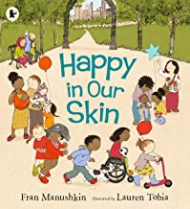  What will Danny do today? Goodhart  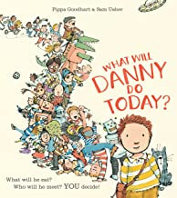 | Tom Thumb  One Finger one thumb/  Head shoulder  Knees and Toes  Do your ears hang low? |  |  |  |  | The colour monster – Llenas  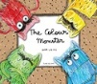  What I like – Anholt  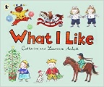  If you’re happy and you know it clap your hands |  |  |  |  |  |  |  |  |  |  |  |  | In every house on every street - Hitchman  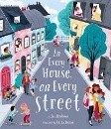  Jill Murphy books about families:  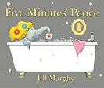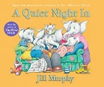  On top of spaghetti |  |  |  |  |  |  |  |  |  | Wanting to be part of a family:  Aarghh Spider!– Monk  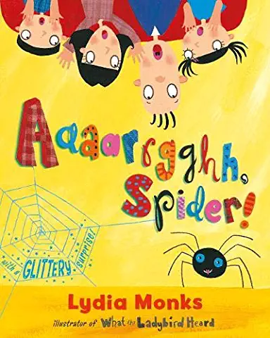 Incy Wincy Spider |  |  |  | Room on the broom Donaldson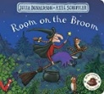 |  |  | The Bear Hunt-  Rosen & Oxenbury  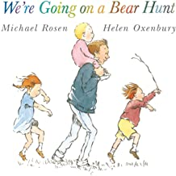 |  |  |  | Little Red Riding Hood – Lady bird  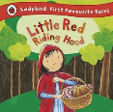 |  |  |  | Handa’s surprise - Browne  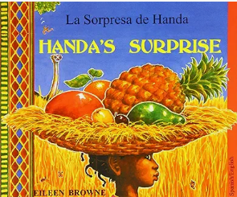  Handa’s Naughty Night  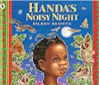 |  |  |  | Ten Little Superheroes – Brownlow & Rickerty  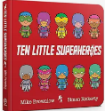  10 little elves 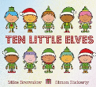 |  |  |  |  | Celebrations:  Christmas – Dickmann    My Divali – little Nippers  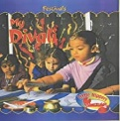  Dear Santa – Campbell  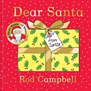  Twinkle Twinkle  little star
Nursery Learning objectives | Continue developing positive attitudes about the differences between people  Sing a large repertoire of songs |  |  |  |  |  |  |  |  |  |  |  |  |  |  |  |  |  |  |  |  |  |  |  |  |  |  |  |  |  |  |  |  | Continue to listen to longer stories and remember much of what happened
Nursery Learning objectives | See ourselves in the world – oracy about  differences & similarities. | Know many rhymes  join in the actions (ongoing). |  |  |  |  | Talk about feelings using words like happy, sad and angry.  Show different emotions in their drawings and paintings  Introduce the work of artists to explore feelings / look at photos of families and feelings.  Begin to make sense of their own life story and family’s history.  Continue developing positive attitudes about the differences between people |  |  |  |  |  |  |  |  |  |  |  |  | Begin to understand the 5 key concepts of print (ongoing): Orientating around a book - modelling reading  Engage in conversation about the different families in the text  Enjoys listening to longer stories and can remember much of what happens |  |  |  |  |  |  |  |  |  | Understand gradually how others might be feeling |  |  |  | Continue developing positive attitudes about the differences between people  (celebrate and value cultural, religious and community events and experiences) |  |  | Know many rhymes.  Talk about familiar books. Be able to tell a long story and sequence it.  Use a wider range of vocabulary – explain unfamiliar words and concepts. Begin to develop complex stories using small world. |  |  |  |  |  |  |  | Use images of the local area to talk about the community and its features  Make imaginative and complex ‘small worlds’ with blocks and construction kits. |  |  |  |  |  |  |  |  | Continue developing positive attitudes about the differences between people  (Celebrate and value religious and community events and experiences)
Nursery Learning objectives | Week 1 |  | Week 2 |  |  |  |  | Week 3 |  |  |  |  |  |  | Week 4 |  |  |  |  |  | Week 5 |  |  |  |  | Week 6 |  |  |  |  | Week 7 |  | Week 8 |  |  |  |  | Week 9 |  |  |  | Week 10 |  |  |  | Week 11 |  |  |  | Week 12 |  |  |  |  | Week 13 |  | Week 14
Nursery Learning objectives | All about me (Me and my family) |  |  |  |  |  |  |  |  |  |  |  |  |  |  |  |  |  |  |  |  |  |  |  |  |  |  |  |  |  |  |  | Stories and songs from all around
Nursery Learning objectives | Who am I? |  | Action rhymes |  |  |  |  | Emotions |  |  |  |  |  |  |  |  |  |  |  |  | Our home |  |  |  |  |  |  |  |  |  | We are family |  | Halloween Celebration  bonfire nigh |  |  |  |  | Journeys through stories |  |  |  |  |  |  |  |  |  |  |  | Christmas & celebrations
Nursery Learning objectives |  |  | O dear, look what I got – Rosen & Oxenbury  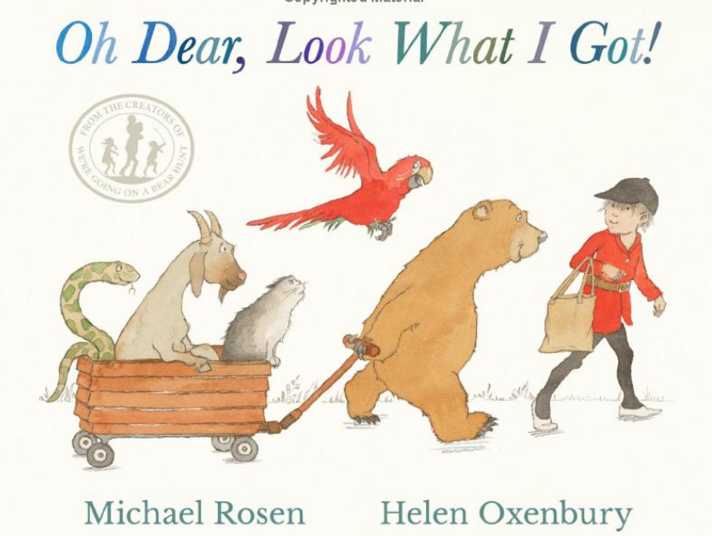 |  |  |  |  | The colour monster – Llenas |  |  |  |  |  |  | The Last Noo Noo – Murphy  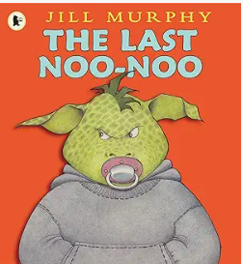 |  |  |  |  |  | Peace at last – Murphy  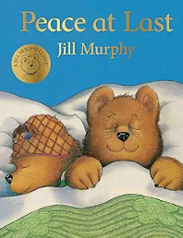 |  |  |  |  | Melt down – Murphy  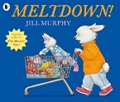 |  |  |  |  | Not now Bernard – McKee  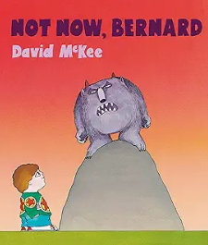 |  | Witch’s Kitchen -  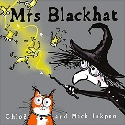  Pumpkin Soup – Cooper  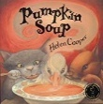  Room on the broom – Donaldson  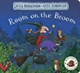 |  |  |  |  | Three billy goats Gruff – Alperin  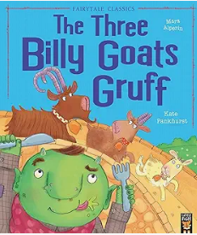 |  |  |  | Three little pigs –  Ladybird  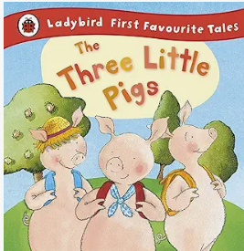 |  |  |  | Goldilocks - Wade  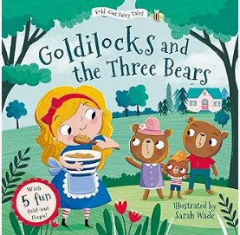  Goldilocks and the three bears – Davidson  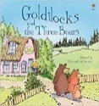 |  |  |  | On the way home – Murphy  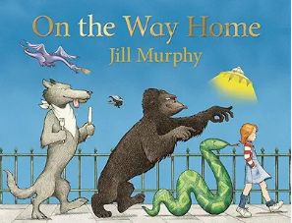 |  |  |  |  | Binny’s Diwali – Umrigar & Chanani  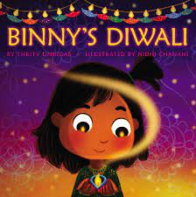
Reception Learning objectives | Talk about members of their family and immediate community.  Name and describe people that are familiar to them.  see themselves as a valuable individual.  Express their feelings and the feelings of others.  Show an understanding of their own feelings and those of others.  Make comments about what they have heard and ask questions to clarify their understanding  Listen attentively and respond to what they hear with relevant questions  Ongoing – sing a range of well-known nursery rhymes and songs |  |  |  |  |  |  |  |  |  |  |  |  |  |  |  |  |  |  |  |  |  |  |  |  |  |  |  |  |  |  |  |  | Know some similarities and differences between different religious and cultural communities … |  |  | Demonstrate understanding of what has been read to them by retelling stories and narratives using their own words and recently introduced vocabulary.  Anticipate where appropriate key events in stories. |  |  |  |  |  |  |  |  |  |  |  |  |  |  |  |  | Know some similarities and differences between different religious and cultural communities in this country drawing on their experiences and what has been read in class. (ongoing)
Reception Learning objectives |  |  |  |  |  |  |  |  |  |  |  |  |  |  |  |  |  |  |  |  |  |  |  |  |  |  |  |  |  |  |  |  |  |  |  |  | Describe their immediate environment using knowledge from observation, discussion, stories, non-fiction texts and maps. |  |  |  |  |  |  |  | Know some similarities and differences between the things in the past and now drawing on their experiences and what has been read in class  Understand the past through settings, characters and events encountered in books read in class and storytelling.
Wrap-around texts | Reference book for using across the provision and with children:  Barefoot book of children – You Choose- Sharratt A great big cuddle – Rosen  Strickland, DePalma & Dean  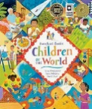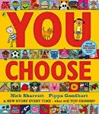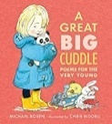 |  |  |  |  |  |  |  |  |  |  |  |  |  |  |  |  |  |  |  |  |  |  |  |  |  |  |  |  |  |  |  |  | The best birthday present ever - Mantle One Snowy Night – Butterworth  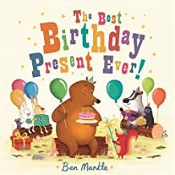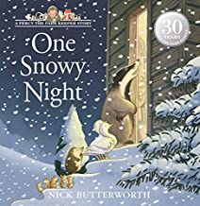
Spring Core Text | Week 1 |  |  |  | Week 2 |  |  |  |  | Week 3 |  |  |  |  |  |  | Week 4 |  |  |  |  |  | Week 5 |  |  |  |  |  | Week 6 |  |  |  | Week 7 |  |  |  |  |  | Week 8 |  |  |  | Week 9 |  |  |  | Week 10 |  |  |  | Week 11 |  |  |  |  | Week 12
Spring Core Text | Winter |  |  |  |  |  |  |  |  |  |  |  |  |  |  |  |  |  |  |  |  |  |  |  |  |  |  |  |  |  |  |  | People who help us |  |  |  |  |  |  |  |  |  |  |  |  |  |  |  |  |  |  |  |  |  |  | Easter
Spring Core Text | Winter & Snowy clothes |  |  |  | What we do in the snow |  |  |  |  | Winter in other lands |  |  |  |  |  |  | Animals from cold lands |  |  |  |  |  | Animals from cold lands |  |  |  |  |  | Chinese new year |  |  |  | In school |  |  |  |  |  | Community |  |  |  | People we visit who help us |  |  |  | Emergency helpers |  |  |  | Farm  Superhero
Spring Core Text | Here Comes Jack Frost - Kohara  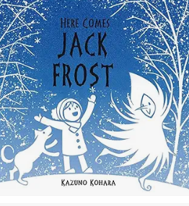 Jack Frost – Harker Stickman – Donaldson  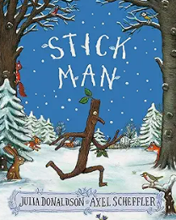 |  |  |  | Spot’s snowy day.  You choose – Christmas – Goodhart & Sharratt  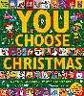  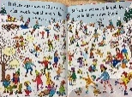 |  |  |  |  | Immi – Littlewood 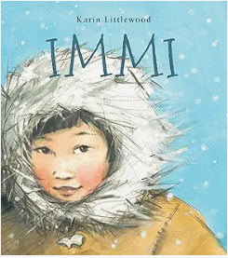Betty & Yeti – Burfoot  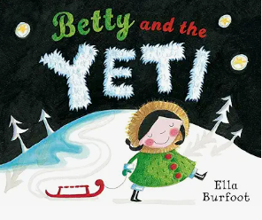 |  |  |  |  |  |  | Polar Bear  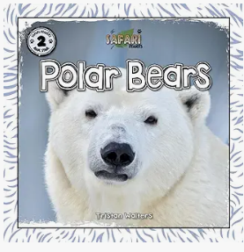 |  |  |  |  |  | Me…. Dodd  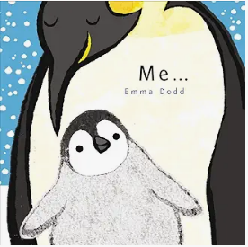  Delightfully Different Dilly – Dale & Darcy  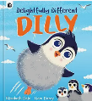  Tango makes three – Richardson  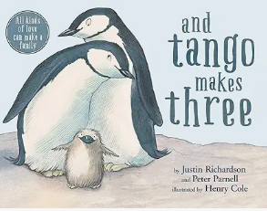 |  |  |  |  |  | I love Chinese New Year –  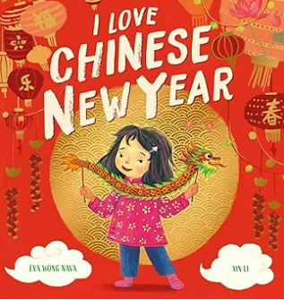 |  |  |  | Going to school – Usborne  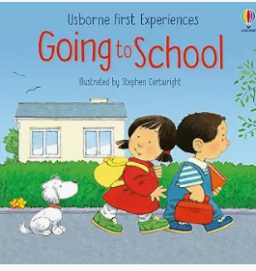  I love my teacher – Andrea  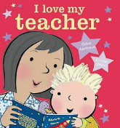 |  |  |  |  |  | Postman Pat  Lulu visits the library –McQuinn  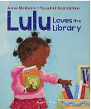  Stanley’s shop – Bee  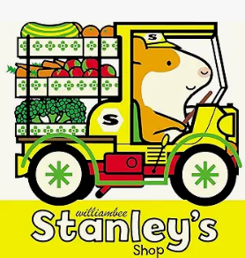  Stanley the builder – Bee  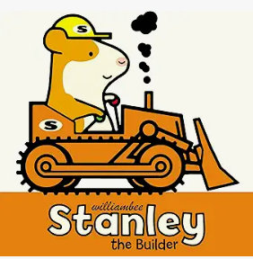 |  |  |  | Mog goes to the v.e.t. – Kerr  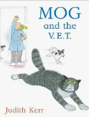  Hairy Maclary's Rumpus At The Vet - Dodd  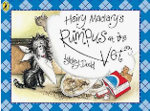  Ness the Nurse - Sharratt  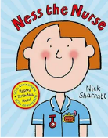 |  |  |  | Fireman Piggy Wiggy – Fox 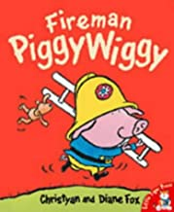  Mr Men’s Fire Station Hargreaves  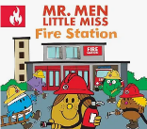  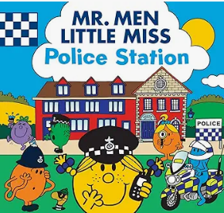 |  |  |  | Supertato –  Hendra & Linnet  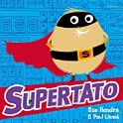  When we grow up –Walsh  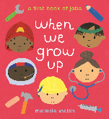 |  |  |  |  | Five little Easter Bunnies – Mumford  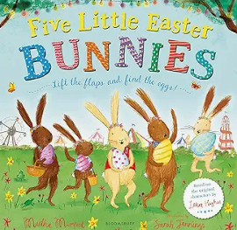
Nursery Learning Outcomes | Continue to listen to longer stories and remember much of what happened.  Be able to talk about familiar books and be able to tell a long story.  Develop imaginative play based on traditional stories eg. making up new endings.  Engage in extended conversations about stories, learning new vocabulary. |  |  |  |  |  |  |  |  |  |  |  |  |  |  |  |  |  |  |  |  |  |  |  |  |  |  |  |  |  |  |  | Print has meaning and can have different purposes (factual books).  Show an interest in different occupations.  Invite people in to learn about their jobs & new vocab about these professions.  Challenge gender and stereo types.
Nursery Learning Outcomes | Small world to reinforce the stories |  |  |  |  |  |  |  |  |  | Sequencing and retelling the story |  |  |  |  |  |  | Explore different material freely, in order to develop their ideas about how to use them eg making an igloo |  |  |  |  |  |  |  |  |  | Continue to develop positive attitudes to the differences between people.  Share books that reflect diversity. |  |  |  |  |  |  |  |  |  |  |  |  |  |  | Continue to develop their phonological awareness. rhythm and rhyme in Hairy Maclary |  |  |  |  |  |  |  | Engage in more complex stores to learn a wider range of vocabulary.
Spring Core Text – Reception | Week 1 |  |  |  |  | Week 2 |  |  |  |  | Week 3 |  |  |  |  |  |  | Week 4 |  |  |  |  |  | Week 5 |  |  |  | Week 6 |  |  |  |  | Week 7 |  |  |  |  |  | Week 8 |  |  |  | Week 9 |  |  |  | Week 10 |  |  |  | Week 11 |  |  |  |  | Week 12
Spring Core Text – Reception | Winter |  |  |  |  |  |  |  |  |  |  |  |  |  |  |  |  |  |  |  |  |  |  |  |  |  |  |  |  |  |  |  | People who help us |  |  |  |  |  |  |  |  |  |  |  |  |  |  |  |  |  |  |  |  |  |  | Easter
Spring Core Text – Reception | Winter & Snowy clothes |  |  |  |  | What we do in the snow |  |  |  |  | Winter in other lands |  |  |  |  |  |  | Animals from cold lands |  |  |  |  |  | Animals from cold lands |  |  |  | Chinese new year |  |  |  |  | In school |  |  |  |  |  | Community |  |  |  | People we visit who help us |  |  |  | Emergency helpers |  |  |  | Farm  Superhero
Spring Core Text – Reception | Once upon a snow storm – Johnson  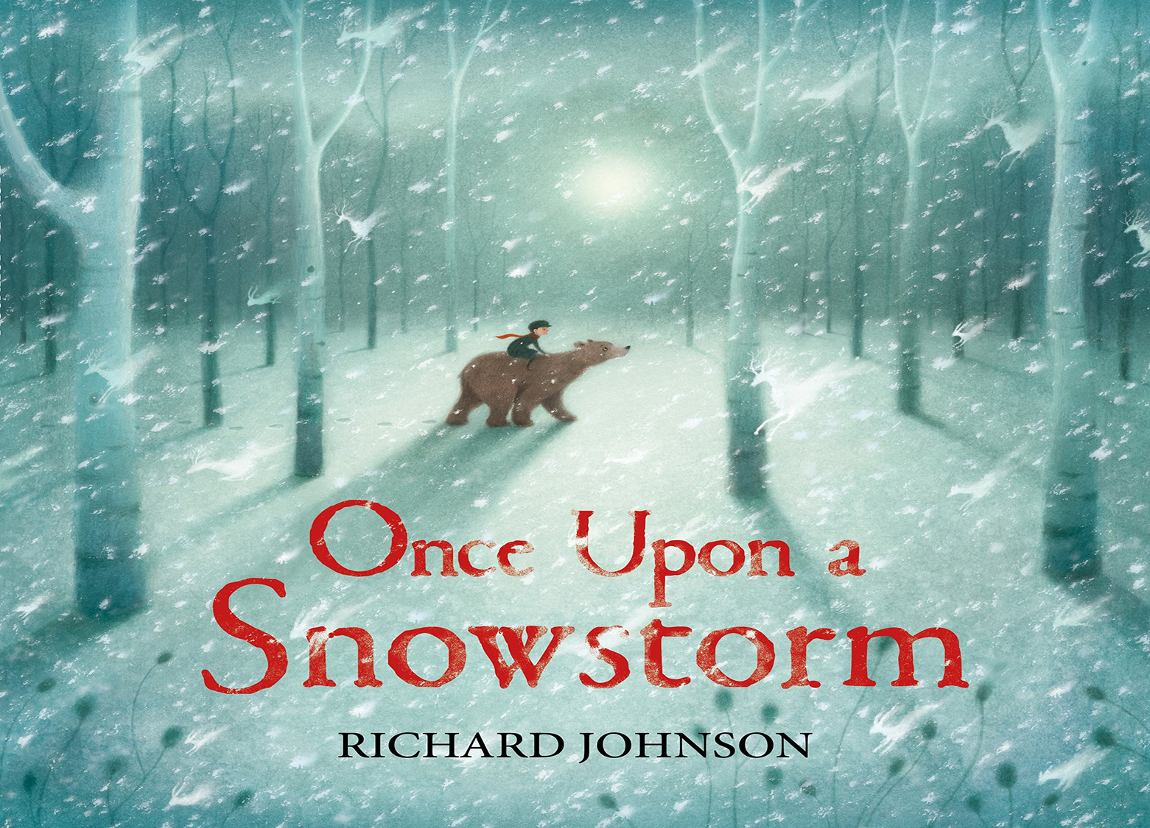 |  |  |  |  | Lost and Found – Jeffers  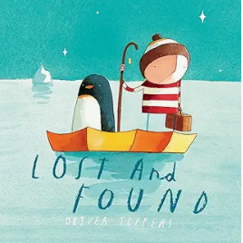 |  |  |  |  |  |  |  |  |  |  |  | Little Polar Bear – Hans de Beer 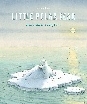 |  |  |  |  |  | Delightfully Different Dilly – Dale & Darcy  Penguin – Dunbar  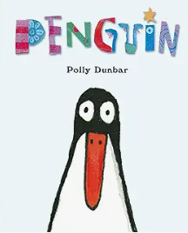 |  |  |  |  |  |  |  |  |  |  |  |  |  |  |  |  |  |  | Runaway cone – Hood  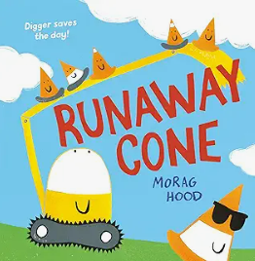 |  |  |  | Cops and robbers – Ahlberg  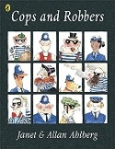 |  |  |  | Supertato –  Hendra & Linnet  When we grow up –Walsh |  |  |  |  | The first Easter Egg Hunt – Guillian 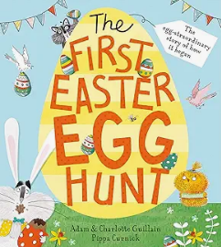
Learning Outcomes - Rec | Engage in non-fiction books .  Invent, adapt and recount narratives and stories with peers and their teachers.  Offer explanations for why things might happen making use of recently introduced vocabulary.  Use and understand recently introduced vocabulary during discussions. about stories, non-fiction, rhymes and poems and during role play |  |  |  |  |  |  |  |  |  |  |  |  |  |  |  |  |  |  |  |  |  |  |  |  |  |  |  |  |  |  |  | Talk about the lives of the people around them and their roles in society.
Learning Outcomes - Rec |  |  |  |  |  |  |  |  |  |  |  |  |  |  |  |  |  |  |  |  |  |  |  |  |  |  |  |  |  |  |  |  | Engage in non-fiction books.  Listen to and talk about selected non-fiction to develop a deep familiarity with new knowledge and vocabulary. |  |  |  |  |  |  |  |  |  |  |  |  |  |  |  |  |  |  |  | Pupils should be able to write simple phrases and sentences that can be read by others.
Wrap-around texts |  |  |  |  |  |  |  |  |  |  |  |  |  |  |  |  |  |  |  |  |  |  |  |  |  |  |  |  |  |  |  |  |  |  | Zog and the flying doctor – Donaldson Thank you – Coelho  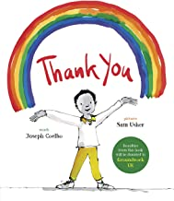  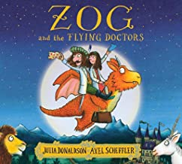
Summer Core Texts  ummer  Summer Core Texts – Nursery | Week 1 |  |  |  |  | Week 2 |  |  |  |  | Week 3 |  |  |  |  |  |  | Week 4 |  |  |  |  |  | Week 5 |  |  |  | Week 6 |  |  |  |  | Week 7 |  |  |  |  |  | Week 8 |  |  |  | Week 9 |  |  |  | Week 10 |  |  |  | Week 11 |  |  |  |  | Week 12
Summer Core Texts  ummer  Summer Core Texts – Nursery | Growing and change |  |  |  |  |  |  |  |  |  |  |  |  |  |  |  |  |  |  |  |  |  |  |  |  |  |  | Holidays and seaside
Summer Core Texts  ummer  Summer Core Texts – Nursery | Human lifecycles |  |  |  |  | Planting |  |  |  |  | Chickens |  |  |  |  |  |  | Butterflies |  |  |  |  |  | Frogs |  |  |  | Our holidays |  |  |  |  | Cold & Hot holidays |  |  |  |  |  | Travelling on holiday |  |  |  | Accommodation |  |  |  | Beach holidays |  |  |  | Seaside creatures |  |  |  |  | The world
Summer Core Texts  ummer  Summer Core Texts – Nursery | Mog and the baby – Kerr |  |  |  |  | Lola plants a garden – McQuinn  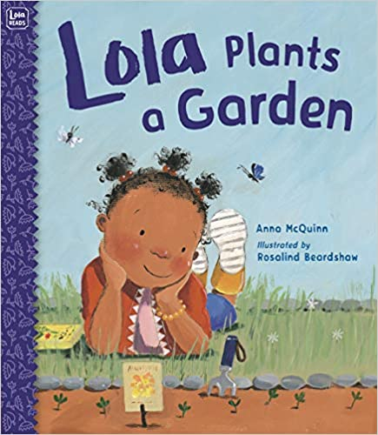  Plant the tiny seed Matheson  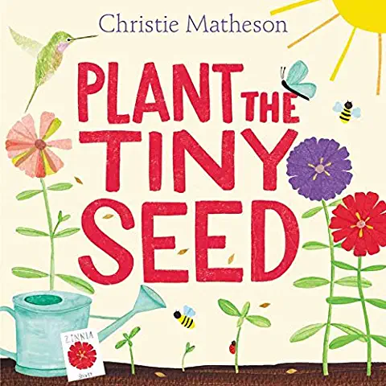  5 Little seeds |  |  |  |  | Click clack peep The cow that laid an egg – Cutbill  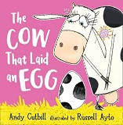  Egg to chicken – Life cycles – Duhig  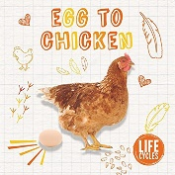 |  |  |  |  |  |  | Monkey Puzzle – Donaldson  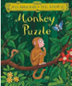  The very hungry caterpillar – Carle  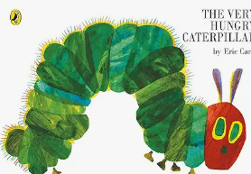 |  |  |  |  |  | Grumpy Frog – Vere  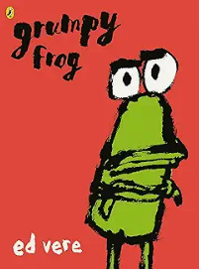Little frog’s Tadpole trouble – Feeney 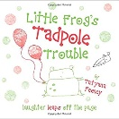  Frog  life cycles – Duhig  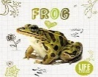  Oi Frog – Grey 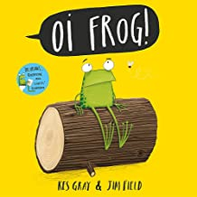  5 little speckled frogs |  |  |  |  |  |  |  |  |  |  |  |  |  |  | The naughty bus – Oke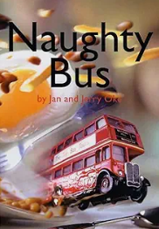 |  |  |  |  |  |  |  | Billy’s bucket
Nursery Learning Outcomes statements | Use some of their print and letter knowledge in their early writing eg. instructions for looking after the animals/growing plants in provision.  Understand ‘why’ questions.  Having extended conversations.  Use longer sentences of four to six words.
Nursery Learning Outcomes statements | Plant seeds and care for growing plants. | Engage in extended conversations about stories learning new vocabulary. |  |  |  |  |  |  |  |  |  |  | Understand the key features of the life cycle of a plant and an animal.  Begin to understand the need to respect and care for the natural environment and all livings things. |  |  |  |  |  |  |  |  |  |  |  |  |  |  |  |  | Know there are different countries in the world and talk about the differences they have seen or experienced in photos (use props etc to explore this)  To use talk to organise themselves and their play.
wrap around texts | Little green helpers – Grow – Engel  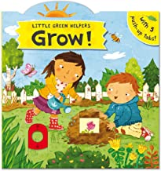 |  |  |  |  |  |  |  |  |  |  |  |  | Babies on the farm – Nelson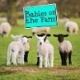 Are you my mummy?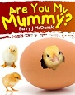 McDonald |  |  |  |  |  |  |  |  |  |  |  |  |  |  |  | 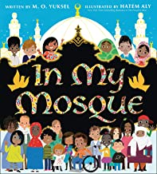In my mosque – Yuksel 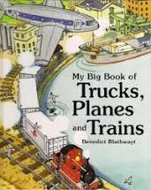  The big book of trucks, trains and planes – Blathwayt
Summer Core Reception | Week 1 |  |  |  |  | Week 2 |  |  |  |  |  | Week 3 |  |  |  |  |  |  | Week 4 |  |  |  |  |  | Week 5 |  |  | Week 6 |  |  |  |  |  |  | Week 7 |  |  |  |  | Week 8 |  |  |  | Week 9 |  |  |  | Week 10 |  |  |  | Week 11 |  |  |  | Week 12
Summer Core Reception | Human lifecycles |  |  |  |  | Planting |  |  |  |  |  | Chickens |  |  |  |  |  |  | Butterflies |  |  |  |  |  | Frogs |  |  | Our holidays |  |  |  |  |  |  | Cold & Hot holidays |  |  |  |  | Travelling on holiday (transport) |  |  |  | Accommodation |  |  |  | Beach holidays |  |  |  | Seaside creatures |  |  |  | The world
Summer Core Reception |  |  |  |  |  | Lola plants a garden – McQuinn  Jack and the beanstalk – Wade  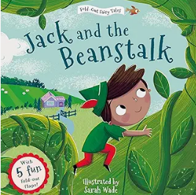 |  |  |  |  |  | Ugly Duckling – Alperin  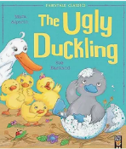 |  |  |  |  |  |  | Monkey Puzzle – Donaldson  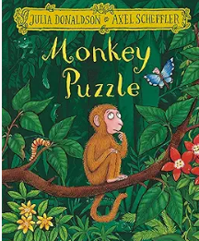 |  |  |  |  |  | Oi Frog -  Gray & Field 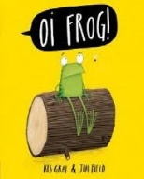 |  |  |  |  |  |  |  |  |  | Alan’s big scary teeth – Jarvis  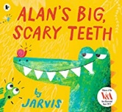 |  |  |  |  | The Naughty Bus – Oke  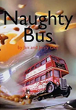 |  |  |  | Home - Ellis  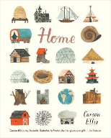 |  |  |  | Billy’s bucket – Gray & Parsons  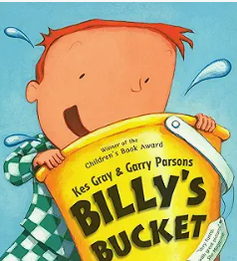 |  |  |  | Sharing a shell – Donaldson  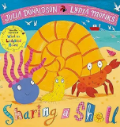
Reception Learning Outcomes | Explore the natural world around them making observations and drawings of animals and plants.  Know some similarities and differences between the natural world around them and contrasting environments drawing on their experiences and what has been read in class.  Engage in non-fiction books.  Listen to and talk about selected non-fiction to develop a deep familiarity with new knowledge and vocabulary.  Hold a pencil effectively in preparation for fluent writing using the tripod grip in almost all cases. Begin to show accuracy and care when drawing. Listen carefully to rhymes and songs paying attention to how they may sound |  |  |  |  |  |  |  |  |  |  |  |  |  |  |  |  |  |  |  |  |  |  |  |  |  |  |  |  |  |  |  |  |  |  | Know some similarities and differences between the things in the past and now drawing on their experiences and what has been read in class (eg travel over time).  Explain some similarities and differences between life in this country and life in other countries drawing on knowledge from stories, non-fiction texts and when appropriate maps.  Know some similarities and differences between the natural world around them and contrasting environments drawing on their experiences and what has been read in class.

